Care Coordination (CC)

Standardized Episodes of Care (SEOC)

Software Version 1.10

Administrative User Guide



January 2020

Department of Veterans Affairs

Office of Information and Technology (OI&T)

Revision History

NOTE: The revision history cycle begins once changes or enhancements are requested after the document has been baselined.

| Date | Revision | Description | Author |
| --- | --- | --- | --- |
| 01/13/2020 | 1.0 | Initial Delivery | AbleVets |

**Artifact Rationale**

Per the Veteran-focused Integrated Process (VIP) Guide, the User’s Guide is required to be completed prior to Critical Decision Point #2 (CD2), with the expectation that it will be updated as needed. A User Guide is a technical communication document intended to give assistance to people using a particular system, such as VistA end users. It is usually written by a technical writer, although it can also be written by programmers, product or project managers, or other technical staff. Most user guides contain both a written guide and the associated images. In the case of computer applications, it is usual to include screenshots of the human-machine interfaces, and hardware manuals often include clear, simplified diagrams. The language used is matched to the intended audience, with jargon kept to a minimum or explained thoroughly. The User Guide is a mandatory, build-level document, and should be updated to reflect the contents of the most recently deployed build. The sections documented herein are required if applicable to your product.

Table of Contents

1. Introduction 1

1.1. Purpose 1

1.2. Document Orientation 1

1.2.1. Organization of the Manual 1

1.2.2. Assumptions 2

1.2.3. Coordination 2

1.2.4. Disclaimers 3

1.2.4.1. Software Disclaimer 3

1.2.4.2. Documentation Disclaimer 3

1.2.5. Documentation Conventions 3

1.2.6. References and Resources 3

1.3. National Service Desk and Organizational Contacts 3

2. System Summary 4

2.1. System Configuration 4

2.2. Data Flows 5

2.3. User Access Levels 5

2.4. Continuity of Operation 6

3. Getting Started 6

3.1. Logging On 6

3.2. System Menu 7

3.3. Changing User ID and Password 8

3.4. Exit System 8

4. Using the Software 8

4.1. Manage Users 10

4.1.1. Filtering Users 11

4.1.1.1. Filter Users by Role 11

4.1.1.2. Filter Users by User Name or VA Network ID 11

4.1.2. Delete a Selected User 12

4.1.3. Edit a Selected User 13

4.1.4. Add a New User 15

4.2. Exporting Data 16

4.2.1. Export the SEOC Data to a JSON File 16

4.2.2. Export the VA PreCert Webpage Data to a JSON File 17

4.3. Managing Billing Codes 17

4.3.1. Search for a Billing Code 19

4.3.2. Deleting Billing Codes 19

4.3.3. Editing Billing Codes 21

4.3.4. Return to SEOC List 23

4.3.5. Exit Maintenance Mode 24

4.4. Editing Disclaimers 25

4.4.1. Edit the General Disclaimer 25

4.4.2. Deactivate Edit the General Disclaimer 29

4.5. View SEOCs 29

4.5.1. View a Selected SEOC 29

4.5.2. Search for a SEOC by Name 30

4.5.2.1. Sort SEOCs Alphabetically by Name 30

4.5.3. Filter SEOCs by Status 32

4.5.4. Discontinue a SEOC 32

4.5.5. Print a SEOC 33

4.5.6. Invalid Characters 35

4.5.6.1. Show Invalid Characters 35

4.5.6.2. Fix Invalid Characters 38

4.5.7. Track Version Changes 39

4.6. Draft a New SEOC 43

4.6.1. Edit an In-Progress SEOC 62

4.6.2. Activate an In-Progress SEOC 62

4.6.3. Delete an In-Progress SEOC 64

4.7. Pending Revisions 65

4.7.1. Create a Revision 65

4.7.2. Activate a Revision 71

4.7.3. Revert a Date Hold SEOC Back to In-Progress 73

5. Troubleshooting 74

6. Acronyms and Abbreviations 74

A. JSON Instructions 76

List of Figures

Figure 1: Overview of SEOC System 4

Figure 2: SEOC Data Flow Diagram 5

Figure 3: VA Single Sign-On for SEOC 6

Figure 4: Session Timeout Warning 7

Figure 5: Standardized Episodes of Care Home Page 7

Figure 6: User Management 11

Figure 7: Filter Users by Role 11

Figure 8: User Search Field 12

Figure 9: Search Users Results 12

Figure 10: Confirm User Deletion 13

Figure 11: User Deleted Confirmation Message 13

Figure 12: Editable User Fields 14

Figure 13: Updated User displayed in the User List 14

Figure 14: Add New User 15

Figure 15: New User Added to the List 16

Figure 16: Export Menu: Export SEOC Data 16

Figure 17: Export SEOC Data Dialog 17

Figure 18: Export SEOC Data 17

Figure 19: Export SEOC PreCert Data Dialog 17

Figure 20: Manage Billing Codes in Manage Menu 18

Figure 21: Billing Code Management 18

Figure 22: Billing Code Search Field 19

Figure 23: Search Billing Codes Results 19

Figure 24: Confirm Delete Billing Code Message 20

Figure 25: Billing Code Deletion Confirmation Message 20

Figure 26: Edit Billing Code 21

Figure 27: Edit Billing Code Confirmation Message 22

Figure 28: Billing Code Saved Message 23

Figure 29: Return to SEOC List 24

Figure 30: SEOC Admin in Maintenance Mode 24

Figure 31: SEOC Admin Not in Maintenance Mode 25

Figure 32: Edit Disclaimer Button 26

Figure 33: Edit Disclaimer Page 26

Figure 34: Fix Invalid Characters in General Disclaimer Dialog 27

Figure 35: Disclaimer Has Been Saved Message 28

Figure 36: View SEOC 29

Figure 37: SEOC Filter Field 30

Figure 38: Search SEOC Results 30

Figure 39: SEOC Name Column Heading 31

Figure 40: SEOC List Sorted in Alphabetical Order by Name 31

Figure 41: SEOC List Sorted in Reverse Alphabetical Order by Name 32

Figure 42: Filter by Status Menu Options 32

Figure 43: Discontinue SEOC Confirmation 33

Figure 44: Discontinued Status 33

Figure 45: Printed SEOC Window 34

Figure 46: Printed SEOC (Bottom of the Page) 34

Figure 47: Show Invalid Characters Button 35

Figure 48: Show Invalid Characters 36

Figure 49: Show Invalid Characters (Bottom of the Page) 36

Figure 50: Print SEOC from Show Invalid Characters Page 37

Figure 51: Print SEOC from Show Invalid Characters (Bottom of the Page) 37

Figure 52: Hide Invalid Characters Button 37

Figure 53: Fix Invalid Characters Button 38

Figure 54: Fix Invalid Characters Confirmation 38

Figure 55: Invalid Characters Fixed Message 39

Figure 56: Track Version Changes Page 40

Figure 57: Track Version Changes (Middle of the Page) 40

Figure 58: Track Version Changes: Payable Services 41

Figure 59: Print SEOC from Track Version Changes Page 41

Figure 60: Print SEOC from Track Version Changes: Additional Information and Provider Taxonomy Codes 42

Figure 61: Print SEOC from Track Version Changes: Payable Services 42

Figure 62: Draft SEOC: Name and Service Line 43

Figure 63: Edit SEOC Menu 44

Figure 64: Edit SEOC: Details 44

Figure 65: Edit SEOC: Details (Middle of the Page) 45

Figure 66: Edit SEOC: Details (Bottom of the Page) 45

Figure 67: Edit SEOC: Provider Taxonomy Codes 47

Figure 68: Edit SEOC: Add Provider Taxonomy Codes 47

Figure 69: Edit SEOC: Provider Taxonomy Code Added Message 48

Figure 70: Edit SEOC: Added Provider Taxonomy Codes 49

Figure 71: Edit SEOC: Confirm Remove HPTC 49

Figure 72: Edit SEOC: Provider Taxonomy Code Removed Message 50

Figure 73: Edit SEOC: Payable Services 50

Figure 74: Edit SEOC: Add Payable Service 51

Figure 75: Edit SEOC: Add Payable Service (Middle of the page) 51

Figure 76: Edit SEOC: Add Payable Service (Bottom of the Page) 52

Figure 77: Edit SEOC: Add Clinical Service Dialog 52

Figure 78: Edit SEOC: Clinical Service Added Message 53

Figure 79: Edit SEOC: New Clinical Services added to the Payable Service 53

Figure 80: Edit SEOC: Clinical Service Removed Message 54

Figure 81: Edit SEOC: No Billing Codes Required Added Message 54

Figure 82: Edit SEOC: No Billing Codes Required Removed Message 55

Figure 83: Edit SEOC: Any Billing Code Accepted Added Message 55

Figure 84: Edit SEOC: Any Billing Code Accepted Removed Message 55

Figure 85: Edit SEOC: Add Billing Code 56

Figure 86: Edit SEOC: Billing Code Added Message 56

Figure 87: Edit SEOC: Define New Billing Code 57

Figure 88: Edit SEOC: New Billing Code Added Message 58

Figure 89: Edit SEOC: Billing Codes added to the Payable Service 58

Figure 90: Edit SEOC: Billing Code Removed Message 58

Figure 91: Edit SEOC: Payable Service added to SEOC 59

Figure 92: Edit SEOC: Delete Payable Service Confirmation 59

Figure 93: Edit SEOC: Payable Service Removed Message 60

Figure 94: Edit SEOC: View SEOC 61

Figure 95: Edit SEOC: View Provider Taxonomy Codes and Payable Services 61

Figure 96: SEOC Activation Errors 62

Figure 97: SEOC Activation Confirmation 63

Figure 98: SEOC Activation Confirmation Calendar 63

Figure 99: SEOC Will be Activated Message 64

Figure 100: Confirm Deletion 64

Figure 101: Revision: Name and Service Line 65

Figure 102: Revision: Details 66

Figure 103: Revision: Details (Middle of the Page) 66

Figure 104: Revision: Details (Bottom of the Page) 67

Figure 105: Revision: SEOC Provider Taxonomy Codes 67

Figure 106: Revision: Payable Services 68

Figure 107: Edit Payable Service 68

Figure 108: Edit Payable Service: Billing Codes 69

Figure 109: Edit Payable Service: Billing Codes and Action Buttons 69

Figure 110: Edit Payable Service: Payable Services List 70

Figure 111: In-Progress (Revision) Status 70

Figure 112: Revision Displayed in SEOC List 71

Figure 113: Revision Activation Errors 71

Figure 114: Revision Activation Confirmation Message 72

Figure 115: Revision Activation Confirmation Date Calendar 72

Figure 116: Revision Will be Activated Message 73

Figure 117: Confirm Revert SEOC to In-Progress 73

Figure 118: SEOC Reversed to In-Progress Message 74

Figure 119: Import Data Window 76

Figure 120: Query Editor 77

Figure 121: List of Records 77

Figure 122: To Table Dialog Box 78

Figure 123: Search Columns to Expand Dialog Box 78

Figure 124: Search Columns to Expand 79

Figure 125: Expanded SEOC Fields 80

Figure 126: Expand to New Rows Menu Option 80

Figure 127: Payable Services Columns 81

Figure 128: Billing Code Columns 81

Figure 129: Expanded HPTC Fields 82

Figure 130: Imported Data 82

# Introduction

The Care Coordination (CC) Standardized Episodes of Care (SEOC) is a reference database for managing care bundles for use by Veterans Information Systems and Technology Architecture (VistA) and other Department of Veterans Affairs (VA) systems. Services are grouped together within the SEOC system into bundles so that clinicians can add these bundles to patients consult records in a standardized fashion, reducing the amount of time spent manually entering consult instructions, and providing uniformity among the patient records and across facilities for how patient care is prescribed for similar complaints.

These bundles group together one or more services that are preselected for different specialties to be added to the consult records. In addition, the clinician is provided with information regarding prescribing rules and preauthorization requirements, so they can make the most informed decisions regarding patient care.

Additionally, SEOC data will be accessible outside of the VistA/Computerized Patient Record System (CPRS) system so that users of downstream applications will be accessing the centralized data, and SEOC descriptions, reducing the chances of disconnects.

## Purpose

The purpose of this document is to provide instruction for utilizing the SEOC application to standardize and streamline consult management for Community Care.

## Document Orientation

The *Care Coordination (CC) Standardized Episodes of Care (SEOC) v1.10 Administrative User Guide* will provide explanations of each screen and of all user interface options within the context of an easy to understand demonstration data scenario.

This document is also designed to provide the user with screen-by-screen “how to” information on the usage of CC SEOC.

### Organization of the Manual

**Section 1: Introduction**

The Introduction section provides the purpose of this manual, an overview of the SEOC software, an overview of the software used, project references, contact information for the user to seek additional information, and an acronyms and abbreviations list for this manual.

**Section 2: System Summary**

The System Summary section provides a graphical representation of the equipment, communication, and networks used by the system, user access levels, how the software will be accessed, and contingencies and alternative modes of operation.

**Section 3: Getting Started**

Information for the Getting Started section provides a general walk-through of the system from initiation through exit, enabling the user to understand the sequence and flow of the system.

**Section 4: Using the Software**

This section gives the user the “how to” information to use SEOC, including many step-by-step procedures.

**Section 5: Troubleshooting**

This section provides troubleshooting for the SEOC user.

**Section 6: Acronyms and Abbreviations**

This section provides a list of acronyms and abbreviations found in this document.

### Assumptions

This guide was written with the following assumed experience/skills of the audience:

* User has Google Chrome and/or Internet Explorer 11 installed on their machine.

1. Please note that SEOC is not fully 508 compliant in Microsoft Edge, so the VA will continue to support 508 in only Google Chrome and Internet Explorer 11.

* The SEOC user has basic knowledge of the SEOC system (such as the use of commands, menu options, and navigation tools).
* The SEOC user has been provided the appropriate active roles, menus, and security keys required for the SEOC User Interface (UI), as defined below in User Roles.
* The SEOC user is using SEOC to perform their daily consult creation workflow and perform the required SEOC functions.
* The SEOC user has validated access to the SEOC UI.
* The SEOC user has been provided training on the SEOC UI and has reviewed the User Guide.
* SEOC Content Authors: The SEOC Content Authors are responsible for creating and update the content within the SEOC repository using the SEOC UI. These users are required to VA access rights and privileges and will sign on to the SEOC application using their SSOI credentials (typically their PIV and access code).
* CPRS Clinicians that are responsible for documenting patient consult records. These clinicians utilize the SEOC content as part of their daily consult creation workflow such that they will add a SEOC bundle to the patient consult record which will provide for a standardized documentation and care plan approach across the VA for these consults.

### Coordination

One Consult - Consult Toolbox 1.9.02 and above and the HealthShare Referral Manager (HSRM) depend on the availability of the SEOC System. Consult Toolbox 1.9.02 requires active SEOCs whereas HSRM requires active and discontinued SEOCs. Coordination between the One Consult – Consult Toolbox, HSRM, and SEOC team is necessary with any updates to SEOC.

### Disclaimers

#### Software Disclaimer

This software was developed at the Department of Veterans Affairs (VA) by employees of the Federal Government in the course of their official duties. Pursuant to title 17 Section 105 of the United States Code this software is not subject to copyright protection and is in the public domain. VA assumes no responsibility whatsoever for its use by other parties, and makes no guarantees, expressed or implied, about its quality, reliability, or any other characteristic. We would appreciate acknowledgement if the software is used. This software can be redistributed and/or modified freely provided that any derivative works bear some notice that they are derived from it, and any modified versions bear some notice that they have been modified.

#### Documentation Disclaimer

The appearance of external hyperlink references in this manual does not constitute endorsement by the Department of Veterans Affairs (VA) of this Web site or the information, products, or services contained therein. The VA does not exercise any editorial control over the information you may find at these locations. Such links are provided and are consistent with the stated purpose of the VA.

### Documentation Conventions

This manual uses several methods to highlight different aspects of the material.

Table 1. Documentation Symbols and Descriptions

|  |  |
| --- | --- |
| Symbol | Description |
| Triangle with an exclamation point (!) inside to indicate caution for the reader to take special notice of critical information. | **CAUTION:** Used to caution the reader to take special notice of critical information. |

1. Notes are used to inform the reader of general information including references to additional reading material.

### References and Resources

Readers who wish to learn more about CPRS and CC SEOC should consult the [VA Software Document Library](https://www.va.gov/vdl/).

## National Service Desk and Organizational Contacts

For issues related to the CC SEOC that cannot be resolved by this manual or the site administrator, please contact the National Service Desk at 855-NSD-HELP (673-4357).

# System Summary

There was an immediate need to provide clinicians the ability to quickly and consistently add care bundles to a patient’s consult record within VistA. SEOC provides this feature for a higher level of uniformity in patient care, easier access to appropriate services, based on initial diagnoses, and the ability to better control care costs. SEOC allows clinicians to enhance the coordination of care for the Veteran.

The system contains SEOCs, or care bundles, that clinicians or other designated individuals can assign to VA patients. These bundles allow for the consistent use of procedures when certain conditions are diagnosed. This consistency allows the VA to effectively manage patient care and provides easier traceability.

## System Configuration

The SEOC System is designed to be a simple reference database with a supporting SEOC API and User Interface (UI) layer. The SEOC system comprises three application tiers as shown below.

Figure 1: Overview of SEOC System

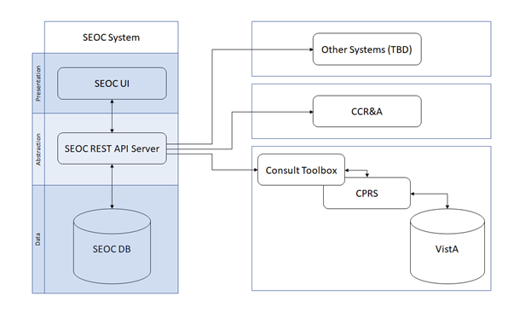

The first tier is the Data Tier. This tier contains SEOC data. SEOC uses Microsoft Structured Query Language (SQL) Server is the database. SEOC data consists of reference data, such as SEOC name, associated procedures, associated Current Procedural Terminology (CPT) codes, procedure durations, etc. Additionally, user role information is maintained within the tables, but no passwords or other credentials are stored. No PHI or PII is stored in the database. SEOC data is associated with patient data in the VistA consult record.

The second tier is the Abstraction Tier. This tier acts as the data broker for the SEOC system. It is a REST Application Programming Interface (API), built as a microservice hosted on container infrastructure (Docker Container). The API itself is built on the Spring MVC framework. The API receives web API calls that are forwarded to the database appropriately. Consuming applications are able to query the SEOC system through the SEOC REST API but will not be able to perform updated operations. The SEOC UI uses certificates to authenticate with the SEOC REST API to allow data modification within the SEOC system by authenticated users. Users are authenticated using SSOI. Additionally, a VistA/MUMPS patch is created to insert the SEOC associations into File # 123.

The third and final tier is the Presentation Tier. This tier consists of the SEOC UI, which provides a user interface for approved, authenticated users to maintain the SEOC collection. This application is a web application built as a microservice hosted on container infrastructure (Docker Container). The UI is built using the React.js JavaScript framework for web applications.

## Data Flows

Figure 2: SEOC Data Flow Diagram

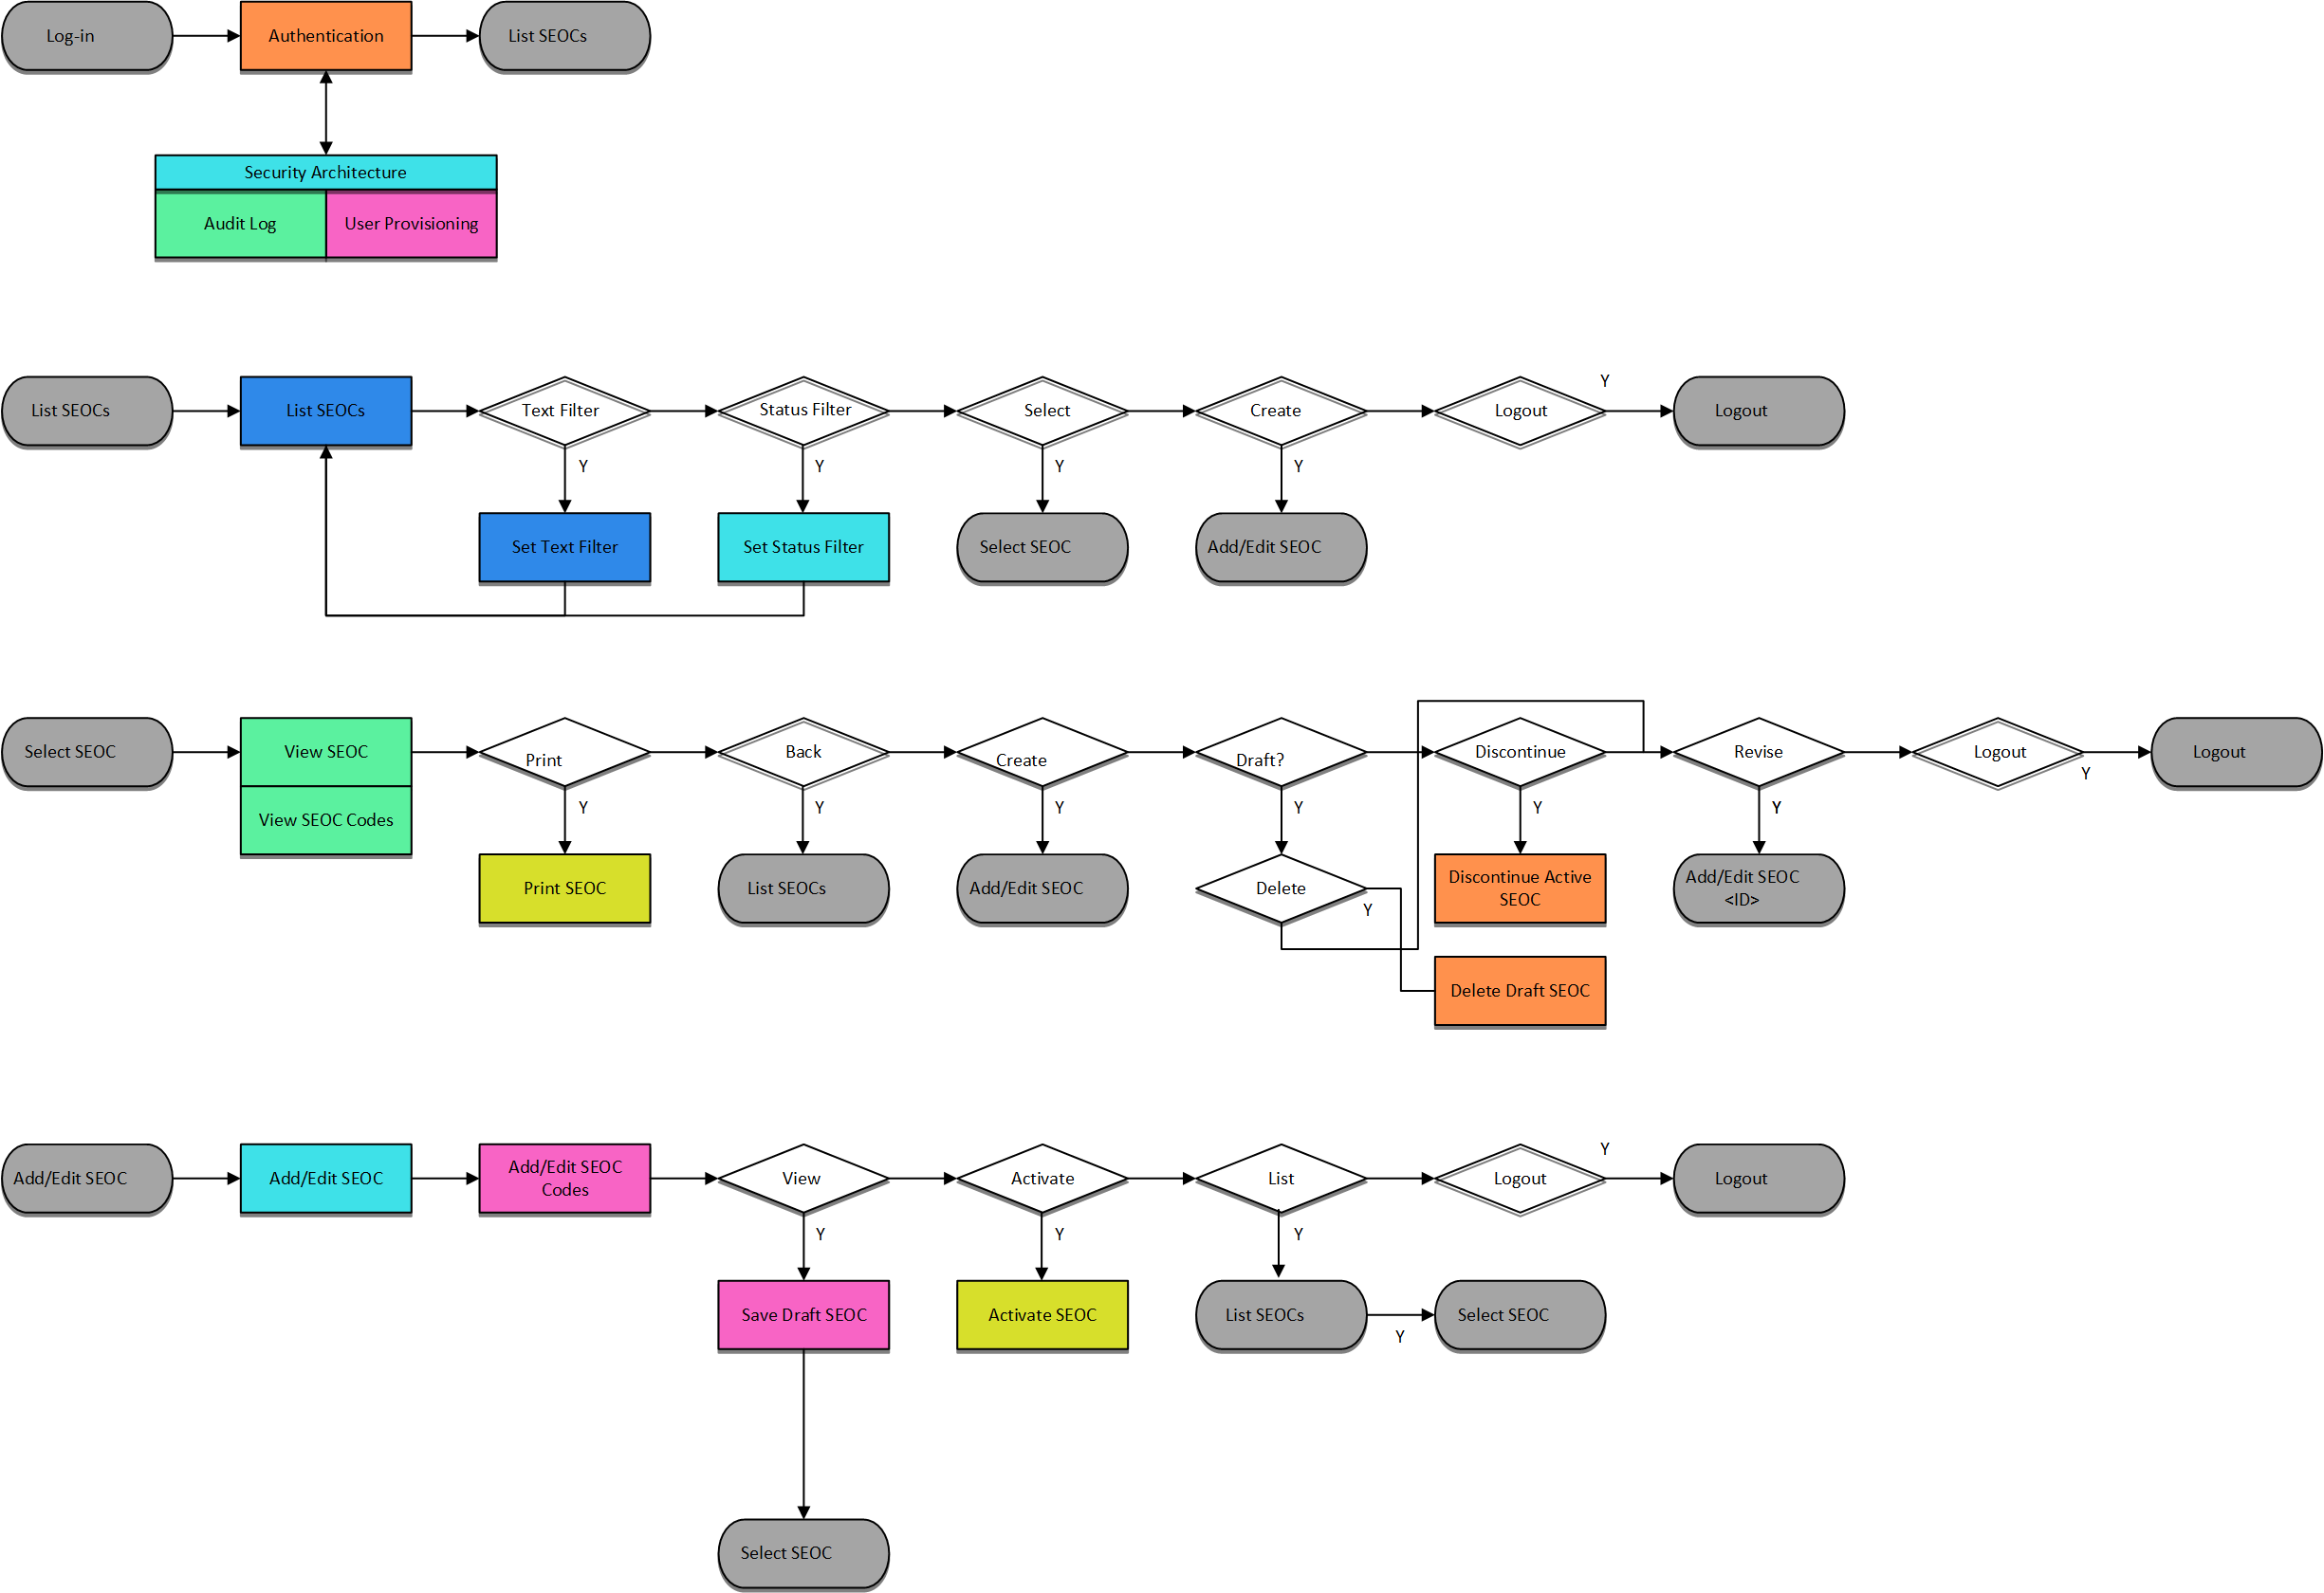

## User Access Levels

SEOC user profiles comprise of the following “types of users”:

* SEOC Content Authors: The SEOC Content Authors are responsible for creating and update the content within the SEOC repository using the SEOC UI. These users are required to VA access rights and privileges and will sign on to the SEOC application using their SSOI credentials (typically their PIV and access code).
* CPRS Clinicians that are responsible for documenting patient consult records. These clinicians utilize the SEOC content as part of their daily consult creation workflow such that they will add a SEOC bundle to the patient consult record which will provide for a standardized documentation and care plan approach across the VA for these consults.
* SEOC data is also accessible to other external consumers in the future (in addition to CPRS users). The SEOC API is a RESTFul API that other (to be determined) users will have access to use.

## Continuity of Operation

The SEOC system is maintained by Enterprise Operations (EO). The continuity of operations is managed by EO.

# Getting Started

This section provides a general walkthrough of CC SEOC from initiation through exit.

## Logging On

CC SEOC is accessed using the VA Single Sign-On Internal (SSOi) log in using the following URL: <https://seoc.va.gov/>

Figure 3: VA Single Sign-On for SEOC

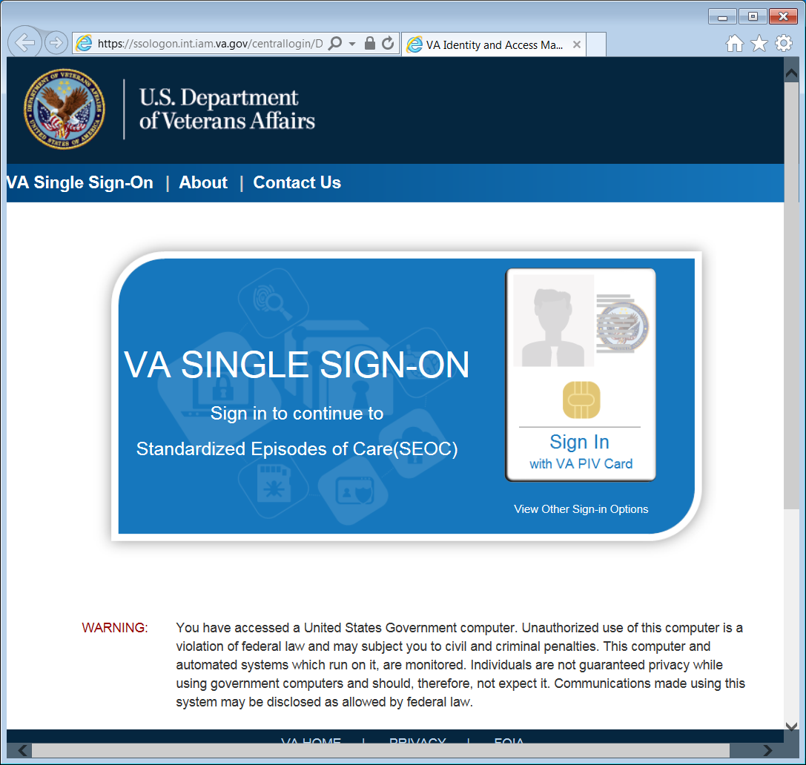

1. After 15 minutes of inactivity the system will automatically log you out. After 13 minutes of inactivity the system will prompt you to extend your session.

Figure 4: Session Timeout Warning

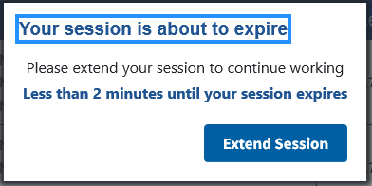

1. The current session is refreshed when a **Request is Made to the API**, a **SEOC is updated**, a **Search or Filter is performed**, or any fields for a **User** or **Billing Code** are updated.

## System Menu

The Standardized Episodes of Care home page offers several features: **Filter by Status**, **Filter by Name**, **Export**, **Manage**, **Edit** **Disclaimer**, **View Selected SEOC**, and **Draft New SEOC**. The home page also displays the user name at the top right of the page.

Figure 5: Standardized Episodes of Care Home Page

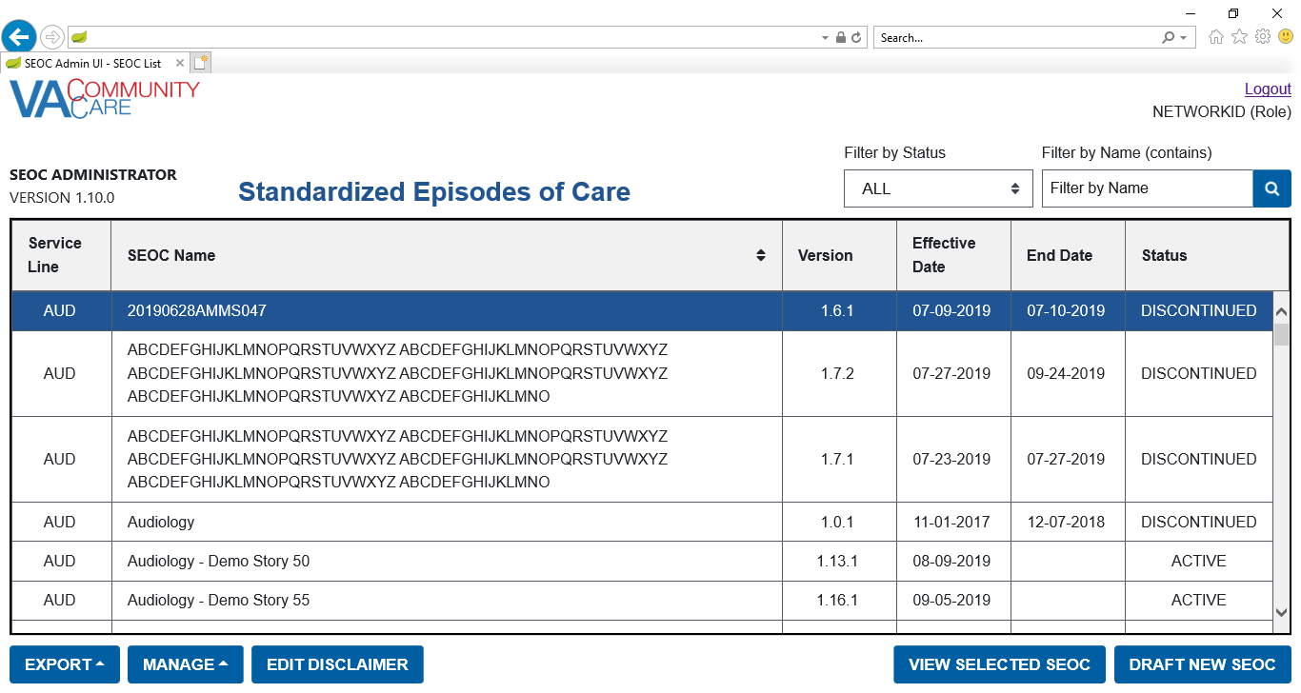

|  |  |
| --- | --- |
| Triangle with an exclamation point (!) inside to indicate caution for the reader to take special notice of critical information. | CAUTION: To view the list of SEOCs using a keyboard interface with assistive technology, you will need to use the “Tab” key to navigate through the list.. |

Standardized Episodes of Care table fields:

* **Service Line** – A broad category of care for the services and procedures included which is intended to be used to group and filter SEOCs for easier accessibility. A standardized three-letter abbreviation of the service line is included at the beginning of the SEOC ID.
* **SEOC Name** – A unique title that categorizes a SEOC by specialty/subspecialty or area of clinical practice.
* **Version** – The version number of the SEOC. The version number is formatted A.B.C where the first digit will be 1, the second digit is the number of published SEOCs in the same Category of Care when a new SEOC is activated, and the third digit is a serialized revision number.
* **Effective Date** –The date the SEOC status was made from In-Progress to Active.
* **End Date** –The date the SEOC status was discontinued.
* **Status** –The SEOC statuses are as follows:
* **Active**: When a SEOC is Active, it will be available for all end users (e.g. API users, scheduling, payment, and auditing purposes).
* **Date Hold**:When the SEOC status is Date Hold, it is pending and set for activation on a designated future date. This status is only available for SEOC Administrative users for editing purposes.
* **Discontinued**:When a SEOC is Discontinued, read-only users will not have access to the discontinued SEOC in the SEOC Database ~~and~~ or the scheduling interface. However, the discontinued version will still be available for payment and auditing purposes. Discontinued SEOCs will remain in the SEOC database for up to six (6) years in the central repository.
* **In-Progress**: The SEOC is available for editing purposes by the Administrators and Authors prior to activation. These SEOCs will not be available via SEOC Database API.

## Changing User ID and Password

If you need to change your user password, you will need to contact your local PIV office.

## Exit System

If you are finished working, log out of VA Single Sign-On and close any secure sessions that may still be open by clicking the **Logout** button.

# Using the Software

The CC SEOC provides user functionality for the following items:

* **Manage Users**
* **Filtering Users**
  + - Filter Users by Role
    - Filter Users by User Name or VA Network ID
* **Delete a Selected User**
* **Edit a Selected User**
* **Add a New User**
* **Exporting Data**
* **Export the SEOC Data to a JSON File**
* **Export the VA PreCert Webpage to a JSON Fil**
* **Manage Billing Codes**
* **Search for a Billing Code**
* **Deleting Billing Codes**
* **Editing Billing Codes**
* **Return to SEOC List**
* **Exit Maintenance Mode**
* **Extend the Current Session**
* **Edit the General Disclaimer**
* **Deactivate the General Disclaimer**
* **Viewing SEOCs**
* **View a Selected SEOC**
* **Search for a SEOC by Name**
  + - Sort SEOCs Alphabetically by Name
* **Filter SEOCs by Status**
* **Discontinue a SEOC**
* **Print a SEOC**
* **Invalid Characters**
  + - Show Invalid Characters
    - Fix Invalid Characters
* **Track Version Changes**
* **Draft a New SEOC**
* **Edit an In-Progress SEOC**
* **Activate an In-Progress SEOC**
* **Delete an In-Progress SEOC**
* **Pending Revisions**
* **Create a Revision**
* **Activate a Revision**
* **Revert a Date Hold SEOC Back to In-Progress**

## Manage Users

The SEOC Admin UI supports the following user roles:

* **Viewer**: Read-Only. This user will only see **Active** or **Discontinued** **SEOCs** on the **Home Page**. They are only able to **View**, **Print**, or **Track Version Changes** on selected **SEOCs**. This user will not see **Provider Codes** on the **View SEOC Page**, the **Track Changes Page**, and the **Print SEOC Page**. Also, by default the SEOC List will show only Active SEOCs for this user.
* **Analyst**:Has all of the privileges of the **Viewer** but can also view **Date Hold SEOCs**. They can also **Export SEOC Data** or **Export VA PreCert Webpage Data** to a JSON file.
* **Author**: Has all of the privileges of the **Viewer** but can also view **In-Progress** or **Date Hold SEOCs**. They can also **Draft a New SEOC**, **Create Pending Revisions**, **Delete** **SEOCs**, or **Edit SEOCs**. This user will see **Provider Codes** on the **View SEOC Page**, the **Track Changes Page**, and the **Print SEOC Page**.
* **Publisher**: Has all of the privileges of the **Author** but can also **Activate** or **Discontinue** SEOCs, **Export SEOC Data** or **Export VA PreCert Webpage Data** to a JSON file, and **Edit the General Disclaimer**.
* **Administrator**: Has all of the privileges of the **Publisher**, but can also open the **User Management** page, **Add New Users**, **Edit Users**, or **Delete Users**. However, an Administrator can’t modify their own privileges. This ensures there will always be at least one **Administrator**.

To manage users for the SEOC Admin UI, follow the steps listed below:

1. As an **Administrator** on the SEOC Admin home page, select **Manage Users** from the **Manage Menu**. The **User Management** window displays.

Figure 6: User Management

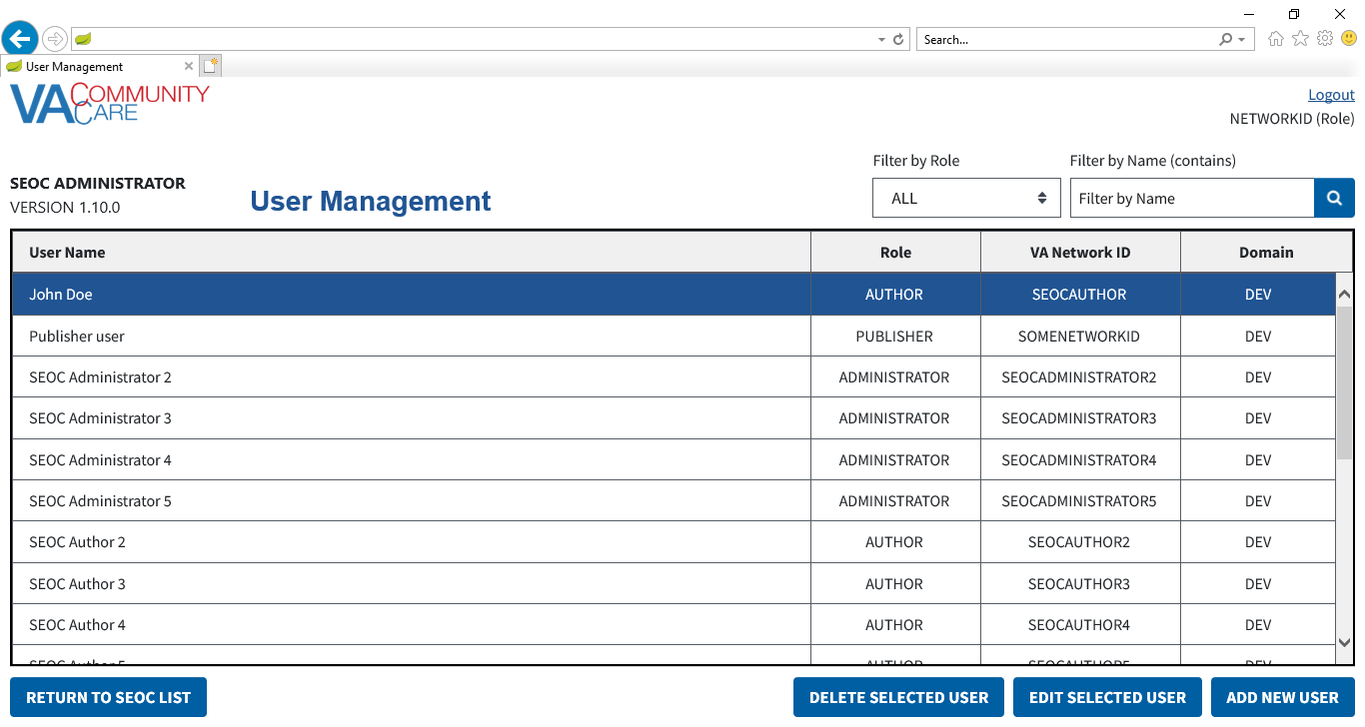

### Filtering Users

#### Filter Users by Role

To filter the list of users in SEOC by role, follow the steps listed below:

1. From the SEOC Admin home page, click **Manage Users**. The **User Management** window displays.
2. From the **Filter by Role** drop-down menu, select **All**, **Viewer**, **Analyst**, **Author**, **Publisher**, or **Administrator** to filter the list of users by role. The list refreshes to display the role selected.

Figure : Filter Users by Role

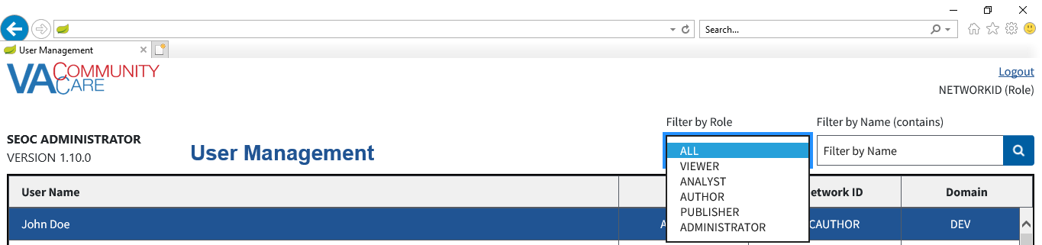

#### Filter Users by User Name or VA Network ID

To filter the list of users in SEOC by user name or VA network ID, follow the steps listed below

1. From the SEOC Admin home page, click **Manage Users**. The **User Management** window displays.
2. From the User Management page, enter the User Name or VA Network ID of the user in the **Filter by Name (contains)** field.

Figure : User Search Field

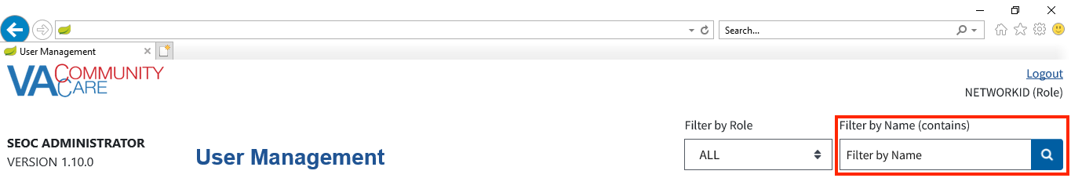

1. Click the **Search** button. The **Search User Results** display.

Figure : Search Users Results

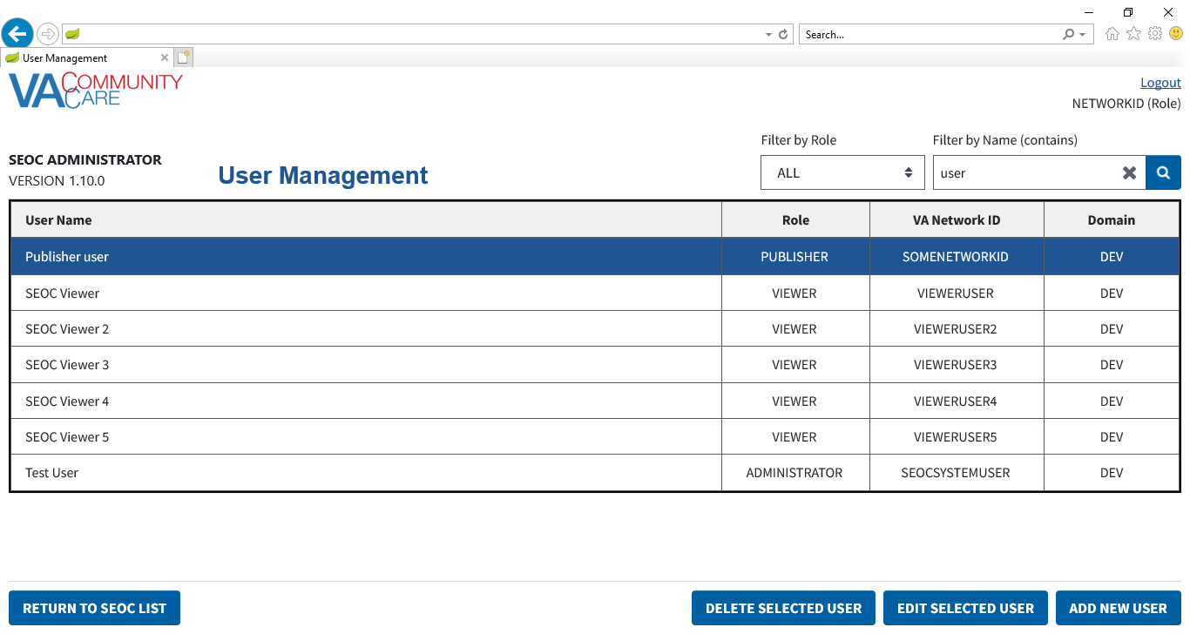

### Delete a Selected User

To delete a user from the User Management list, follow the steps listed below:

1. From the SEOC Admin home page, click **Manage Users**. The **User Management** window displays.
2. From the list of users, select the user that you would like to delete.
3. Click **Delete Selected User**. A message displays confirming that you would like to delete the user.

Figure 10: Confirm User Deletion

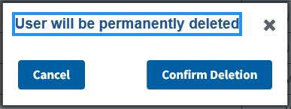

1. Click **Confirm Deletion**. The **User** will be deleted from the **User List** and a confirmation message will display.

Figure 11: User Deleted Confirmation Message

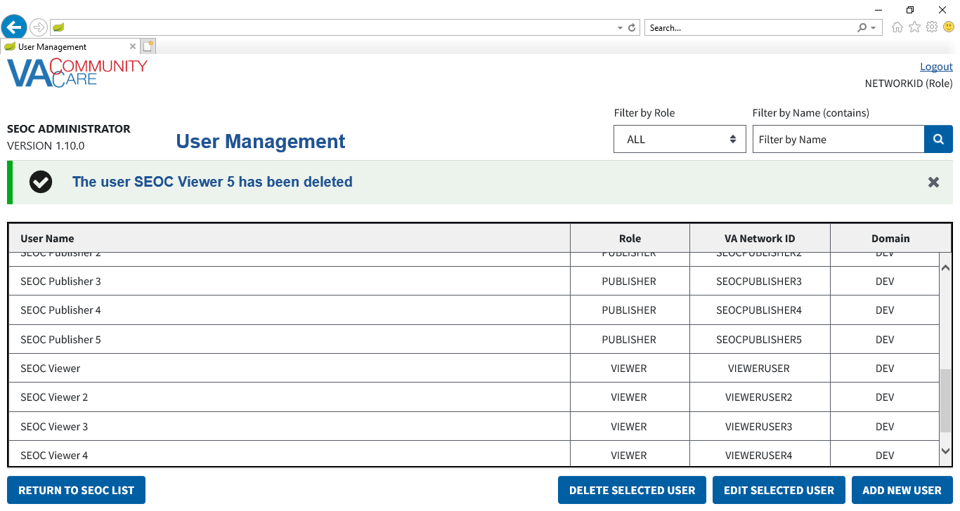

1. The confirmation message can be dismissed by clicking the X button.

### Edit a Selected User

To edit a user in SEOC, follow the steps listed below:

1. From the SEOC Admin home page, click **Manage Users**. The **User Management** window displays.
2. From the list of users, select the user that you would like to edit.
3. Click **Edit Selected User**. The **Edit User** form will display, populated with the selected **User** information.

Figure 12: Editable User Fields

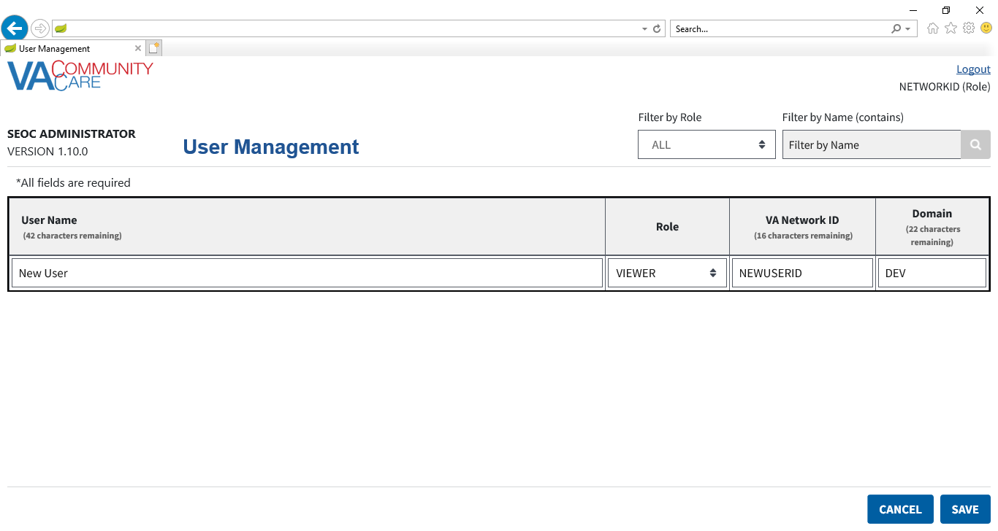

1. Edit the **User Name**, **Role**, **VA Network ID**, and **Domain** fields as needed.
2. Click **Save**. The updated user will display in the list of users.

Figure : Updated User displayed in the User List

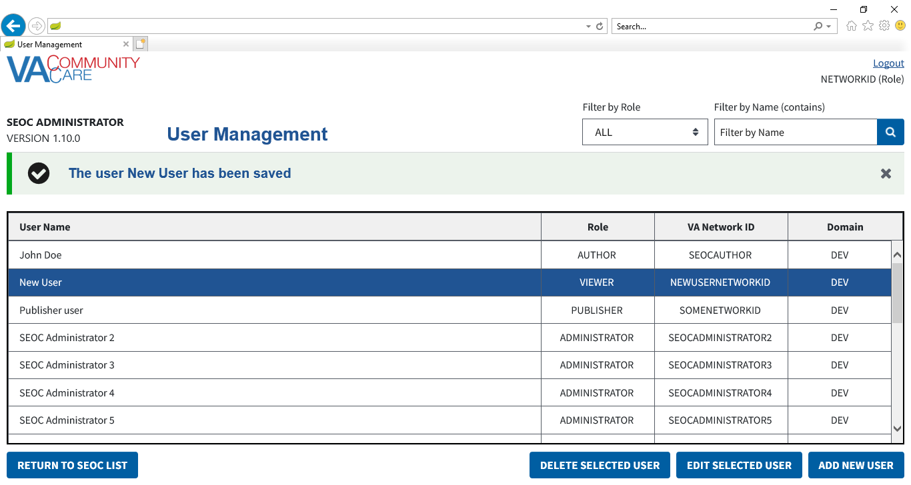

1. If any of the fields are not populated, or if **VA Network ID** or **Domain** have characters other than letters and numbers, an error message will display when you click **Save**.
2. Both the error message and the confirmation message can be dismissed by clicking the X button.

### Add a New User

To add a new user from the User Management list, follow the steps listed below:

1. From the SEOC Admin home page, click **Manage**, and select **Manage Users**. The **User Management** window displays.
2. Click **Add New User**. The **Add New User** form displays.

Figure 14: Add New User

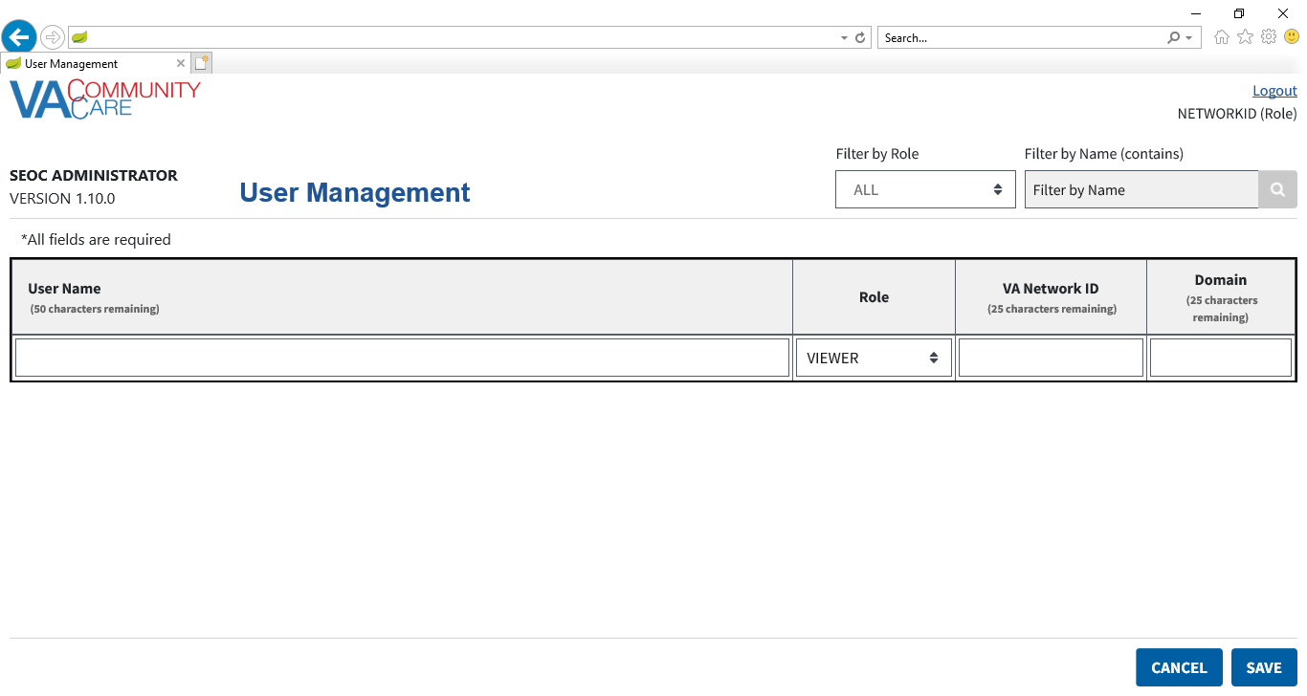

1. In the **User Name** field, which is required, enter the users name.
2. From the **Role** menu, which is required, select **Viewer**, **Analyst**, **Author**, **Publisher**, or **Administrator**.
3. In the **VA Network ID** field, which is required, enter the name of the VA network.
4. In the **Domain** field, which is required, enter the name of the domain.
5. Click the **Save** button. The new **User** will appear in the **User List** and a confirmation message will display.

Figure : New User Added to the List

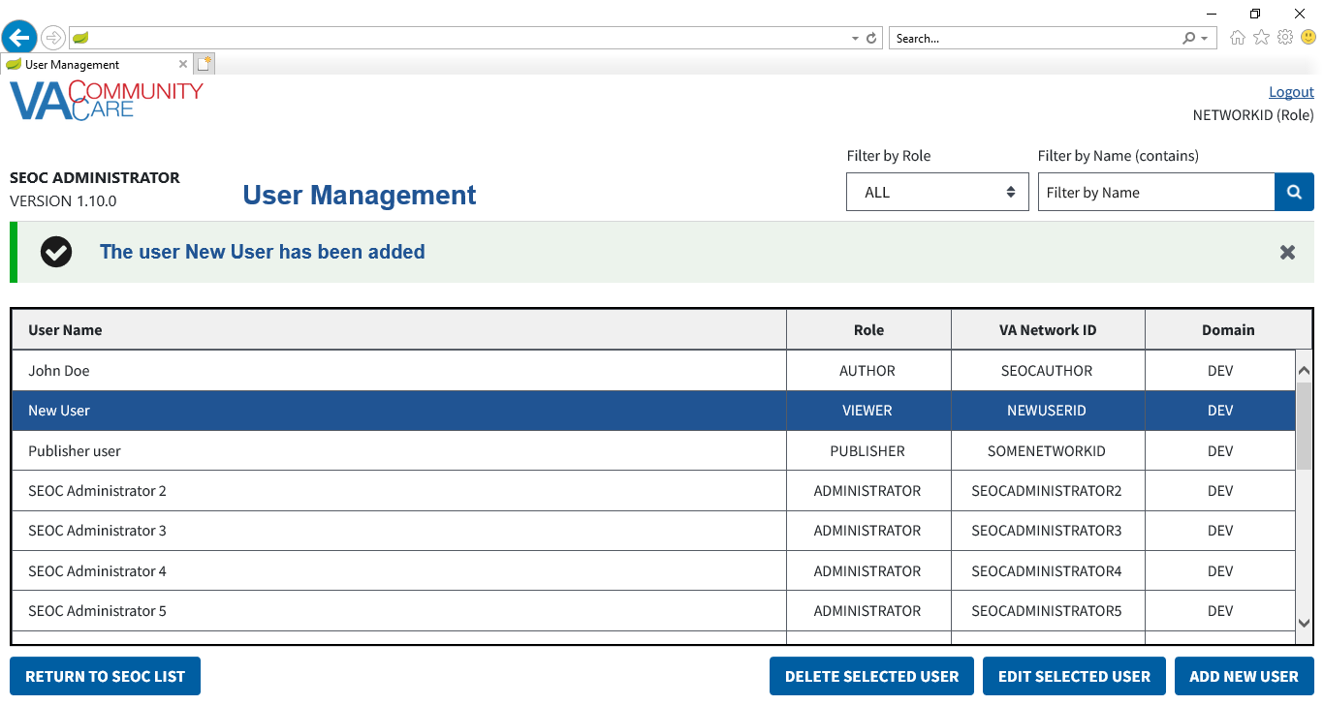

1. If any of the fields are not populated, **VA Network ID** or **Domain** have characters other than letters and numbers, or if **User Name** has a backslash character, an error message will display when you click **Save**.
2. Both the error message and the confirmation message can be dismissed by clicking the X button.

## Exporting Data

### Export the SEOC Data to a JSON File

To export the **SEOC Data**, follow the steps listed below:

Figure 16: Export Menu: Export SEOC Data

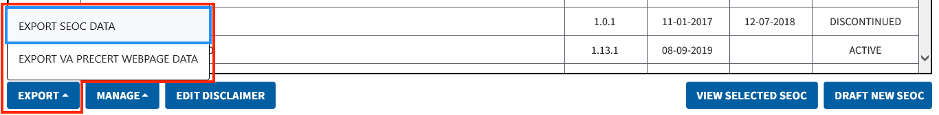

1. As an **Analyst**, **Publisher**, or **Administrator** on the SEOC Admin home page, click **Export SEOC Data**. A dialog displays indicating the data is being downloaded.

Figure 17: Export SEOC Data Dialog

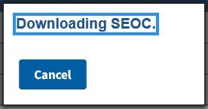

1. If needed, click **Cancel** on the dialog to cancel the data download.

### Export the VA PreCert Webpage Data to a JSON File

For all users who can **Export SEOC Data**, the **SEOC Admin UI** also allows them to export the data required for the **VA PreCert Webpage**.

To export the **SEOC PreCert Data**, follow the steps listed below:

Figure 18: Export SEOC Data

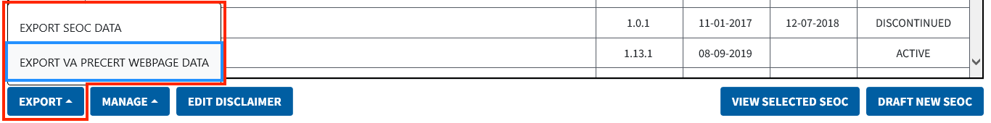

1. As an **Analyst**, **Publisher**, or **Administrator** on the SEOC Admin home page, click **Export PreCert Data**. A dialog will appear indicating the data is being downloaded.

Figure 19: Export SEOC PreCert Data Dialog

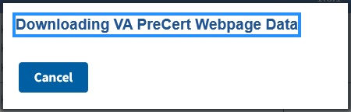

1. If needed, click **Cancel** on the dialog to cancel the data download.
2. Please refer to Appendix A for additional steps on converting the JSON file into an Excel file.

## Managing Billing Codes

1. When updating the Billing Codes, SEOC will go into maintenance mode. SEOC users will be unable to update the system until the Admin has completed managing the billing codes.
2. Maintenance mode can be turned off by any Admin.
3. When you click on Return to SEOC list from Billing Code Management, it will automatically turn maintenance mode off.

Figure : Manage Billing Codes in Manage Menu

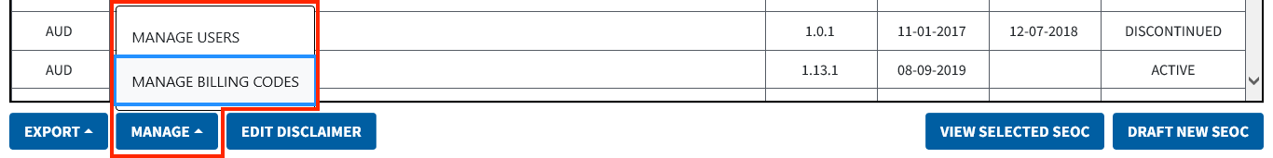

To manage the billing codes in SEOC, follow the steps listed below:

1. From the SEOC Admin home page, click **Manage**, and select **Manage Billing Codes**. The **Billing Code Management** window displays.

Figure 21: Billing Code Management

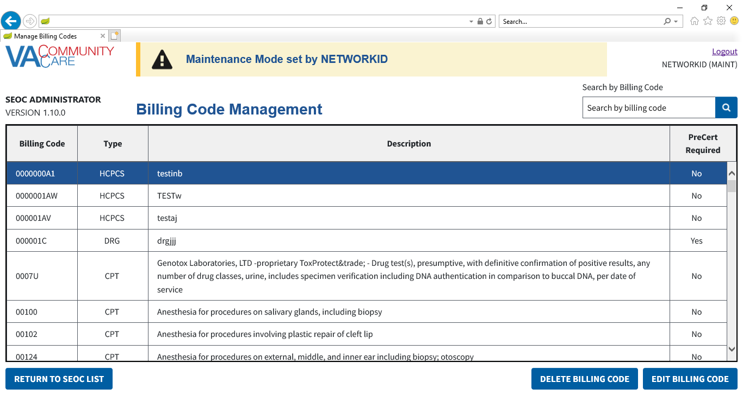

1. This will place the application into **Maintenance Mode** for all users. While **Maintenance Mode** is active, users will be unable to save **SEOC** information or navigate to the **User Management Page**.

### Search for a Billing Code

To search for a **Billing Code**, follow the steps listed below.

1. From the SEOC Admin home page, click **Manage**, and select **Manage Billing Codes**. The **Billing Code Management** window displays.
2. From the **Billing Code Management** page, enter text in the **Search by Billing Code** field.

Figure : Billing Code Search Field

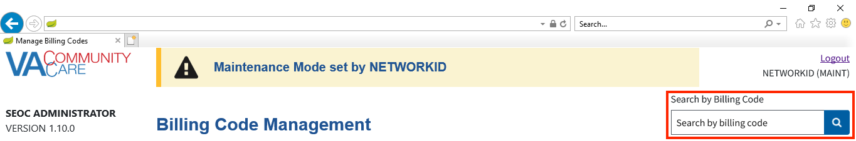

1. Press **Enter** or click the **Search** button. The table will display all rows where the **Billing Code** column starts with the text you entered.

Figure : Search Billing Codes Results

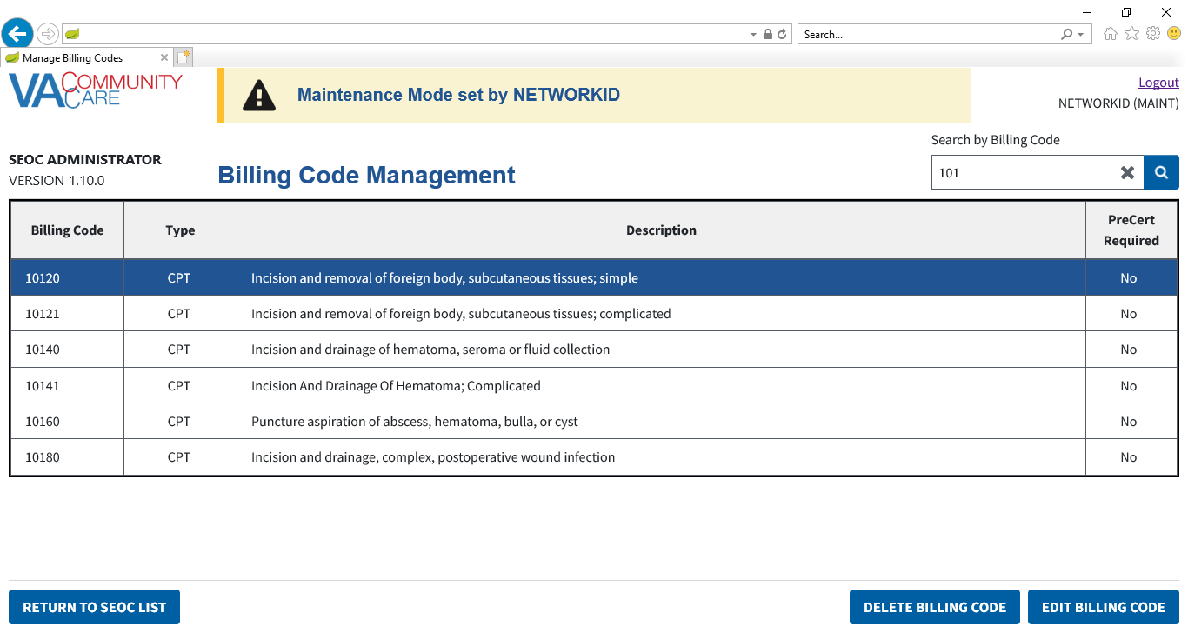

### Deleting Billing Codes

To delete billing codes in SEOC, follow the steps listed below:

1. From the SEOC Admin home page, click **Manage**, and select **Manage Billing Codes**. The **Billing Code Management** page displays.
2. From the list of billing codes, select the code that you would like to delete.
3. Click **Delete Billing Code**. The **Confirm Delete Billing Code** dialog box will display showing all of the **SEOCs** that will be affected.

Figure 24: Confirm Delete Billing Code Message

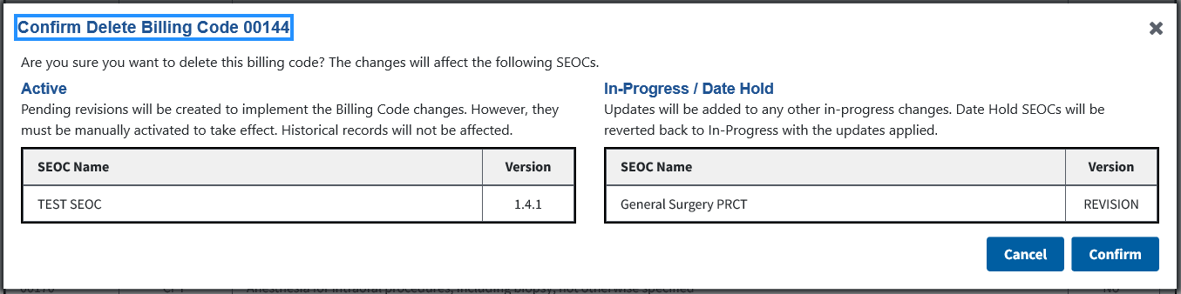

1. Verify that you want to delete the billing code listed, as the changes will affect the SEOCs listed in the Active and In-Progress tables.
2. Click **Confirm**. The **Billing Code** will be deleted from the **Billing Codes List**. A message will display confirming that that the billing code was deleted and the billing code will no longer display in the list.
3. For all affected **SEOCs** with a status of **Active**, a **Revision** will be created with the **Billing Code** deleted. For all affected **SEOCs** with a status of **In-Progress**, whether a **New** **SEOC** or a **Revision**, the **Billing Code** will be removed. For all affected **SEOCs** with a status of **Date Hold**,the **SEOC** will be reverted back to **In-Progress** and the **Billing Code** will be removed. **Discontinued** **SEOCs** are not affected.

Figure 25: Billing Code Deletion Confirmation Message

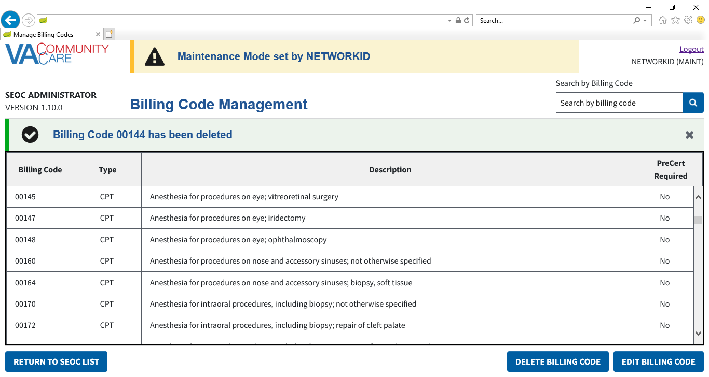

1. The confirmation message can be dismissed by clicking the X button.

### Editing Billing Codes

To manage the billing codes in SEOC, follow the steps listed below:

1. From the SEOC Admin home page, click **Manage**, and select **Manage Billing Codes**. The **Billing Code Management** window displays.
2. From the list of billing codes, select the code that you would like to edit.
3. Click **Edit Billing Code**. The **Edit Billing Code** form displays, populated with the selected **Billing Code** information..

Figure 26: Edit Billing Code

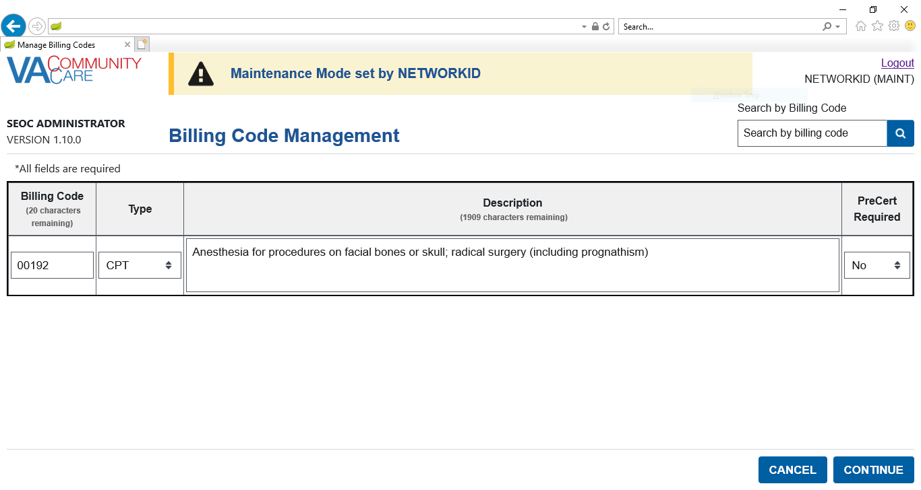

1. Update the **Billing Code** field as needed. The maximum number of characters for this field is 25.
2. From the **Type** field, select the correct option: **CPT**, **DRG**, **HCPCS**, **HIPPS**.
3. Update the **Description** field as needed. The maximum number of characters for this field is 2,000.
4. From the **PreCert Required** field, select the correct option: **NO** or **YES**.
5. Click **Continue**. The **Confirm Update to Billing Code** dialog box will display showing all of the **SEOCs** that will be affected.

Figure 27: Edit Billing Code Confirmation Message

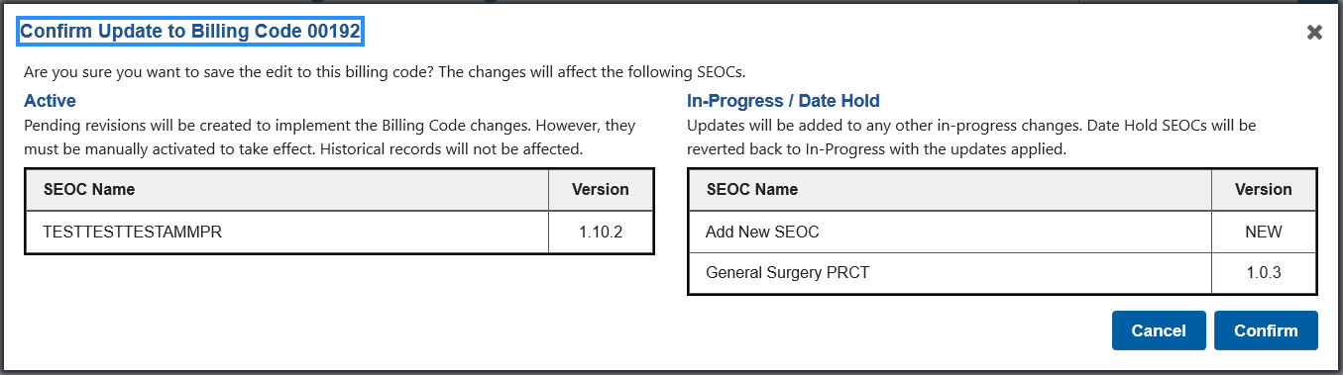

1. Verify that you want to delete the billing code listed, as the changes will affect the SEOCs listed in the Active and In-Progress tables.
2. Click **Confirm**. The updated **Billing Code** will be displayed in the **Billing Codes List**. A confirmation message will display stating that the edits were made to the billing code.
3. For all affected **SEOCs** with a status of **Active**, a **Revision** will be created with the **Billing Code** updated. For all affected **SEOCs** with a status of **In-Progress**, whether a **New** **SEOC** or a **Revision**, the **Billing Code** will be updated. For all affected **SEOCs** with a status of **Date Hold**,the **SEOC** will be reverted back to **In-Progress**, and the **Billing Code** will be removed. **Discontinued** **SEOCs** are not affected.
4. If the value of the **Billing Code** column was not changed as part of the update, the change will not be reflected in **Track Version Changes**.
5. It is possible to update a **Billing Code** without changing any values. When a **Billing Code** is updated, the previous version is deactivated, and another **Billing Code** with the updates is used instead. If no values are updated when a **Billing Code** is saved, the current **Billing Code** is deactivated, and another is created with the same values.
6. If any of the fields are not populated, there are any characters in the **Billing Code** field that are not letters, numbers, a hyphen, or a period, or the **Description** field has a backslash character, an error message will appear when you click **Continue** on the **Edit Billing Code** form.
7. The error message can be dismissed by clicking the X button.

Figure : Billing Code Saved Message

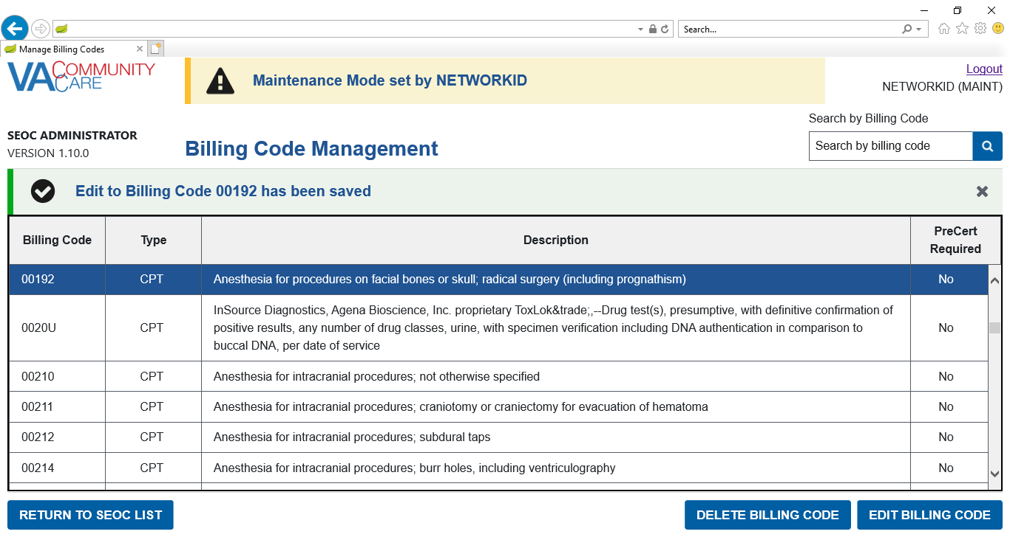

1. The confirmation message can be dismissed by clicking the X button.

### Return to SEOC List

To return to the SEOC Admin home page and exit **Maintenance Mode**, follow the steps listed below.

1. From the **Billing Code Management** page click **Return to SEOC List**. The SEOC Admin home page will be displayed, and the application will no longer be in **Maintenance Mode**.

Figure : Return to SEOC List

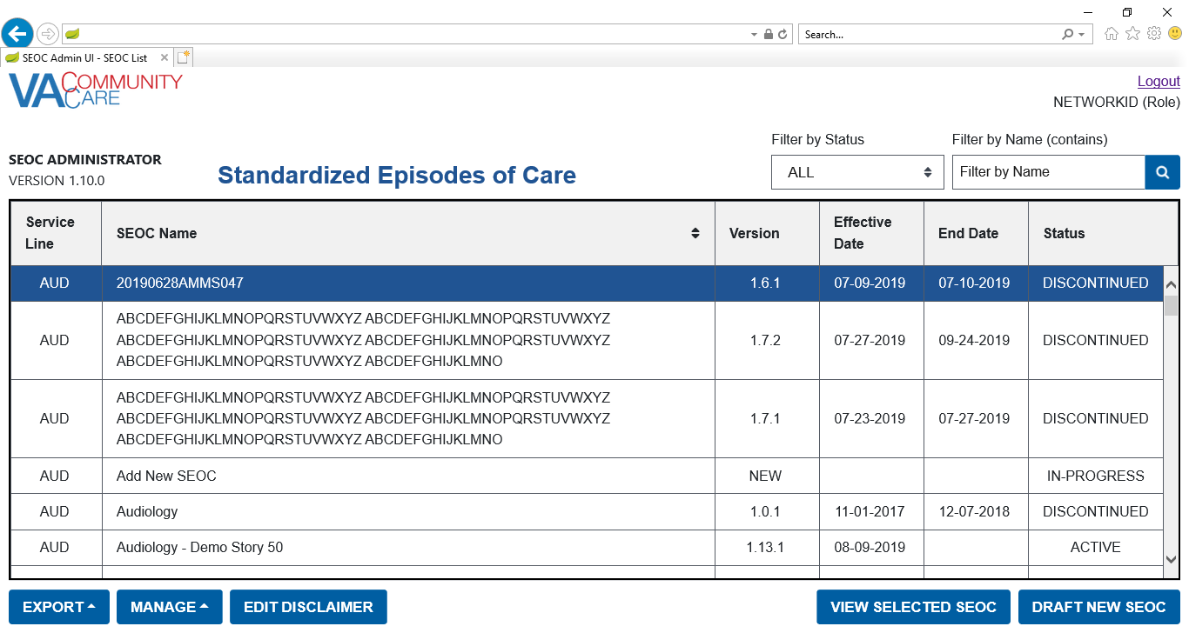

### Exit Maintenance Mode

When the application is in **Maintenance Mode**, all users will see a notification at the top of the page.

Figure : SEOC Admin in Maintenance Mode

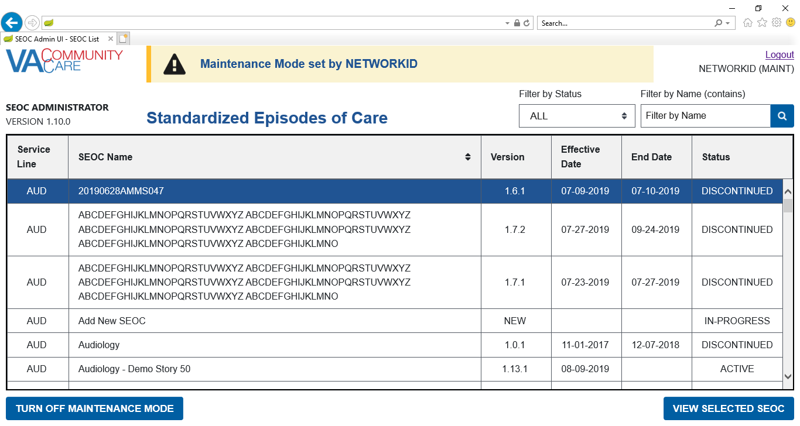

To exit **Maintenance Mode** without navigating to the **Billing Code Management** page, follow the steps listed below.

1. From the SEOC Admin home page, click **Turn Off Maintenance Mode**. The SEOC Admin home page will update, and the application will no longer be in **Maintenance Mode**.

Figure : SEOC Admin Not in Maintenance Mode

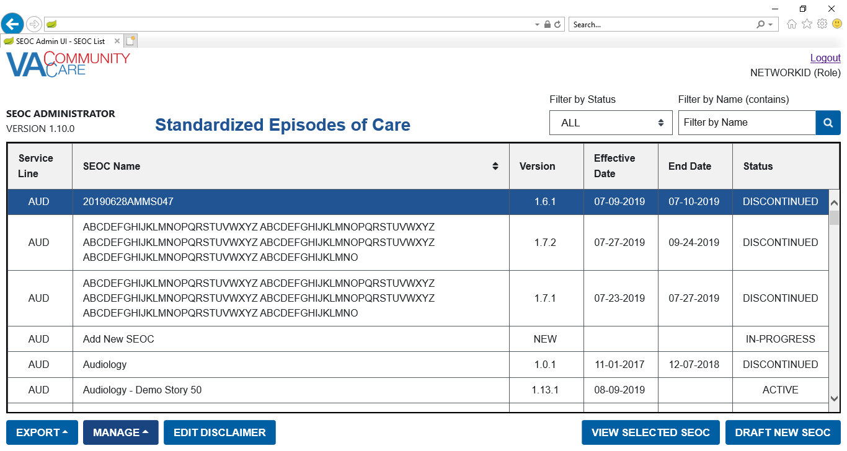

## Editing Disclaimers

### Edit the General Disclaimer

All SEOCs share a common **General Disclaimer**. In the **View SEOC Page**, **Print SEOC Window**, and **Edit SEOC: Details** page, it is displayed as **Disclaimer**. **Publishers** and **Administrators** can access the **Edit Disclaimer** page which allows the user to update the **General Disclaimer** for all **SEOCs**.

Each **SEOC** also has **Additional Information**, which can be used to provide **SEOC**-specific information in addition to the **General Disclaimer**.

1. When the **General Disclaimer** is updated, the change is reflected across all **SEOCs** instantly without updating version numbers or creating new revisions.
2. **Additional Information** is **SEOC**-specific and requires modifying **SEOCs** with the usual methods.

To edit the **General Disclaimer**, follow the steps below:

1. From the SEOC Admin home page, click **Edit Disclaimer**. The **Edit Disclaimer** page will display.

Figure : Edit Disclaimer Button



Figure : Edit Disclaimer Page

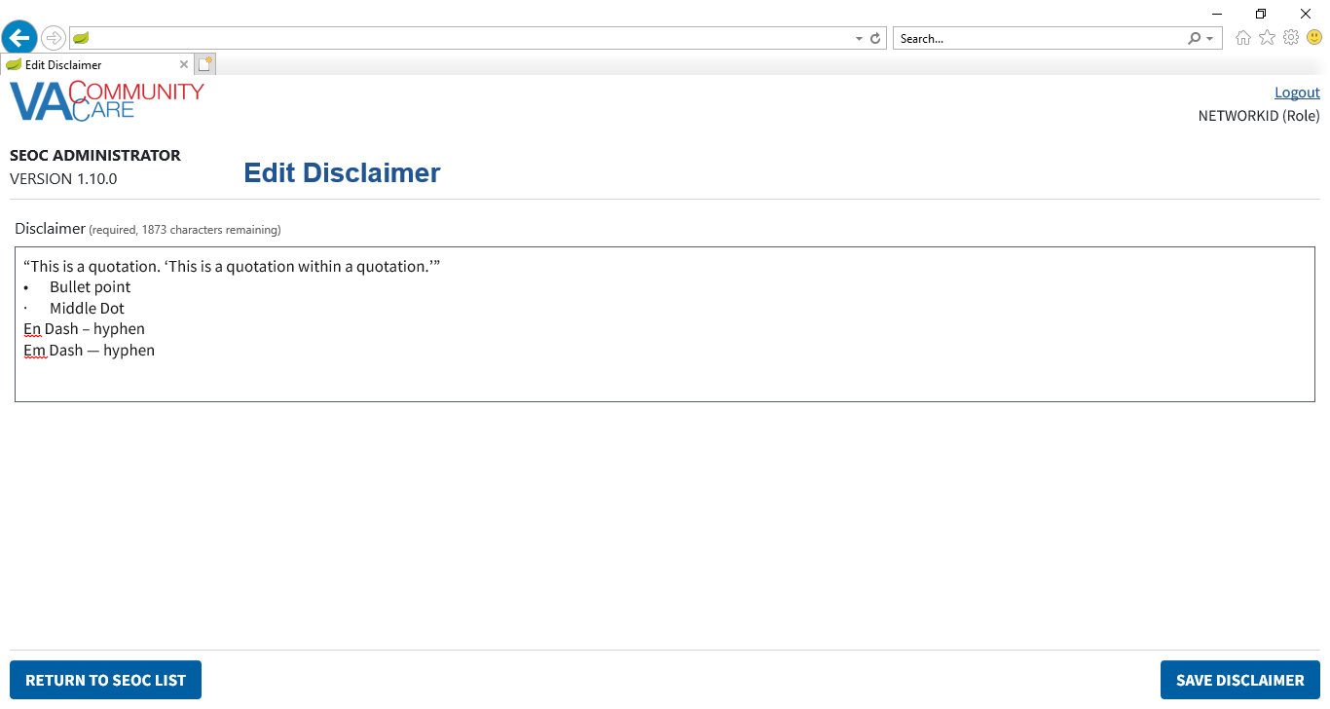

1. Make any updates to the **General Disclaimer** as needed.

Click **Save Disclaimer**. If there are any invalid characters, a dialog will display. For additional information on invalid characters, refer to the 4.5.6

1. Invalid Characters section in this document.

Figure : Fix Invalid Characters in General Disclaimer Dialog

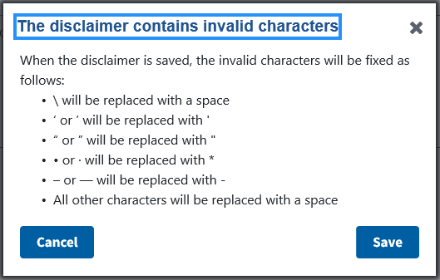

1. To close the dialog and manually fix the invalid characters, click **Cancel**.
2. To save the **General Disclaimer** and automatically fix the invalid characters, click **Save**. The invalid characters will be fixed as follows:

* \ will be replaced with a space
* ‘ or ’ will be replaced with '
* “ or ” will be replaced with "
* • or · will be replaced with *
* – or — will be replaced with -
* All other characters will be replaced with a space

Regardless of whether there are invalid characters, a confirmation message will display when the **General Disclaimer** has been saved.

Figure : Disclaimer Has Been Saved Message

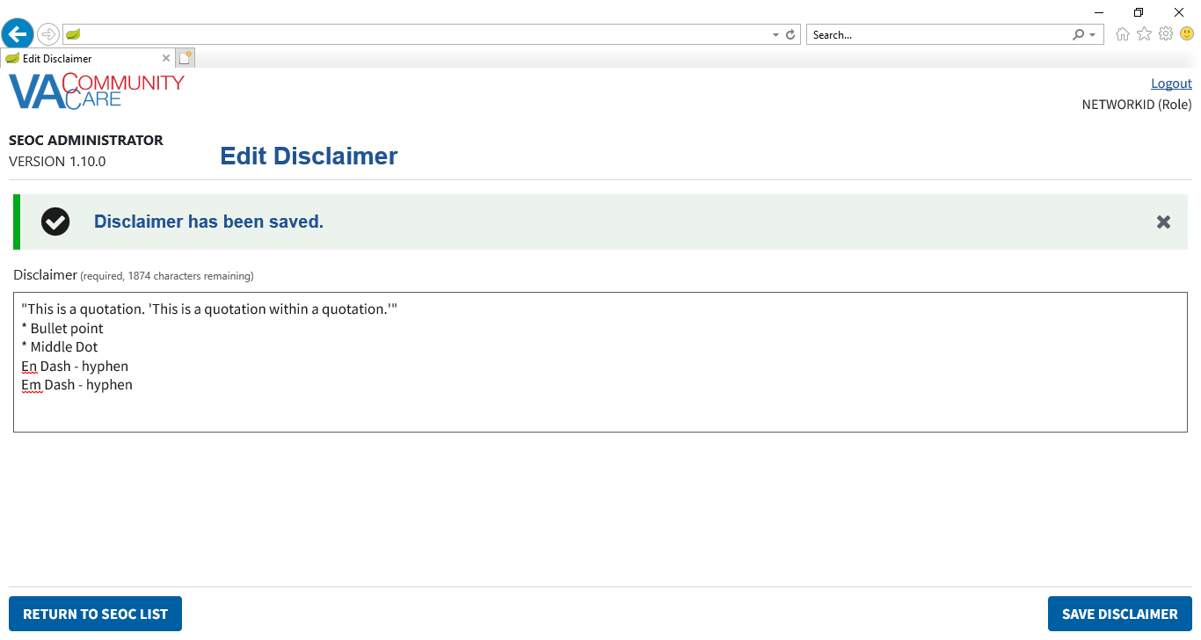

1. The confirmation message can be dismissed by clicking the X button.
2. Click **Return to SEOC List** to navigate back to the SEOC Admin UI home page.
3. For the **Edit Disclaimer** page, the **Return to SEOC List** button will not save the **General Disclaimer**.

### Deactivate Edit the General Disclaimer

When the description field of the Disclaimer table in the database is set to NULL, the **Edit Disclaimer** page in the SEOC Admin UI will be inaccessible. The **Edit Disclaimer** button on the SEOC Admin UI home page will be disabled, and if the user attempts to navigate directly to the **Edit Disclaimer** page using the browser address bar, they will be redirected back to the SEOC Admin UI home page once the request to fetch the disclaimer is complete. This is similar functionality to what is used to restrict users from accessing pages they do not have the privileges to access.

To reactivate the **Edit Disclaimer** page in the SEOC Admin UI, set the description field of the Disclaimer table in the database to a value other than null.

## View SEOCs

### View a Selected SEOC

To view a SEOC from the SEOC list, follow the steps listed below:

1. From the SEOC Admin home page, select the SEOC you would like to view.
2. Click **View Selected SEOC**. The **View SEOC** page displays.

Figure 36: View SEOC

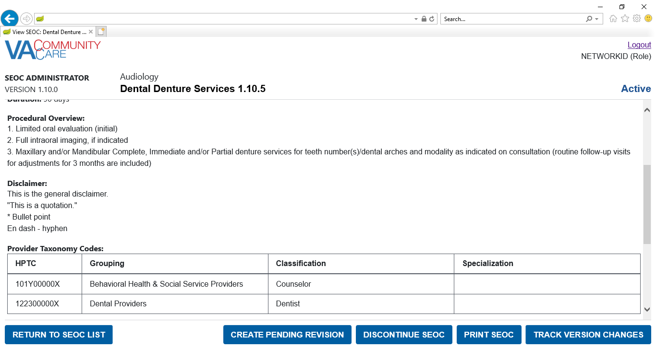

### Search for a SEOC by Name

To search for a SEOC, follow the steps listed below:

1. From the SEOC Admin home page, enter the name of the SEOC in the **Filter by Name (contains)** field.

Figure 37: SEOC Filter Field

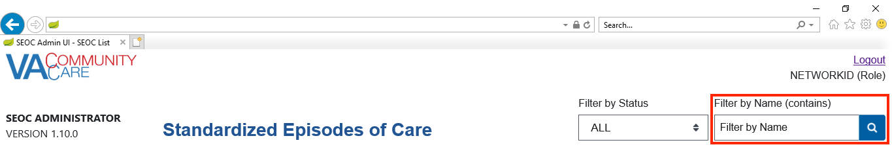

1. Click the **Search** button. The **Search SEOC Results** displays.

Figure 38: Search SEOC Results

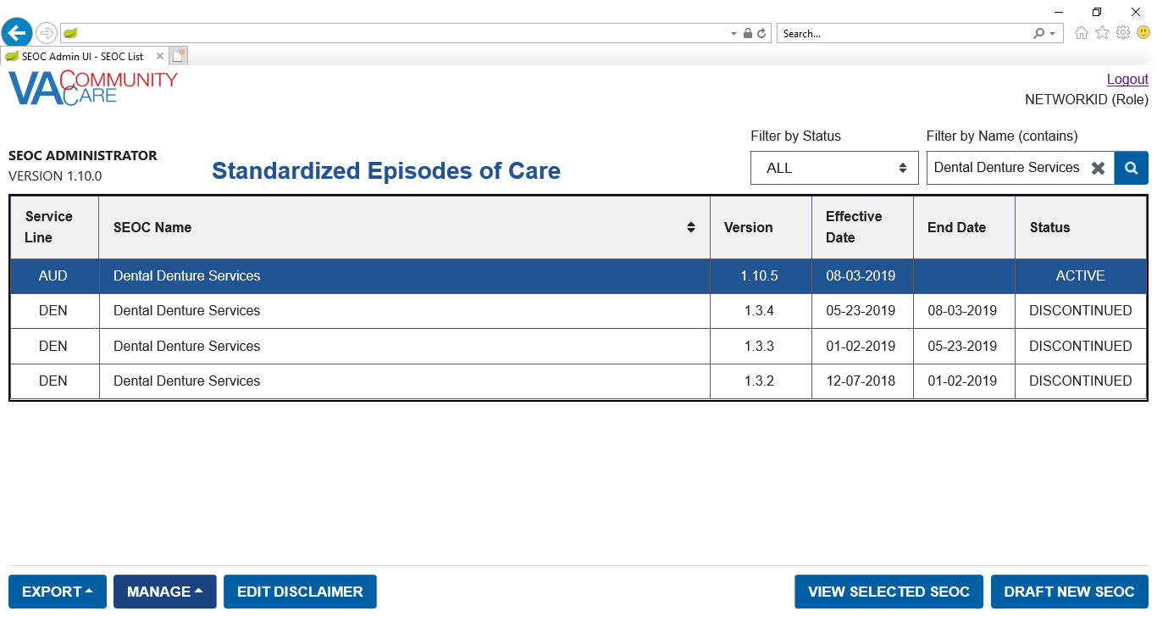

#### Sort SEOCs Alphabetically by Name

To sort the list of SEOCs alphabetically by name, follow the steps listed below:

1. From the SEOC Admin home page, select the **SEOC Name Column Heading**. This will sort the list of **SEOCs** in alphabetical order by name.

Figure 39: SEOC Name Column Heading

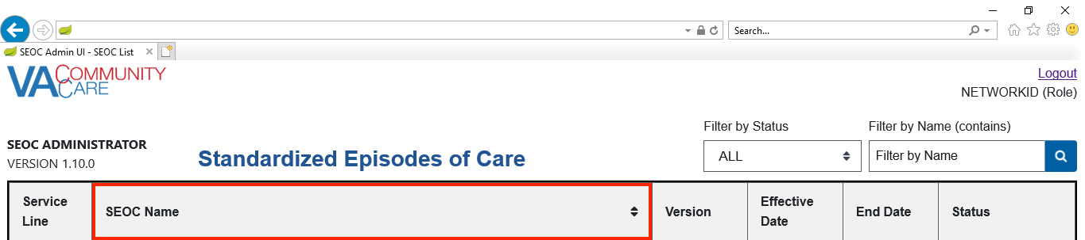

Figure 40: SEOC List Sorted in Alphabetical Order by Name

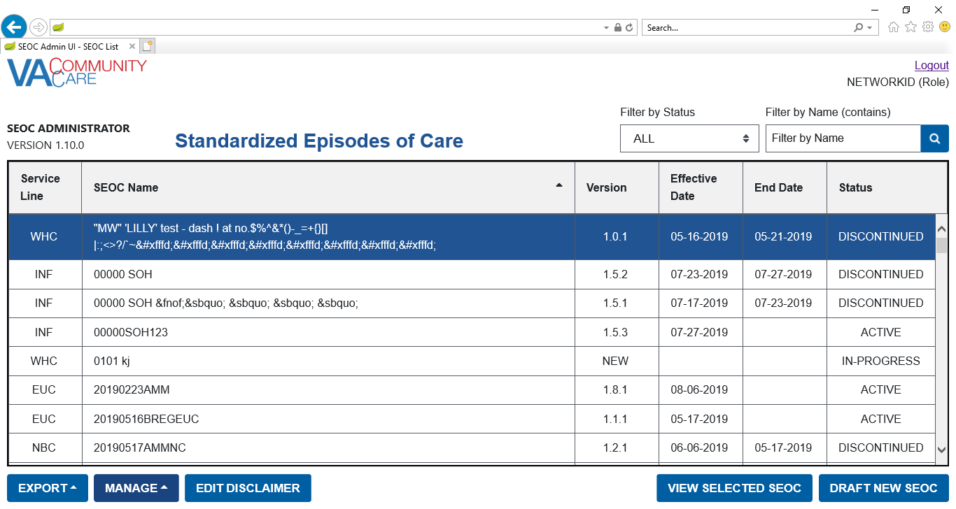

1. To sort the list of **SEOCs** in reverse alphabetical order, select the **SEOC Name Column Heading** again.

Figure 41: SEOC List Sorted in Reverse Alphabetical Order by Name

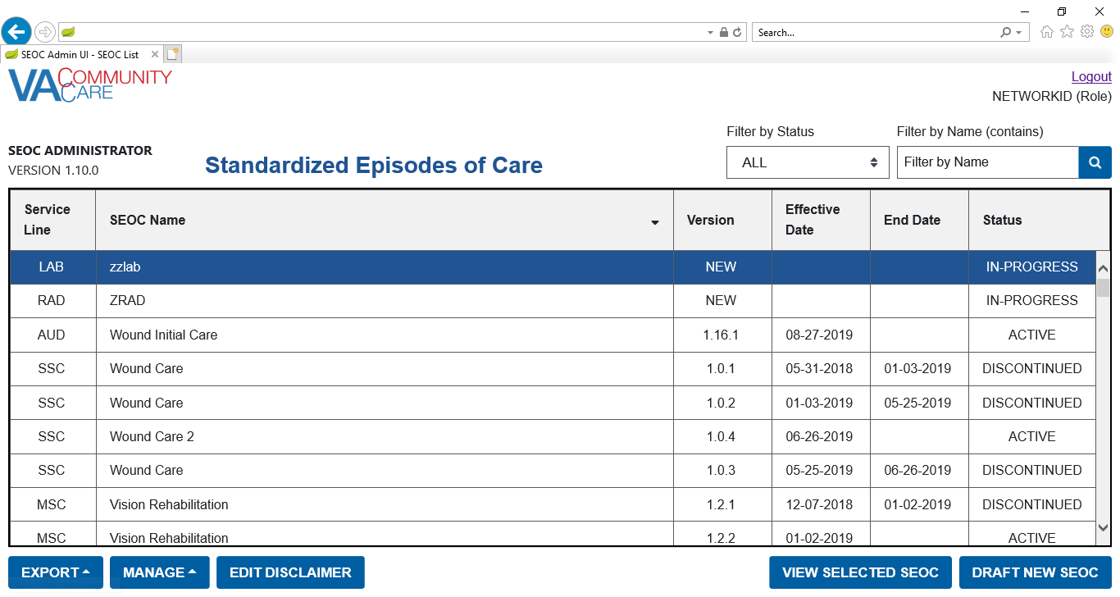

1. To return to the default sort order, either refresh the page or click the logo in the upper-right-hand corner of the page.

### Filter SEOCs by Status

To filter the list of SEOCs by status, follow the steps listed below:

1. From the SEOC Admin home page, select **Filter By Status** menu.

Figure 42: Filter by Status Menu Options

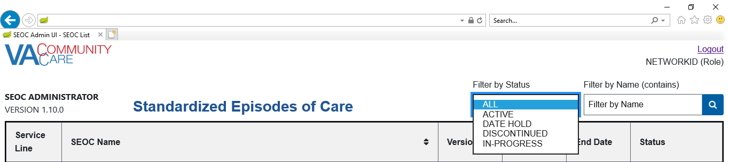

1. From the list of options select to filter by: **All**, **Active**, **Date Hold**, **Discontinued**, or **In-Progress**. The SEOC list refreshes to display the status filtered by.

### Discontinue a SEOC

To discontinue a selected Active SEOC, follow the steps listed below:

1. From the SEOC Admin home page, select the SEOC you would like to discontinue.
2. Click **View Selected SEOC**, the **View SEOC** page displays.
3. Click **Discontinue SEOC**. The discontinue SEOC confirmation dialog box displays.

Figure 43: Discontinue SEOC Confirmation

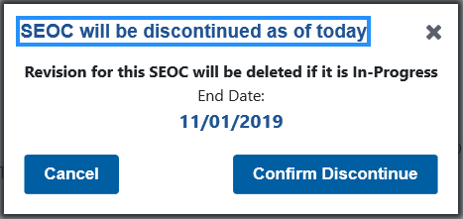

1. Click **Confirm Discontinue**. The **View SEOC** page displays with the updated status of the SEOC.

Figure 44: Discontinued Status

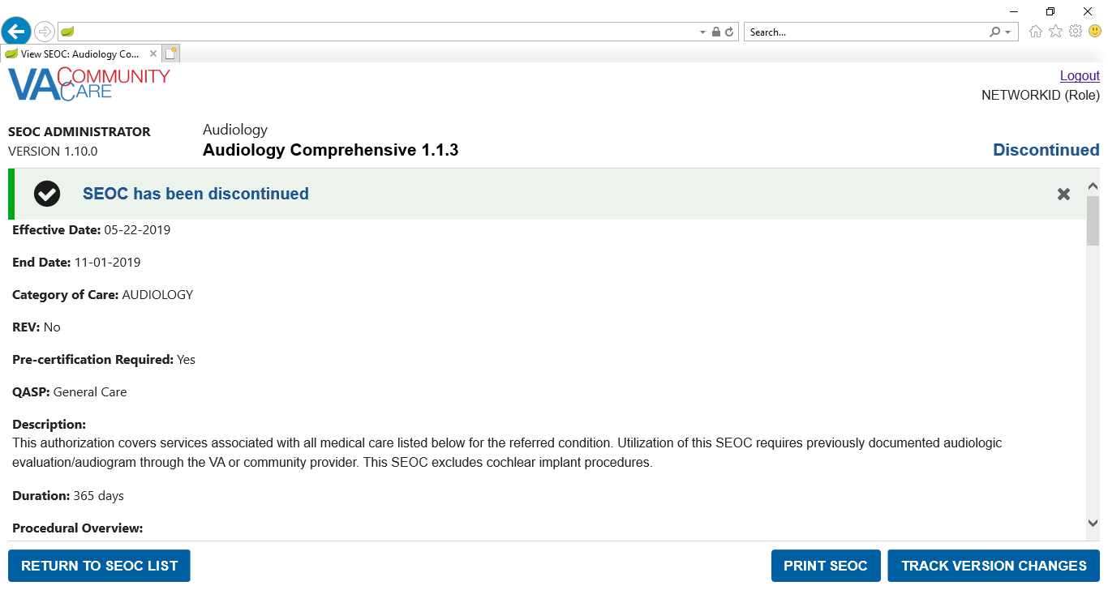

### Print a SEOC

To print a SEOC, follow the steps listed below:

1. From the SEOC Admin home page, select the SEOC you would like to print.
2. Click **View Selected SEOC**, the **View SEOC** page displays.
3. Click **Print SEOC**. The printed SEOC will display in another window. Print or save using local browser capabilities.

Figure 45: Printed SEOC Window

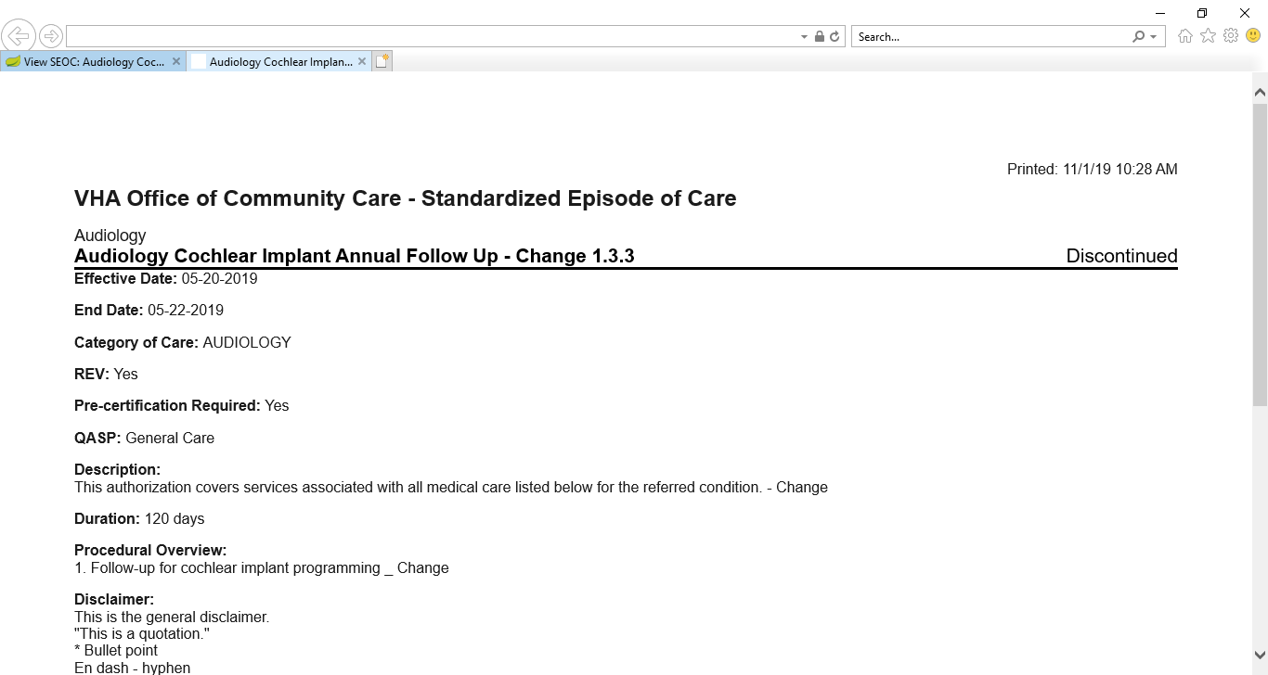

Figure 46: Printed SEOC (Bottom of the Page)

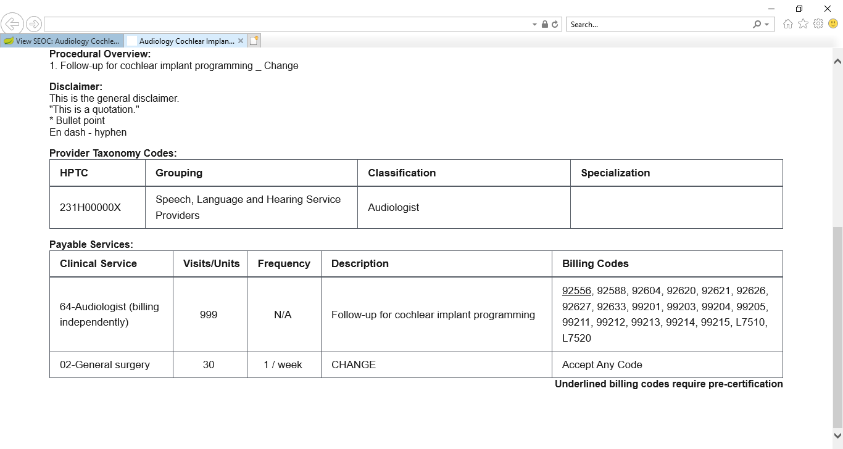

### Invalid Characters

The following business rules for valid characters are enforced in the SEOC Admin UI:

* For the **Description**, **Procedural Overview**, and **Additional Information** fields in a **SEOC**, and the **Description** field in a **Payable Service**, the following characters are accepted:
* Line Feed (ASCII 10)
* Carriage Return (ASCII 13)
* The printable ASCII characters (ASCII 32 – 126) except the DELETE character (ASCII 127)
* For the **SEOC Name**, the above characters are accepted except:
* & - Ampersand (ASCII 38)
* / - Slash (ASCII 47)
* : - Colon (ASCII 58)
* \ - Backslash (ASCII 92)
* ^ - Caret (ASCII 94)
* | - Vertical Bar (ASCII 124)
* ~ - Tilde (ASCII 126)
* For a **Billing Code** value, the following characters are accepted:
* Letters
* Numbers
* - Hyphen (ASCII 45)
* . - Period (ASCII 46)

The user will not be able to activate a SEOC unless all of these rules have been followed. In the case of the **SEOC Name**, the user will be unable to navigate past the **SEOC Name** and **Service Line** page of the **Create / Edit SEOC Workflow** if the **SEOC Name** has invalid characters. For **Billing Codes**, the user will be unable to save the **Billing Code** if the **Billing Code** value has invalid characters.

The **Show Invalid Characters** feature allows the user to highlight invalid characters on any SEOC, regardless of status.

#### Show Invalid Characters

To show invalid characters on a SEOC, follow the steps listed below:

1. From the SEOC Admin home page, select a **SEOC** with invalid characters.
2. Click **View Selected SEOC**, the **View SEOC** page will display.
3. Click **Show Invalid Characters**. The **Show Invalid Characters** page will display.

Figure 47: Show Invalid Characters Button



Figure 48: Show Invalid Characters

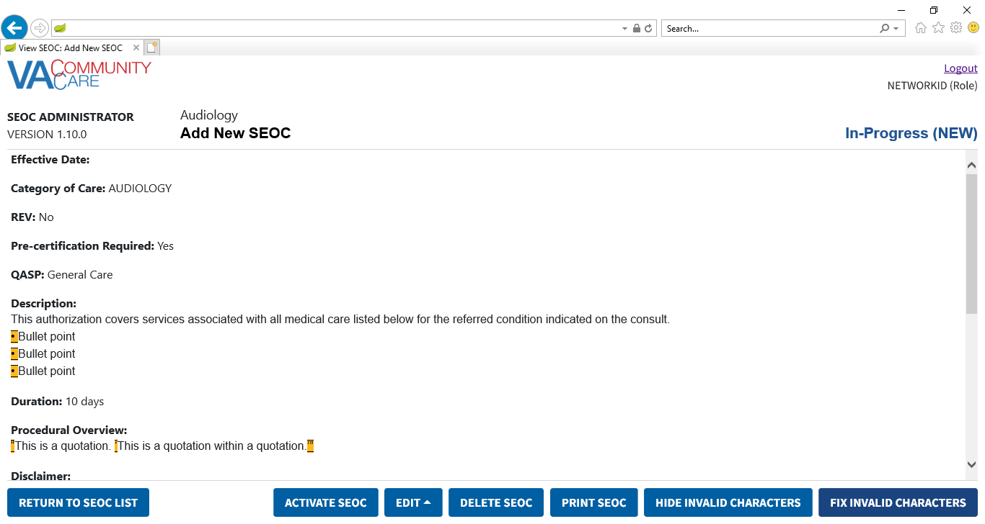

Figure : Show Invalid Characters (Bottom of the Page)

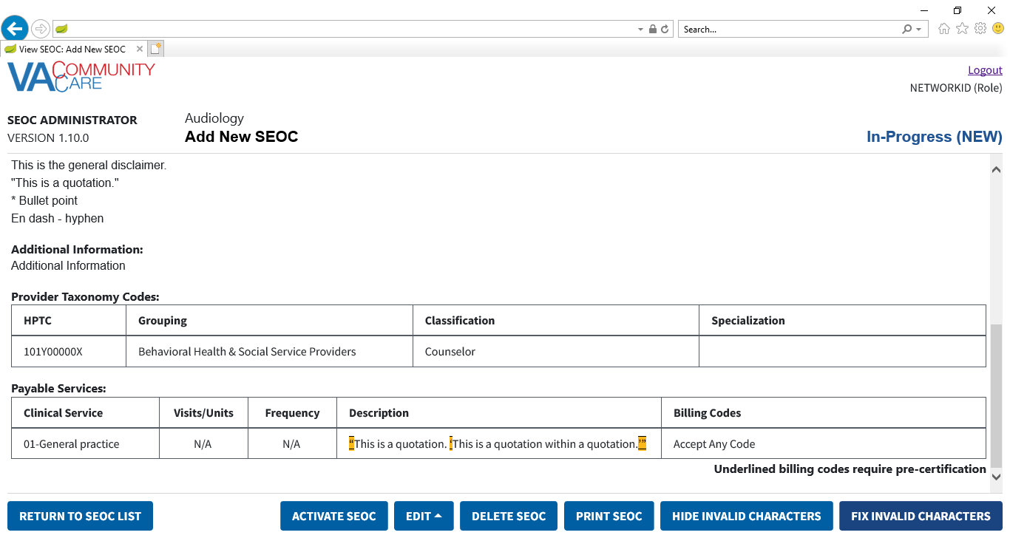

1. To print the **SEOC** with invalid characters shown, click **Print SEOC**. The **Print SEOC** page will display with invalid characters shown.

Figure 50: Print SEOC from Show Invalid Characters Page

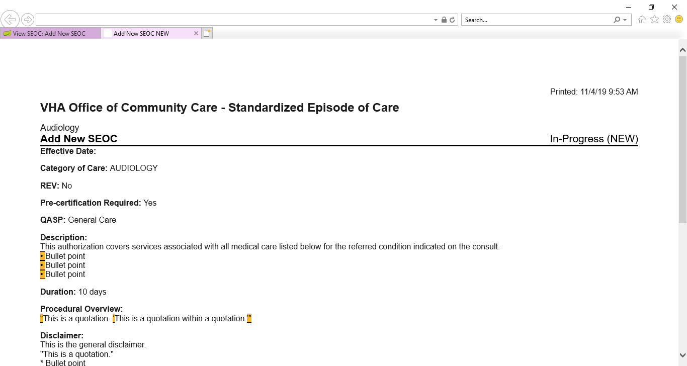

Figure 51: Print SEOC from Show Invalid Characters (Bottom of the Page)

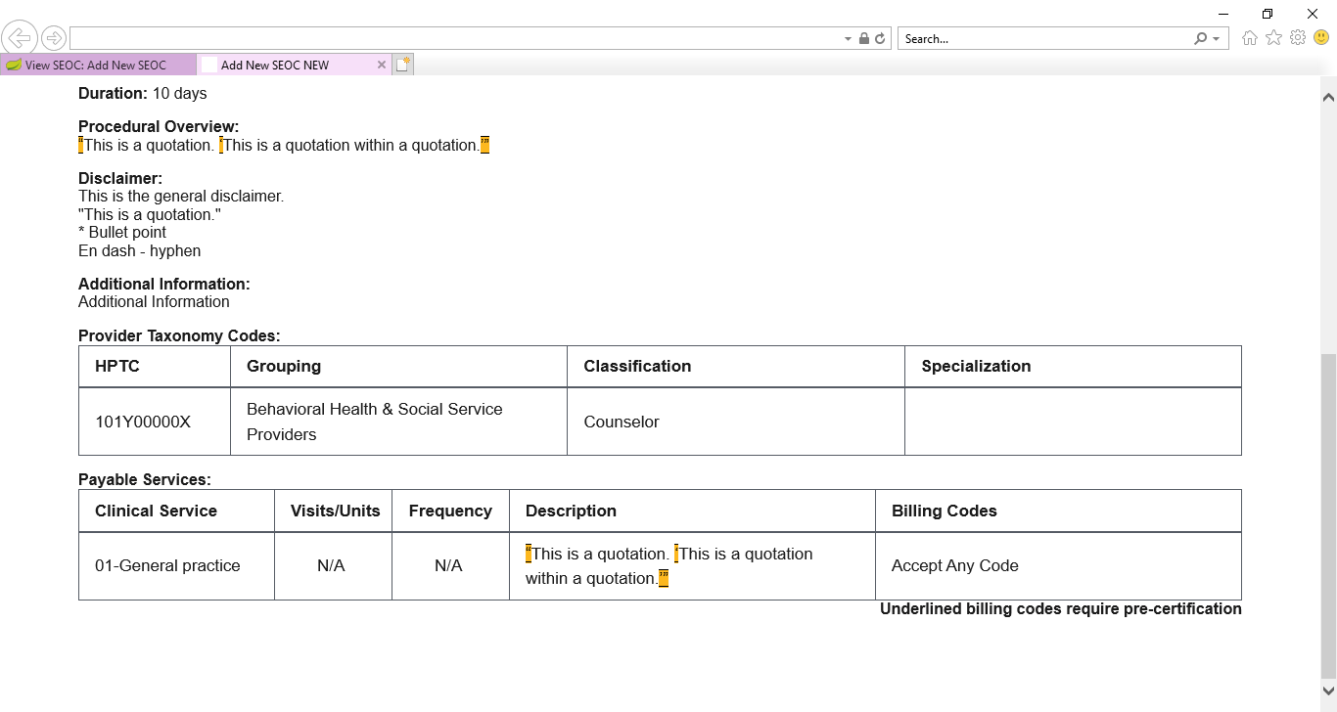

1. To return to the **View SEOC** page from the **Show Invalid Characters** page, click the **Hide Invalid Characters** button.

Figure 52: Hide Invalid Characters Button



1. The **Show Invalid Characters** button is only available if the SEOC has invalid characters.

#### Fix Invalid Characters

Invalid characters in a **SEOC** can either be fixed manually through the **Edit SEOC** workflow, or automatically with the **Fix Invalid Characters** feature. Invalid characters are fixed as follows:

* |, ^, ~, \, /, and & in the SEOC Name will be replaced with spaces
* ‘ or ’ will be replaced with '
* “ or ” will be replaced with "
* • or · will be replaced with *
* – or – will be replaced with –
* All other characters will be replaced with a space

To automatically **Fix Invalid Characters**, follow the steps listed below:

1. From the SEOC Admin home page, select a **SEOC** with invalid characters.
2. Click **View Selected SEOC**, the **View SEOC** page will display.
3. Click Show Invalid Characters. The Show Invalid Characters page will display.
4. Click **Fix Invalid Characters**. The **Fix Invalid Characters** confirmation dialog will display.

Figure 53: Fix Invalid Characters Button



Figure 54: Fix Invalid Characters Confirmation

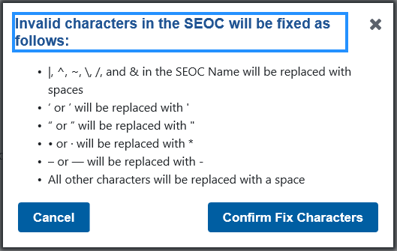

1. Click **Confirm Fix Characters**. A confirmation message will display.

Figure 55: Invalid Characters Fixed Message

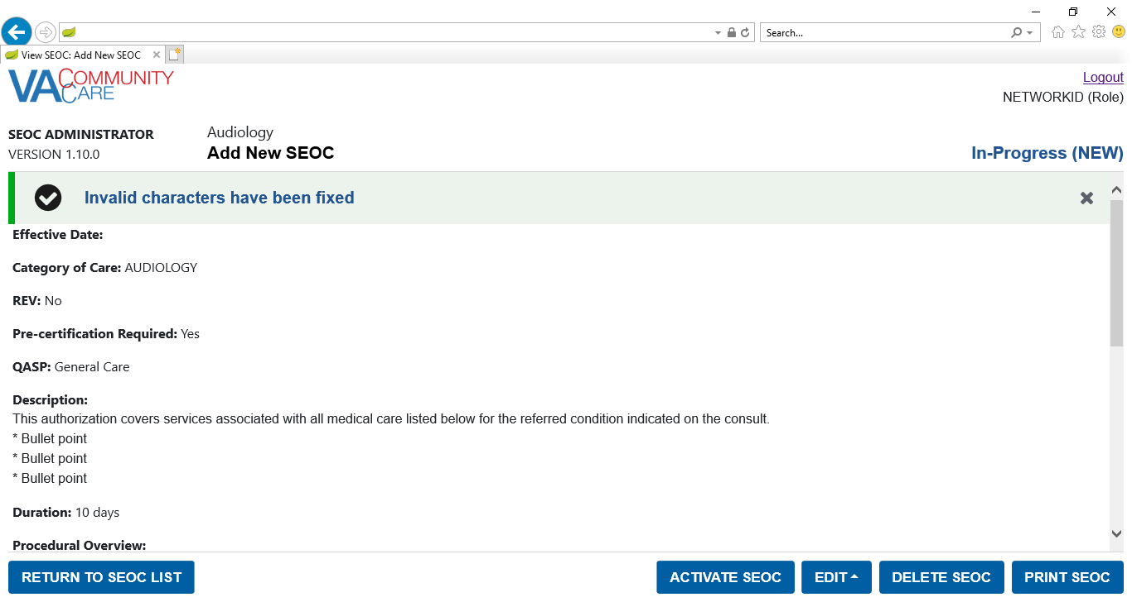

1. This feature is only available for **In-Progress SEOCs**. For **Active SEOCs** with invalid characters, create a **Pending Revision**, then fix the invalid characters.
2. The confirmation message can be dismissed by clicking the X button.

### Track Version Changes

To track the version changes of a SEOC, follow the steps listed below:

1. From the SEOC Admin home page, select a **SEOC** with a previous version.
2. Click **View Selected SEOC**, the **View SEOC** page displays.
3. Click the **Track Version Changes** button when it becomes active. The **Track Version Changes** page will display.

Figure 56: Track Version Changes Page

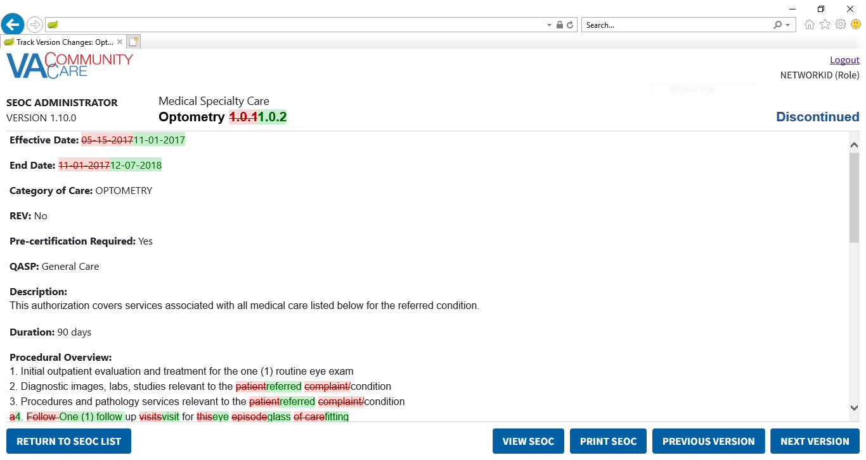

Figure : Track Version Changes (Middle of the Page)

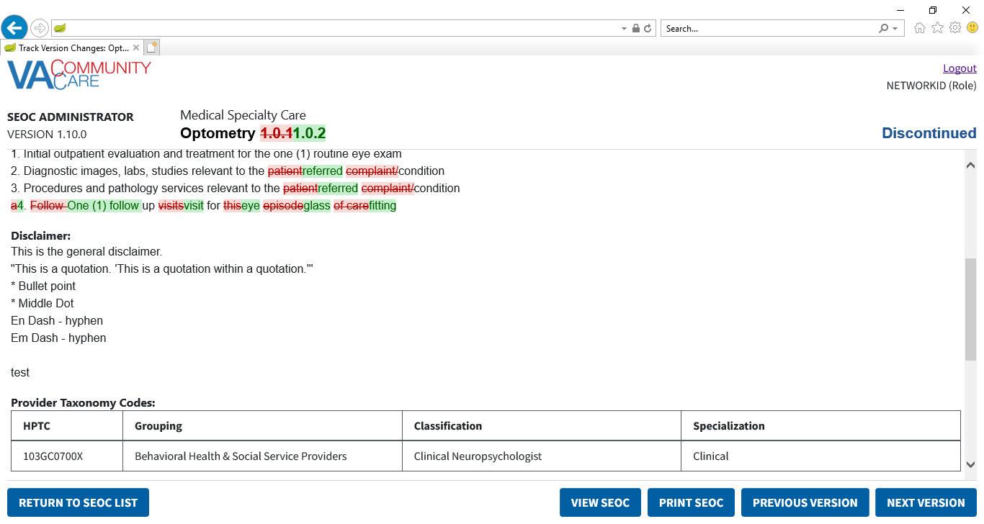

Figure : Track Version Changes: Payable Services

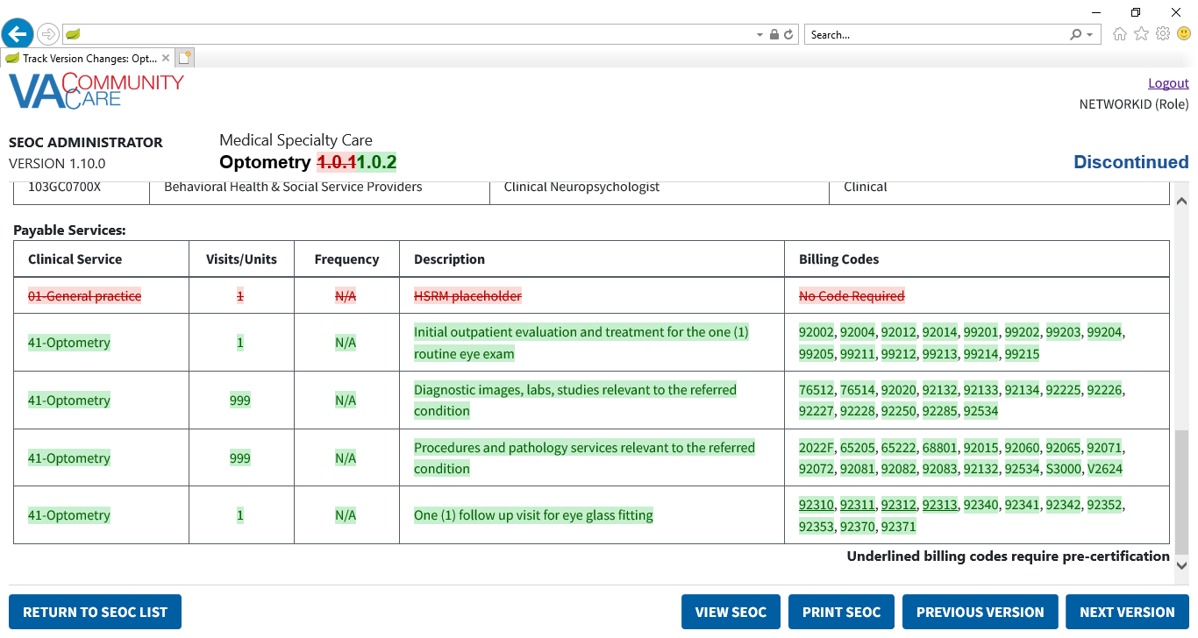

1. Click the **Previous Version** button. The changes for the previous version will be shown. If the previous version is the first version of this **SEOC**, no changes will be displayed.
2. Click the **Next Version** button. The changes for the next version will be shown.
3. Click the **Print SEOC** button. The **Print SEOC** page will display with the current changes.

Figure 59: Print SEOC from Track Version Changes Page

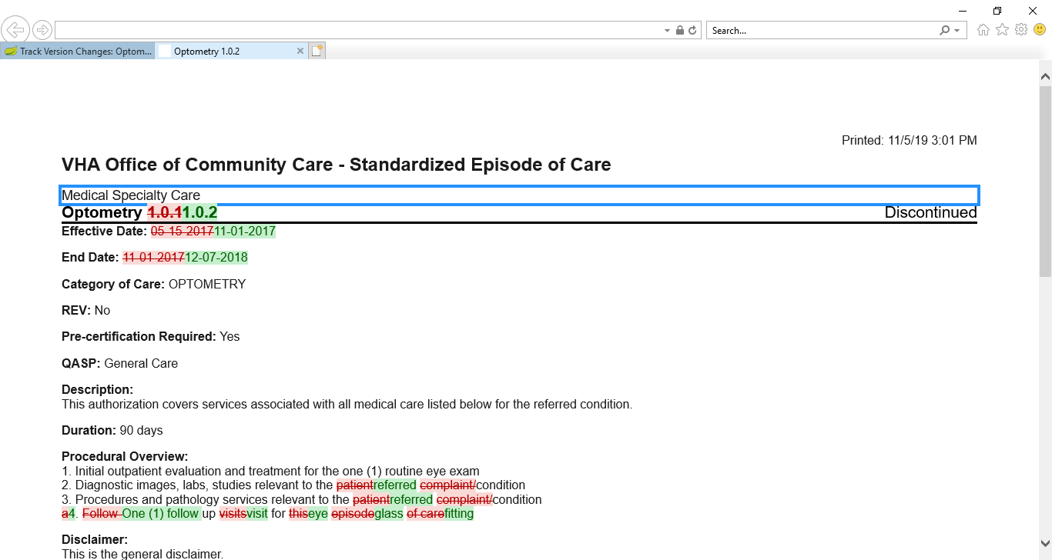

Figure : Print SEOC from Track Version Changes: Additional Information and Provider Taxonomy Codes

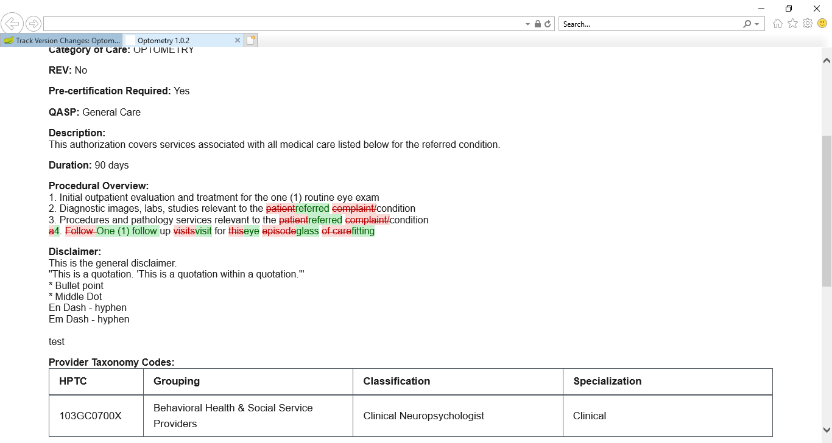

Figure : Print SEOC from Track Version Changes: Payable Services

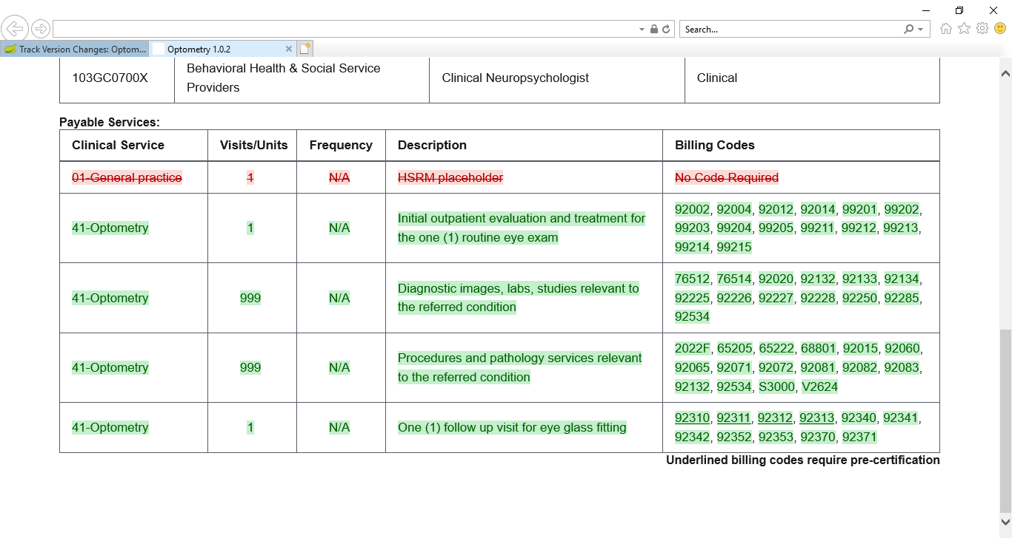

1. By default, IE11 will not print the red and green background colors. In order to print the red and green background colors, check the **Print Background Colors and Images** box in the **Page Setup** dialog from the **Print** menu.

## Draft a New SEOC

To draft a new SEOC, follow the steps listed below:

1. From the SEOC Admin home page, click **Draft New SEOC**. The **Draft SEOC: Name and Service Line** window displays.

Figure 62: Draft SEOC: Name and Service Line

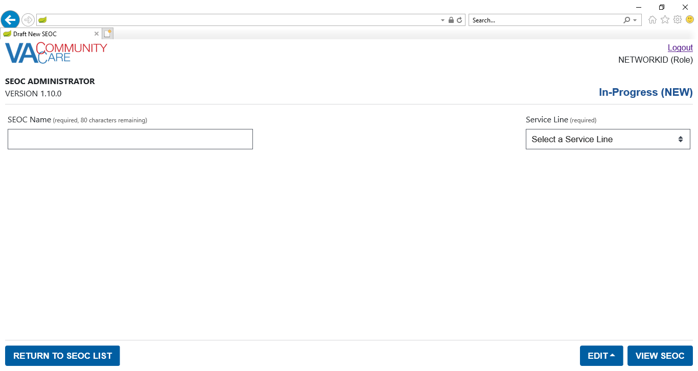

1. **Draft New SEOC** only applies to the first page in the **Create/Edit SEOC** workflow. When you navigate to any other page, it will save the **SEOC**, and thereafter the workflow will be presented as an edit to an existing **SEOC**.
2. To return to the SEOC Admin home page while creating a **New SEOC**, click **Return to SEOC List** in the bottom left-hand corner of any page in the **Create/Edit SEOC** workflow. It will not save your changes to the **New SEOC**.
3. In the **SEOC Name** field, enter the name for the new SEOC (required field). The maximum number of characters for this field is 80.
4. From the **Service Line** menu, select a service line (required field).
5. If either the **SEOC Name** or **Service Line** are not populated, an error will display when you click **Add/Edit SEOC Details**.
6. If the **SEOC Name** is already being used by another SEOC, an error will display when you click **Add/Edit SEOC Details**. It is not case-sensitive and it does not take extra spaces into account.
7. The error message can be dismissed by clicking the X button.

Figure : Edit SEOC Menu

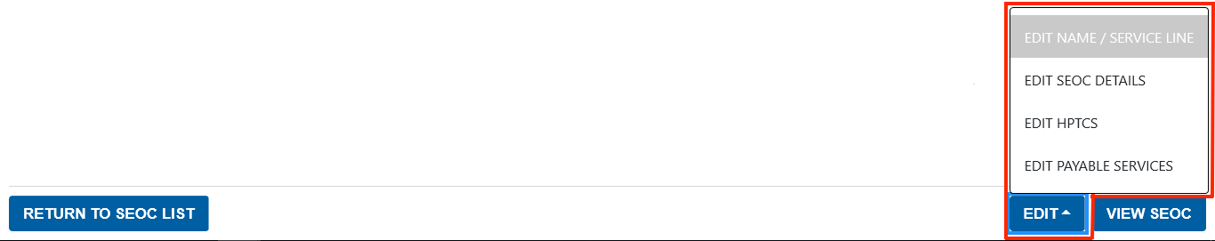

1. In the footer, you can use the **Edit** menu to save the SEOC and navigate to any other page in the **Create / Edit SEOC Workflow**.
2. You can also click View SEOC to save the SEOC and open the View SEOC page.
3. The option in the **Edit Menu** for the current page will be disabled. For instance, in the screenshot above, this is the **Edit Name / Service Line** page, so that option is disabled, but in any other page in the workflow, it will be available.
4. For the purposes of this document, the steps will go through all pages of the **Create/Edit SEOC Workflow** in sequential order, though this is not required in the application.
5. Select **Edit SEOC Details** from the **Edit Menu**. The **Edit SEOC: Details** page will display.

Figure : Edit SEOC: Details

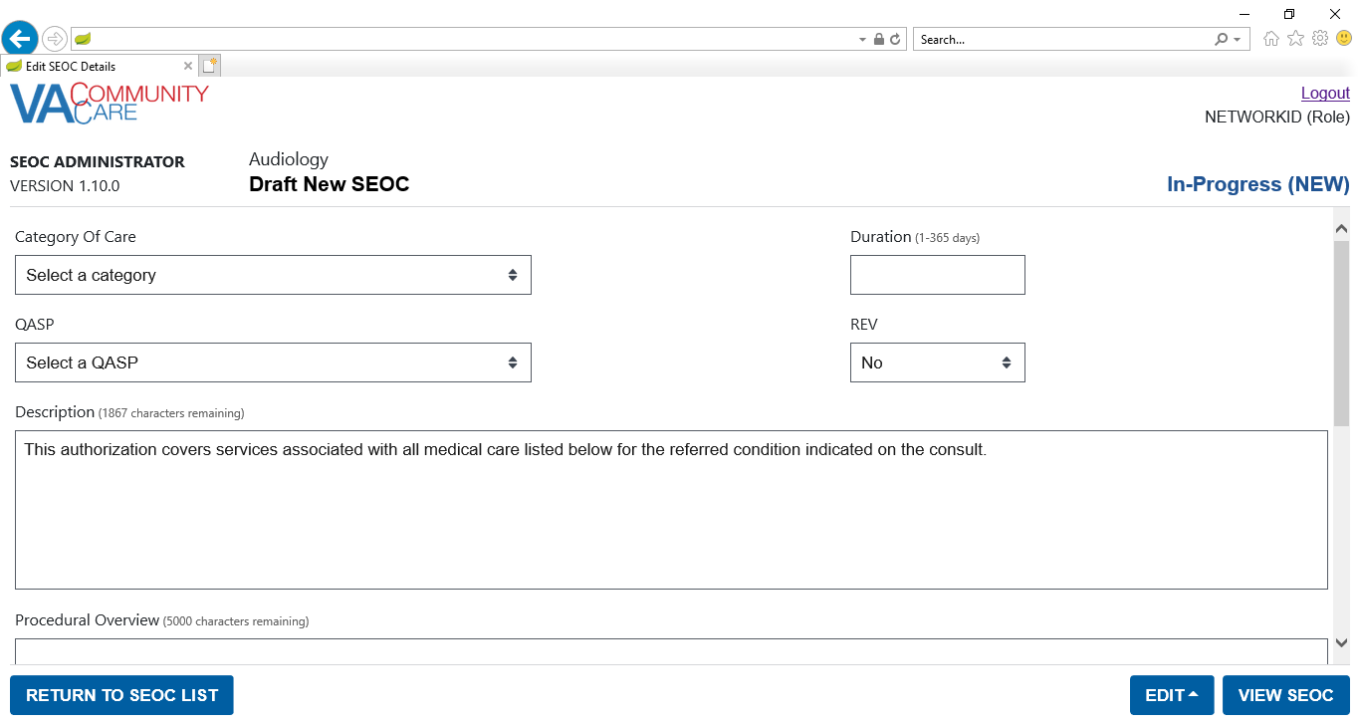

Figure : Edit SEOC: Details (Middle of the Page)

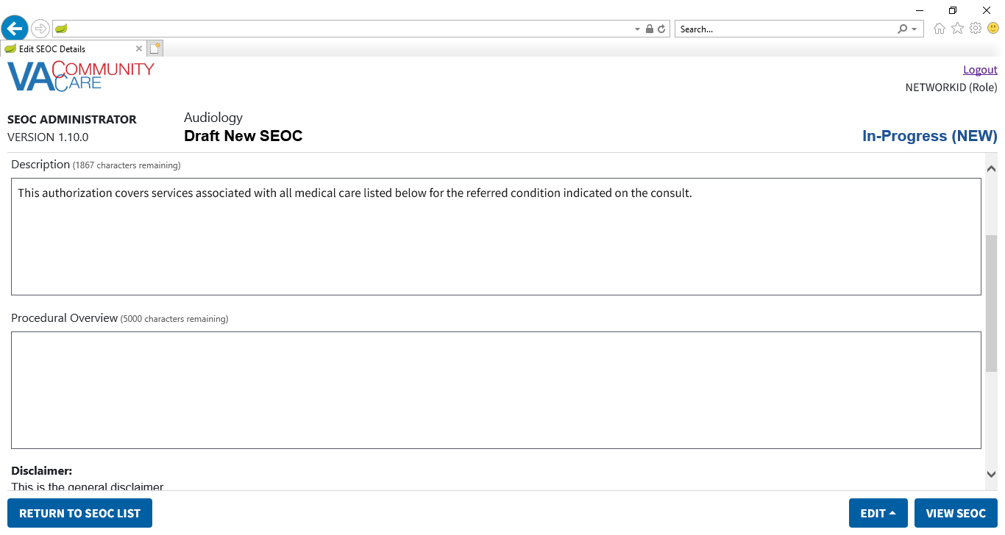

Figure : Edit SEOC: Details (Bottom of the Page)

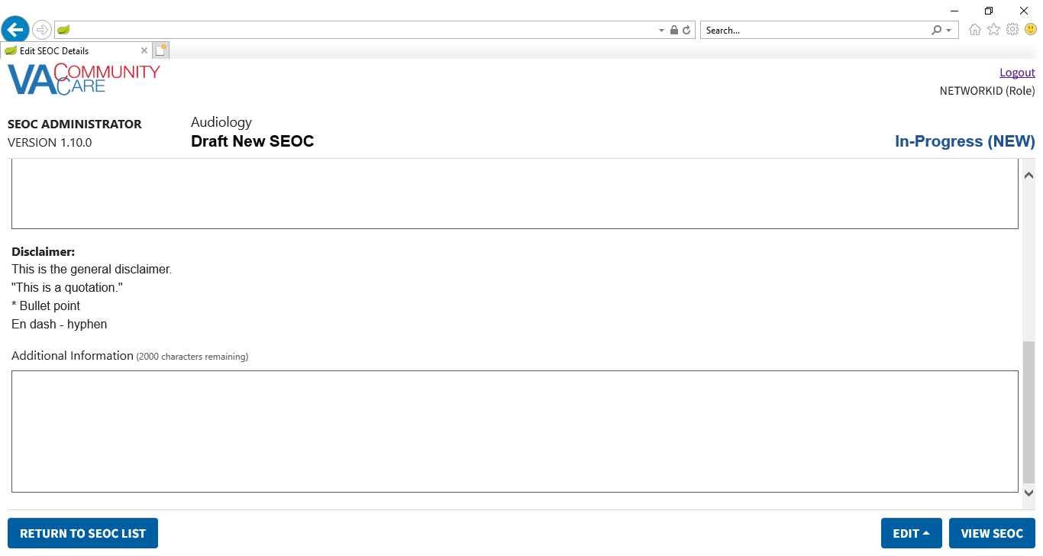

1. From the **Category of Care** drop-down menu, select the **Category of Care**.
2. In the **Duration (days)** field, enter the duration.
3. If the value of **Duration** is not a number between 1 and 365, an error will be displayed if you click **Return to SEOC List** or **View SEOC**, or if you navigate using the **Edit Menu**.
4. The error message can be dismissed by clicking the X button.
5. From the **QASP** drop-down menu, select the **QASP**.
6. From the **REV** drop-down menu, select **Yes** or **No**.
7. In order to activate a **SEOC**, the **REV** flag can only be true if at least one **Payable Service** has a **Billing Code** that requires **Pre-Certification** or is set to **Any Code Accepted** or **No Code Required**.
8. In the **Description** field, enter a description for the procedure.
9. The maximum amount of characters for the **Description** field is 2000.
10. In the **Procedural Overview** field, enter an overview on the procedure.
11. The maximum amount of characters for the **Procedural Overview** field is 5000.
12. In the **Additional Information** field, enter additional information regarding the procedure if desired.
13. The maximum amount of characters for the **Additional Information** field is 2000.
14. **Disclaimer**, above the **Additional Information** field, refers to the **General Disclaimer** which is shared across all **SEOCs**. To update the **General Disclaimer**, use the **Edit Disclaimer** functionality found on the front page.
15. Select **Edit SEOC HPTCs** from the **Edit Menu**. The **Edit SEOC: SEOC Provider Taxonomy Codes** page will display.

Figure : Edit SEOC: Provider Taxonomy Codes

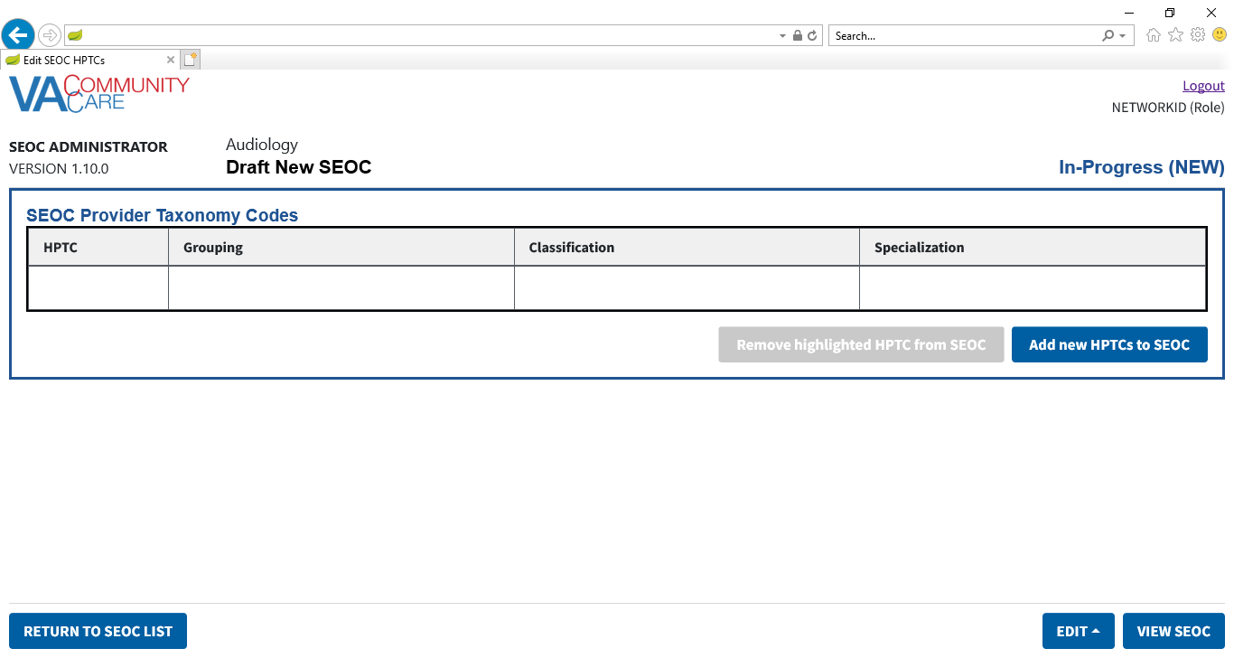

1. Click **Add new HPTCs to SEOC**. The **Edit SEOC: Add Provider Taxonomy Codes** page will display.

Figure : Edit SEOC: Add Provider Taxonomy Codes

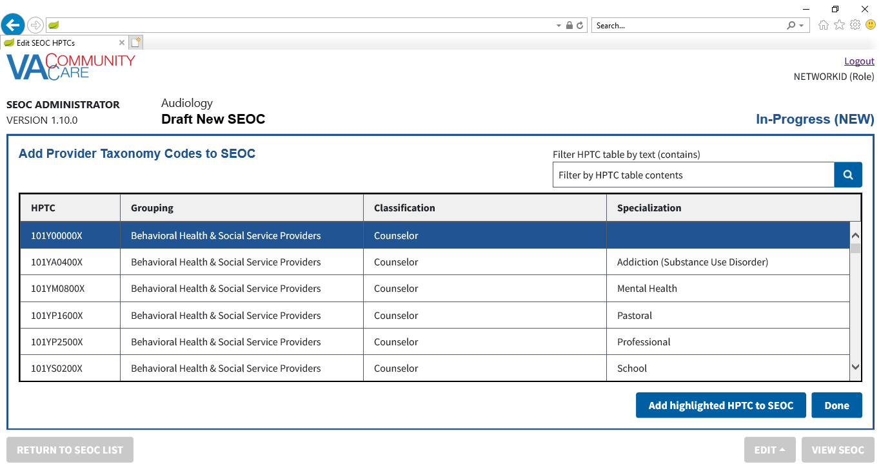

1. The navigation buttons in the footer will be disabled while this page is displayed. In order to enable the navigation buttons, click the **Done** button to return to the previous page.
2. Enter text in the **Filter HPTC table by text** field. Press **Enter** or click the **Search** button. The table displays all rows with the text you entered in any of the four columns: **Provider Code**, **Grouping**, **Classification**, or **Specialization**.
3. Select a **Provider Taxonomy Code (HPTC)**.
4. Click **Add Highlighted HPTC to SEOC**. A confirmation message will display.

Figure : Edit SEOC: Provider Taxonomy Code Added Message

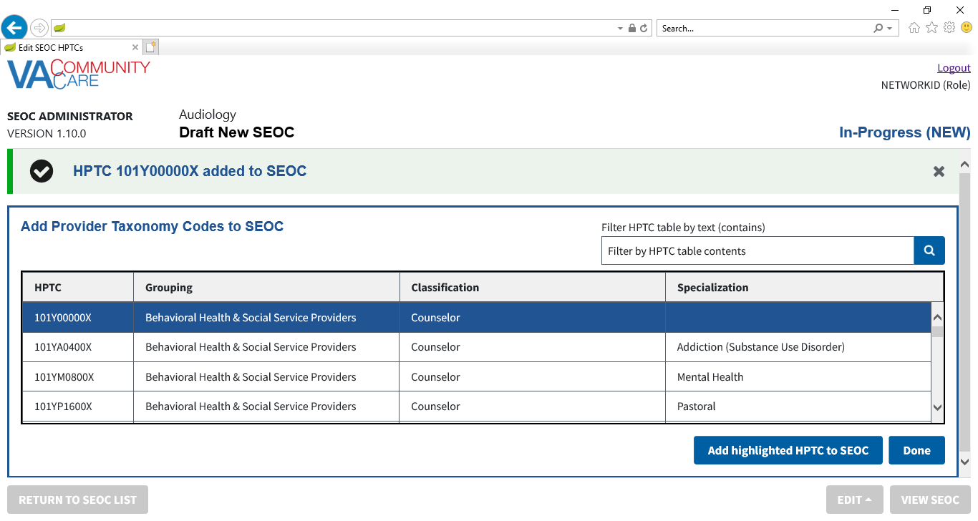

1. The confirmation message can be dismissed by clicking the X button.
2. If the selected **HPTC** has already been added to the **SEOC**, an error dialog will display when you click **Add highlighted HPTC to SEOC**.
3. Repeat steps 16-18 to add additional **HPTCs** to the **SEOC**.
4. When you are finished adding provider codes, click **Done**. The **Edit SEOC:** **SEOC Provider Taxonomy Codes** page will display. The table displays the provider codes you added on the previous page.

Figure : Edit SEOC: Added Provider Taxonomy Codes

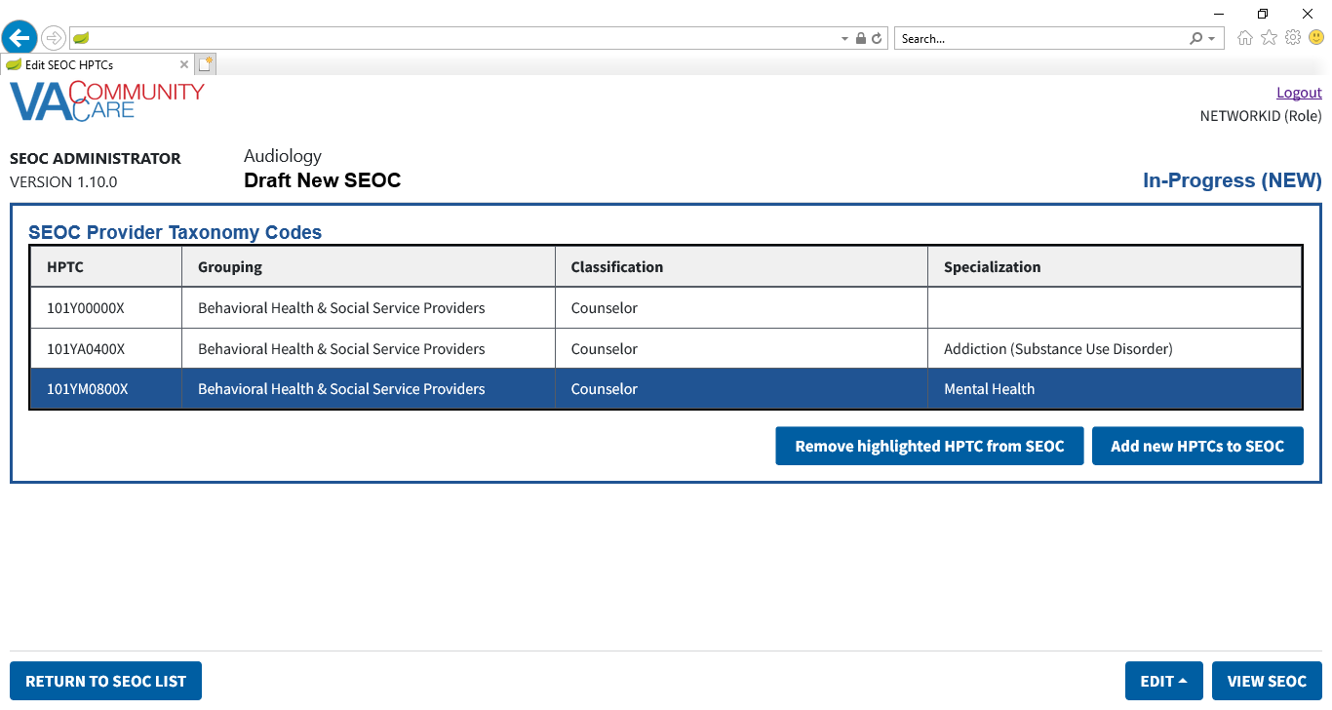

1. If needed, you can select an **HPTC** row and click **Remove highlighted HPTC from SEOC** to remove an **HTPC**. The **Confirm Remove HPTC** dialog will display.

Figure : Edit SEOC: Confirm Remove HPTC

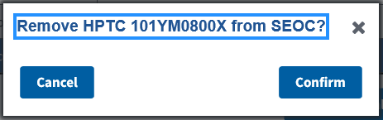

1. Click **Confirm** to remove the **HPTC** from the **SEOC**. A confirmation message will display.

Figure : Edit SEOC: Provider Taxonomy Code Removed Message

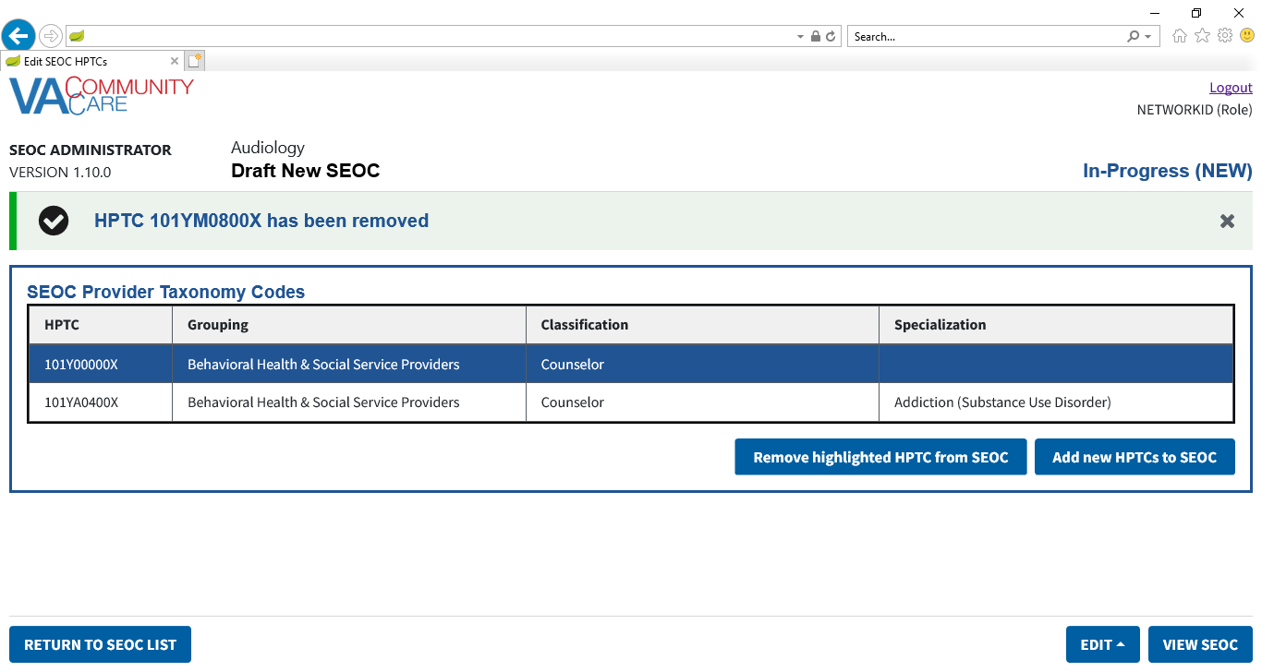

1. The confirmation message can be dismissed by clicking the X button.
2. Select **Edit SEOC Payable Services** from the **Edit Menu**. The **Edit SEOC: Payable Services** page will display.

Figure : Edit SEOC: Payable Services

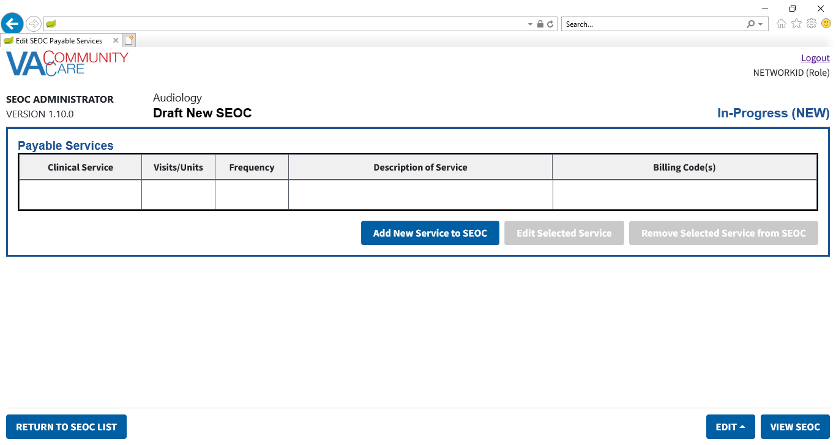

1. Click **Add New Service to SEOC**. The **Edit SEOC: Add Payable Service** section displays at the top of the page.

Figure : Edit SEOC: Add Payable Service

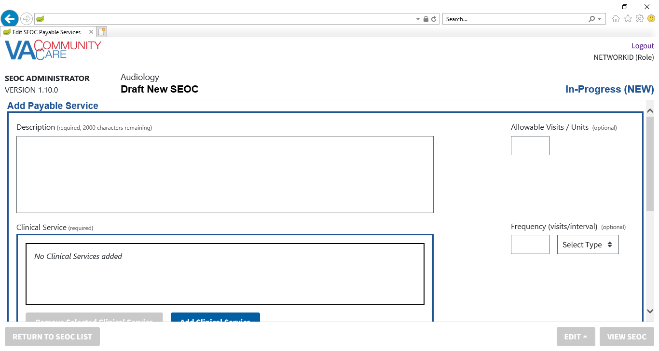

Figure : Edit SEOC: Add Payable Service (Middle of the page)

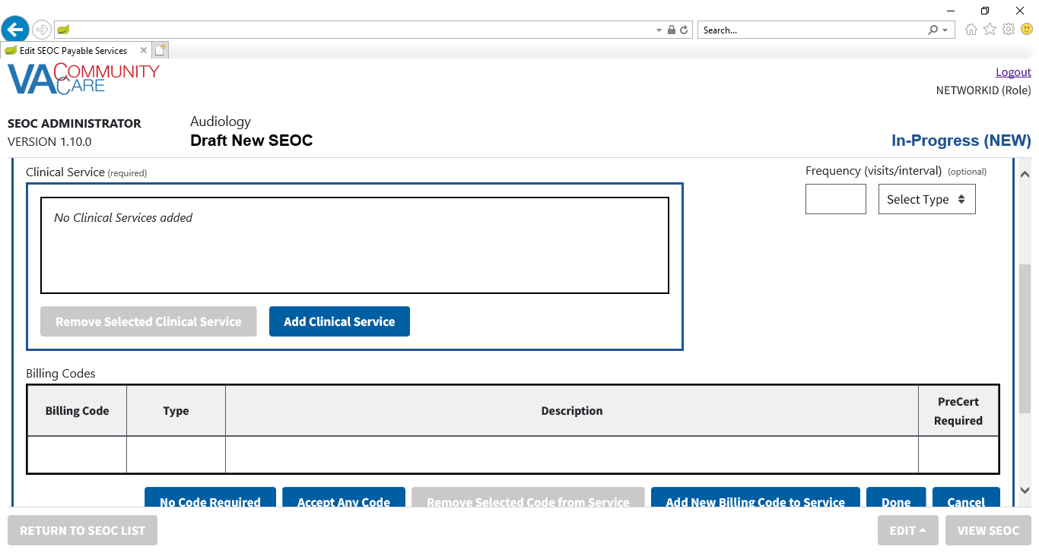

Figure : Edit SEOC: Add Payable Service (Bottom of the Page)

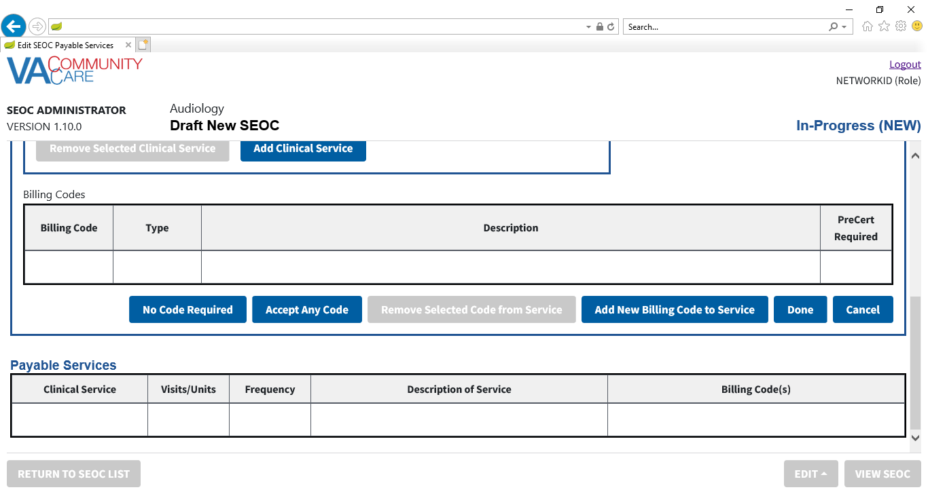

1. In the **Description** field, which is required, enter a description for the payable service.
2. The maximum number of characters for the **Description** field is 2000.
3. Under **Clinical Services**, which are required, select **Add Clinical Service**. The **Edit SEOC: Add Clinical Service** dialog box will display.

Figure : Edit SEOC: Add Clinical Service Dialog

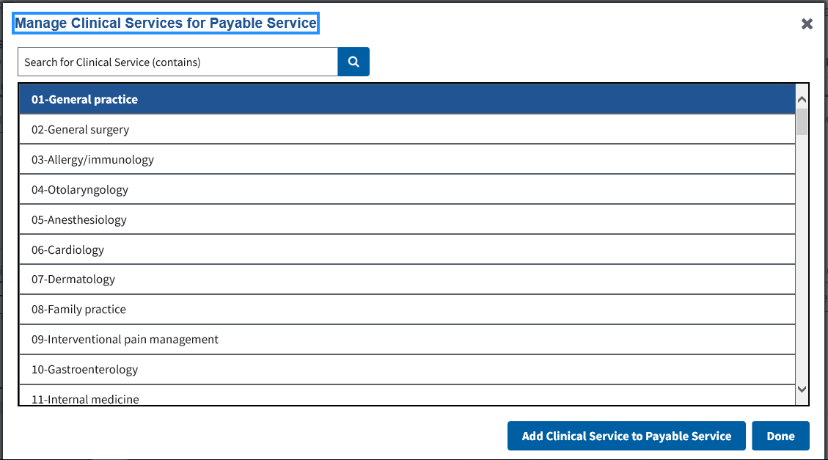

1. Enter text in the **Search for Clinical Service** field. Press **Enter** or click the **Search** button. The table displays all rows with the text you entered.
2. Select the desired **Clinical Service**.
3. Click **Add Clinical Service to Payable Service**. A confirmation message will display.

Figure : Edit SEOC: Clinical Service Added Message

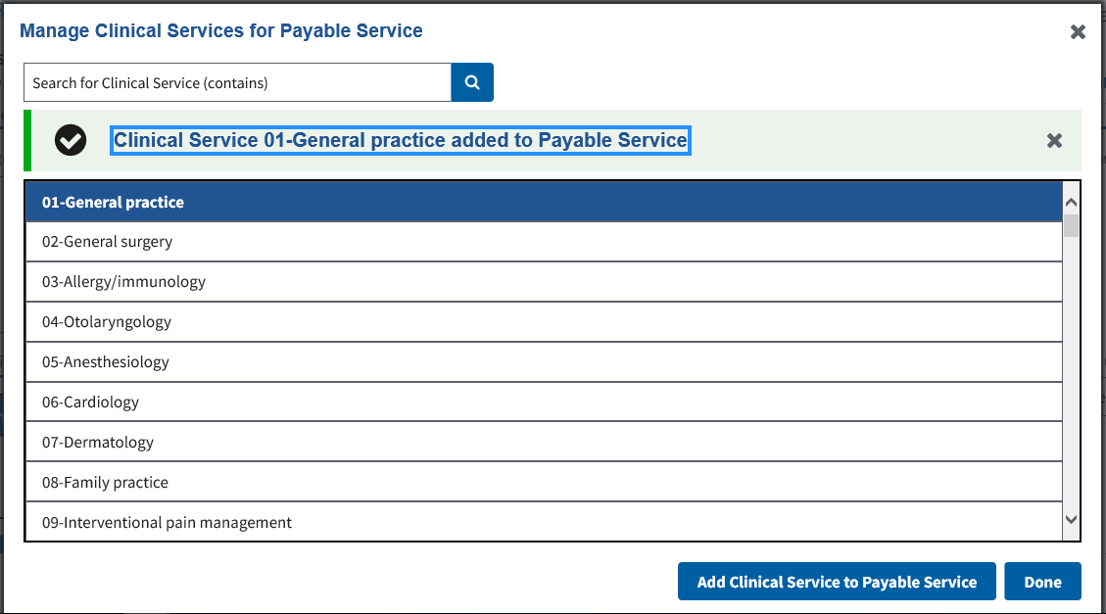

1. If a **Clinical Service** is already associated with the **Payable Service**, an error message will display.
2. Both the confirmation message and the error message can be dismissed by clicking the X button.
3. Repeat steps 27-29 to add additional **Clinical Services** to the **Payable Service**.
4. Click **Done**. The **Edit SEOC: Add Payable Service** section will display.

Figure : Edit SEOC: New Clinical Services added to the Payable Service

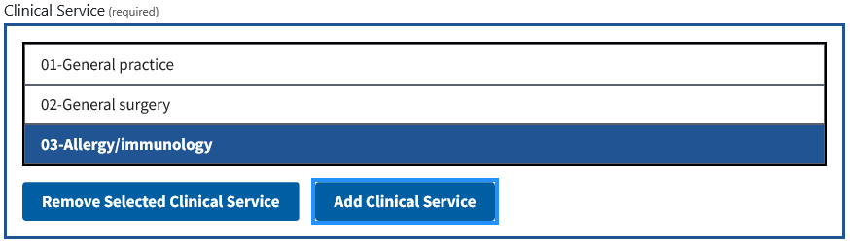

1. If needed, select a **Clinical Service** row and click **Remove Selected Clinical Service** to remove a **Clinical Service**. A confirmation message will display.

Figure : Edit SEOC: Clinical Service Removed Message

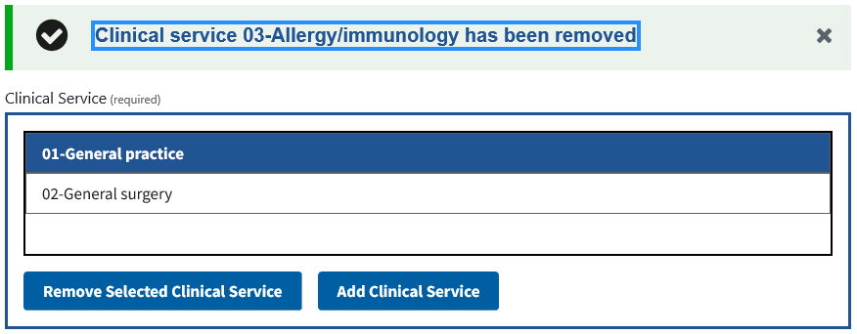

1. The confirmation message can be dismissed by clicking the X button.
2. In the **Allowable Visits / Units** field, which is optional, enter the number of allowed visits or other units.
3. The maximum value for the **Allowable Visits / Units** field is 999.
4. In the **Frequency (visits/interval)** fields, which are optional, enter the frequency of visits and select if it is per week, month, or year.
5. The maximum value for the **Frequency Visits** field is 999.
6. If either the **Frequency** **Visits** or the **Frequency Interval** field is populated without the other, an error will be displayed if you click **Done**.
7. The error message can be dismissed by clicking the X button.
8. If this service does not require billing codes, select **No Code Required**. A confirmation message will display.

Figure : Edit SEOC: No Billing Codes Required Added Message

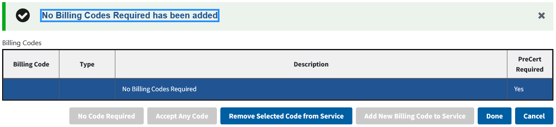

1. The confirmation message can be dismissed by clicking the X button.
2. If you need to remove this and select something else, click **Remove Selected Code from Service**. A confirmation message will display.

Figure : Edit SEOC: No Billing Codes Required Removed Message

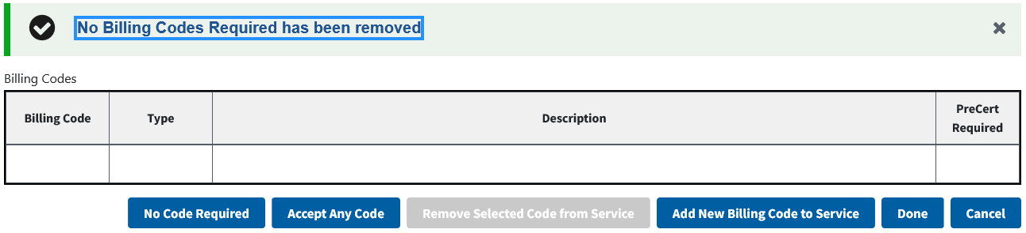

1. The confirmation message can be dismissed by clicking the X button.
2. If this service can accept any billing code, select **Accept Any Code**. A confirmation message will display.

Figure : Edit SEOC: Any Billing Code Accepted Added Message

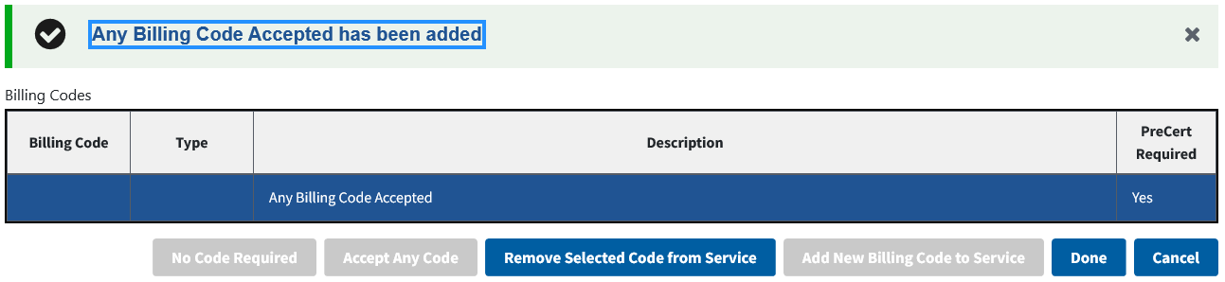

1. The confirmation message can be dismissed by clicking the X button.
2. If you need to remove this and select something else, click **Remove Selected Code from Service**. A confirmation message will display.

Figure : Edit SEOC: Any Billing Code Accepted Removed Message

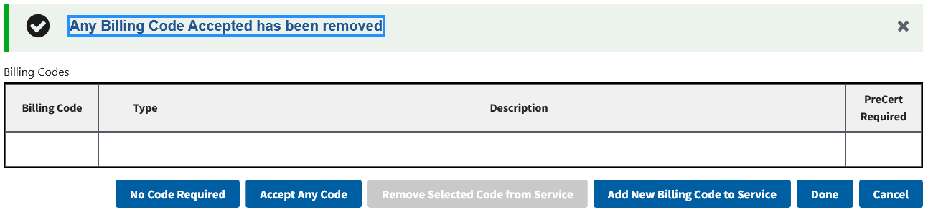

1. The confirmation message can be dismissed by clicking the X button.
2. If this service requires billing codes, click **Add New Billing Code to Service**. The **Edit SEOC: Add Billing Code** dialog box will display.

Figure : Edit SEOC: Add Billing Code

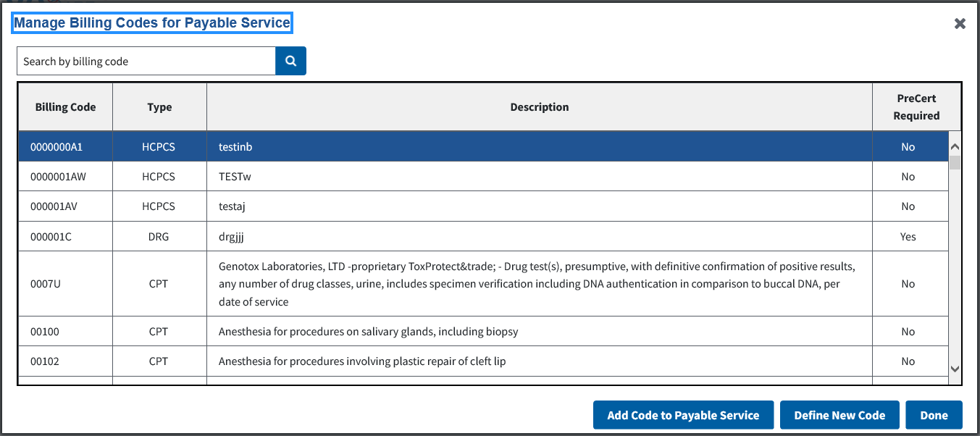

1. Enter text in the **Search by billing code** field. Press **Enter** or click the **Search** button. The table will display all rows where the **Billing Code** column starts with the text you entered.
2. Select the desired **Billing Code**.
3. Click **Add Code to Payable Service**. A confirmation message will display.

Figure : Edit SEOC: Billing Code Added Message

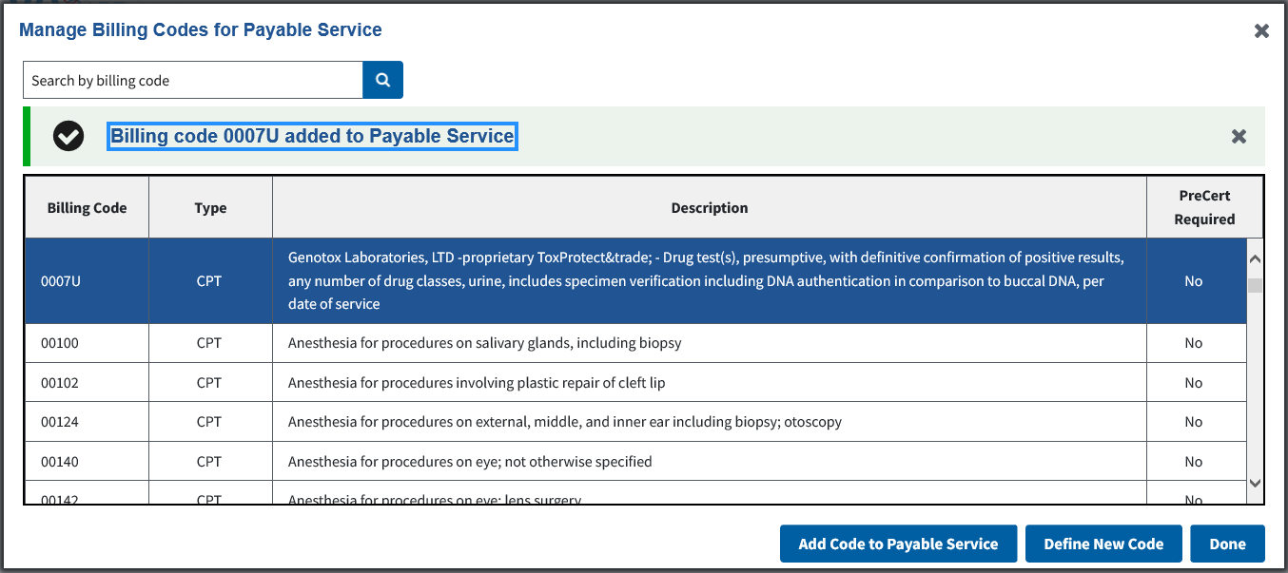

1. The confirmation message can be dismissed by clicking the X button.
2. Repeat steps 40-42 to add additional **Billing Codes** to the **Payable Service**.
3. To define a new **Billing Code**, click **Define New Code**. The **Define New Code** form will display.

Figure : Edit SEOC: Define New Billing Code

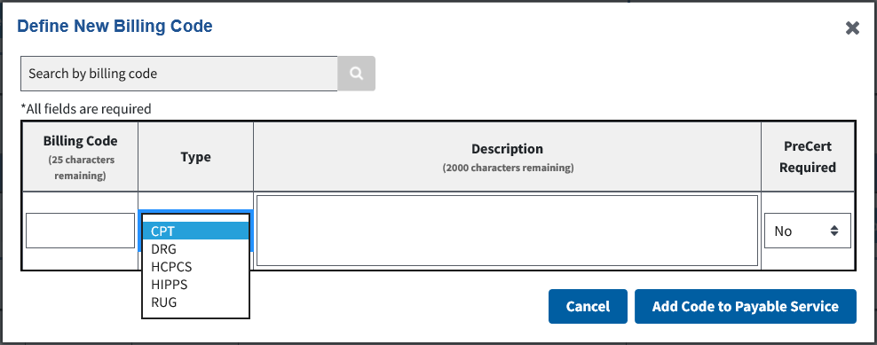

1. If you had entered a billing code in the **Search by Billing Code** **Field** before clicking **Define New Code**, the **Billing Code Field** will be pre-populated with the value from the **Search by Billing Code Field.**
2. If the pre-populated value for the **Billing Code Field** starts with a letter, the **Type** menu will default to **DRG**. Otherwise, it will default to **CPT**.
3. In the **Billing Code** field, which is required, enter the billing code.
4. The maximum number of characters for the **Billing Code** field is 25.
5. From the **Type** menu, select the type of billing code (required field).
6. In the **Description** field, which is required, enter the billing code description.
7. The maximum number of characters for the **Description** field is 2000.
8. From the **PreCert Required** menu, select whether the billing code requires pre-certification (required field).
9. Click **Add Code to Payable Service**. The new code will be added to the current payable service. A confirmation message will display. It will also be available in the list of billing codes in the **Add Billing Code** dialog box.
10. If any of the fields are not populated, there are any characters in the **Billing Code** field that are not letters, numbers, a hyphen, or a period, or the **Description** field has a backslash character, an error message will appear when you click **Add Code to Payable Service**.
11. The error message can be dismissed by clicking the X button.

Figure : Edit SEOC: New Billing Code Added Message

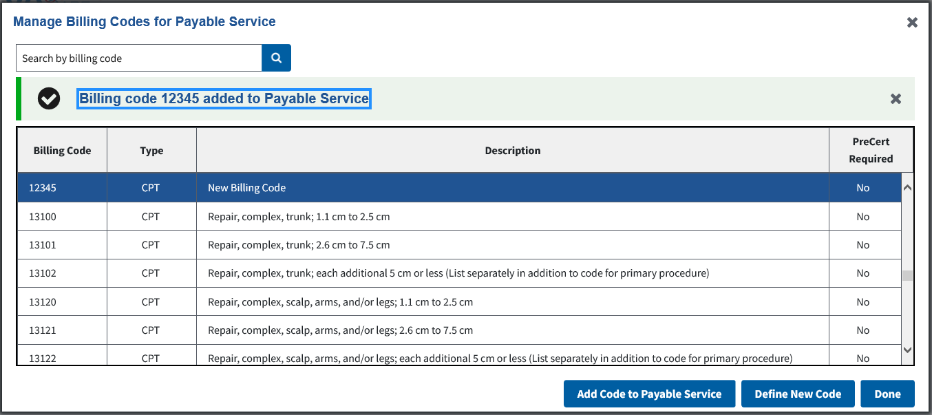

1. The confirmation message can be dismissed by clicking the X button.
2. Click **Done**. The **Edit SEOC: Add Payable Service** section will display.

Figure : Edit SEOC: Billing Codes added to the Payable Service

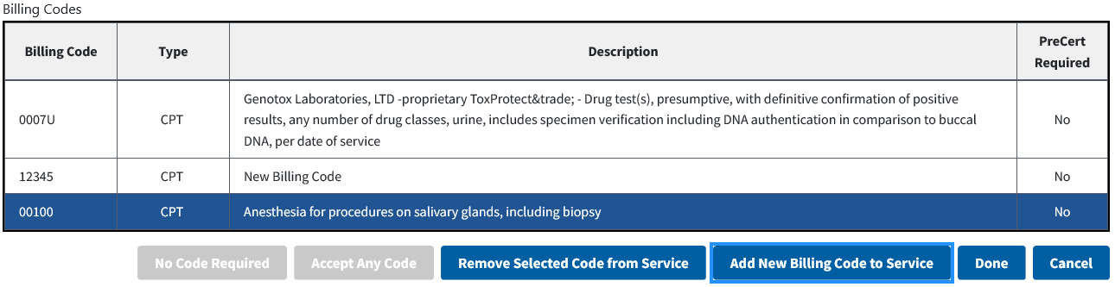

1. If needed, you can select a **Billing Code** row and click **Remove Selected Code from Service** to remove a **Billing Code**. A confirmation message will display.

Figure : Edit SEOC: Billing Code Removed Message

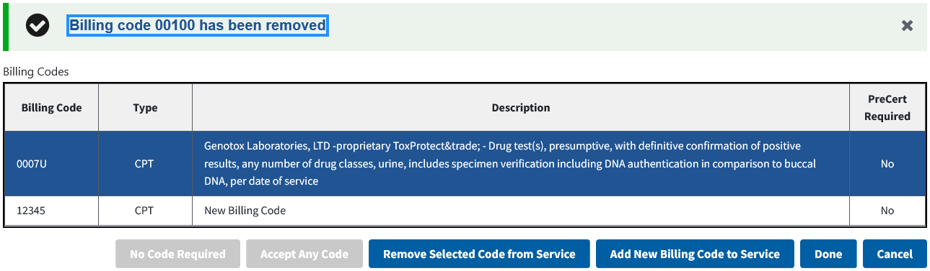

1. The confirmation message can be dismissed by clicking the X button.
2. Click **Done**. The **Edit SEOC: Payable Services** section displays at the top of the page.

Figure : Edit SEOC: Payable Service added to SEOC

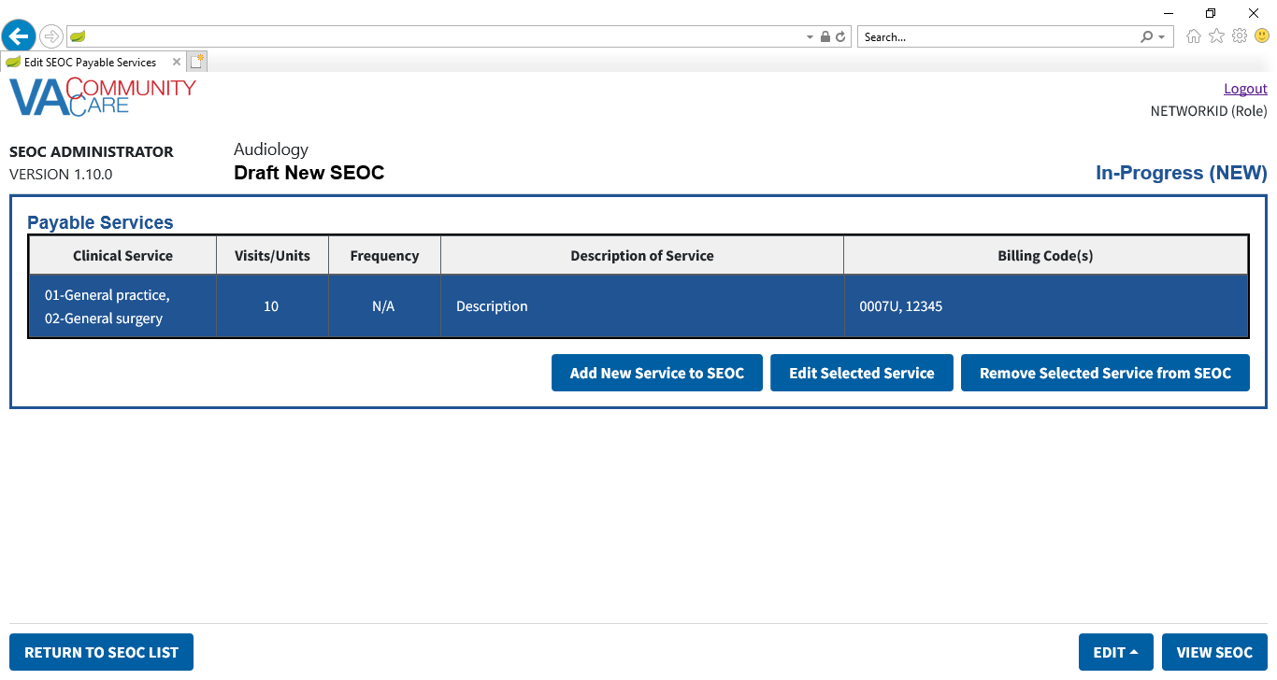

1. If any of the required fields are not populated, or if **Allowable Visits/Units** or **Frequency** are not numbers within the specified range, an error message will appear when you click **Done**.
2. The error message can be dismissed by clicking X.
3. If needed, you can select a **Payable Service** row and click **Remove Selected Service from SEOC** to remove a **Payable Service**. The **Confirm Delete Payable Service** dialog will display.

Figure : Edit SEOC: Delete Payable Service Confirmation

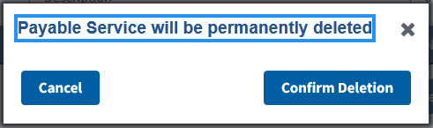

1. Click **Confirm Deletion** to remove the **Payable Service**. A confirmation message will appear.

Figure : Edit SEOC: Payable Service Removed Message

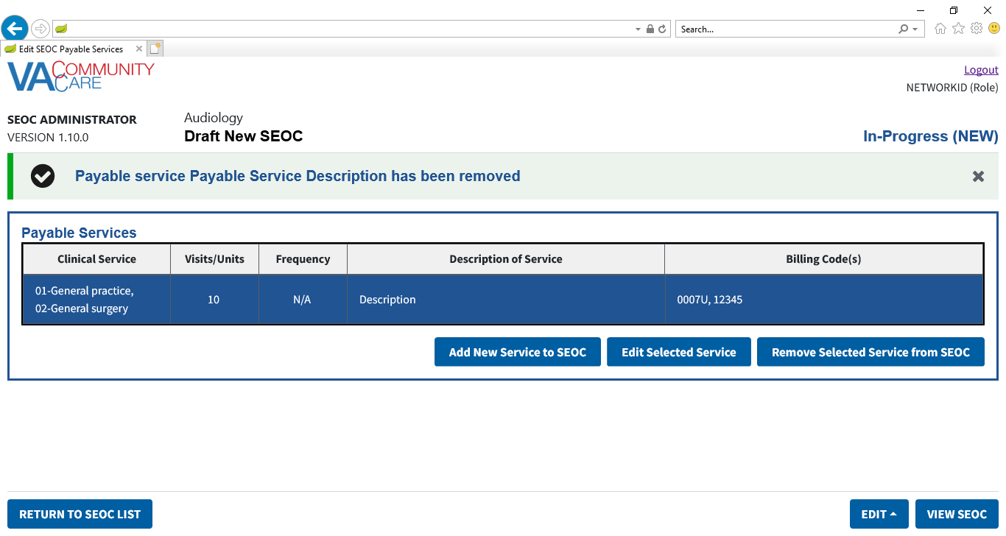

1. The confirmation message can be dismissed by clicking the X button.
2. You can also select a **Payable Service** row and click **Edit Selected Service** to edit the selected **Payable Service**.
3. Click **View SEOC**. The information you entered will be displayed, including **Provider Taxonomy Codes (HPTCs)** and **Payable Services**. The **In-Progress (New)** status will display in the window.

Figure : Edit SEOC: View SEOC

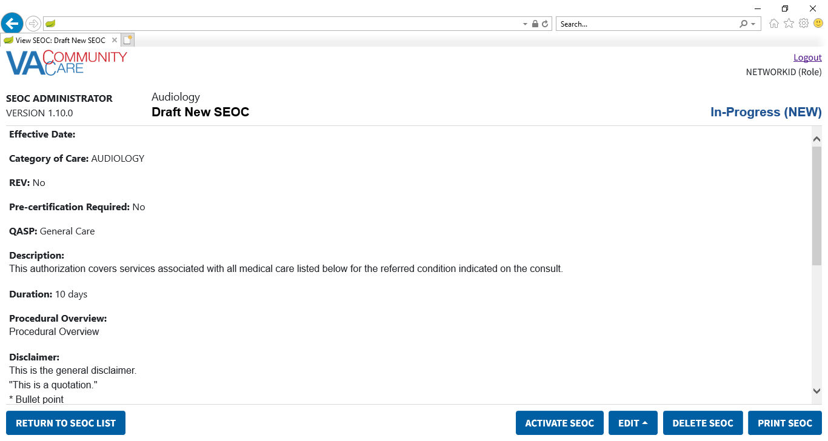

Figure : Edit SEOC: View Provider Taxonomy Codes and Payable Services

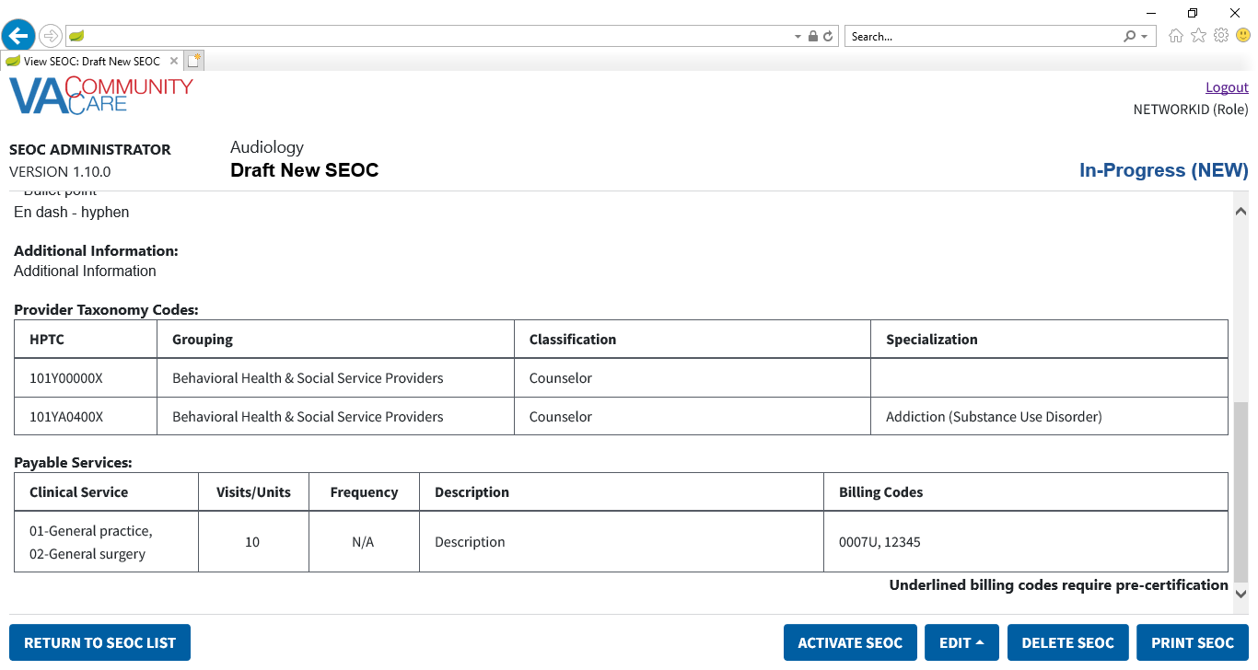

### Edit an In-Progress SEOC

1. If a user attempts to edit a SEOC that another user is already editing, the user will receive a message stating that the request can’t be processed.
2. If a user attempts to edit a SEOC while the system is in maintenance mode for Billing Code Management, the user will receive a message stating that the request can’t be processed.

To edit a SEOC that is currently marked as In-Progress, follow the steps listed below:

1. From the SEOC Admin home page, select the SEOC you would like to edit.
2. Click **View Selected SE**OC, the **View SEOC** page displays.
3. Click **EDIT SEOC**. The **Edit SEOC: Name** window displays.
4. Follow the workflow in the previous section to edit any fields as necessary.
5. Click **View SEOC** to confirm the edits.

### Activate an In-Progress SEOC

To activate a SEOC that is currently marked as In-Progress, follow the steps listed below:

1. From the SEOC Admin home page, select the SEOC you would like to activate.
2. Click **View Selected SEOC**, the **View SEOC** page displays.
3. Click **Activate SEOC**.
4. Once the SEOC is activated, the previous version status is automatically set to Discontinued.
5. If there are activation errors, the **Activation Error** dialog will display listing what needs to be resolved before the **SEOC** can be activated.

Figure 96: SEOC Activation Errors

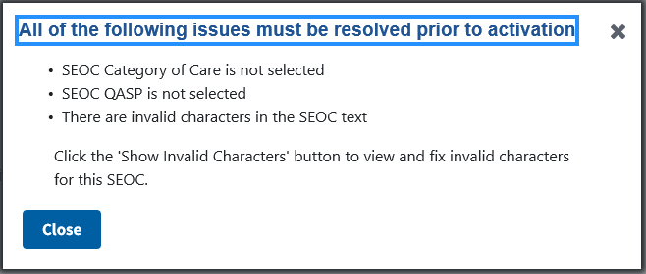

1. If there are no activation errors, the **Confirm Activation** dialog displays.

Figure 97: SEOC Activation Confirmation

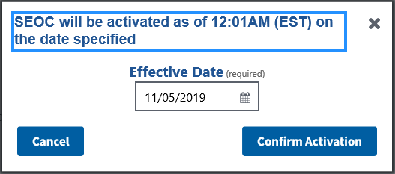

1. The **Effective Date** will default to the next day at 12:01AM EST. If needed, enter a new **Effective Date** in the input or click the calendar icon to select a date.

Figure 98: SEOC Activation Confirmation Calendar

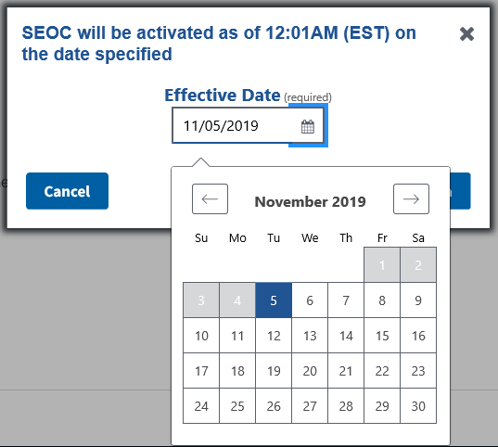

1. Click **Confirm Activation**. A confirmation message will display. The **Date Hold** status will display in the upper-right-hand corner of the page.
2. The **SEOC** will remain in **Date Hold** status until 12:01AM EST on the specified **Effective Date**. At that time, the **SEOC** will change to **Active** status.

Figure 99: SEOC Will be Activated Message

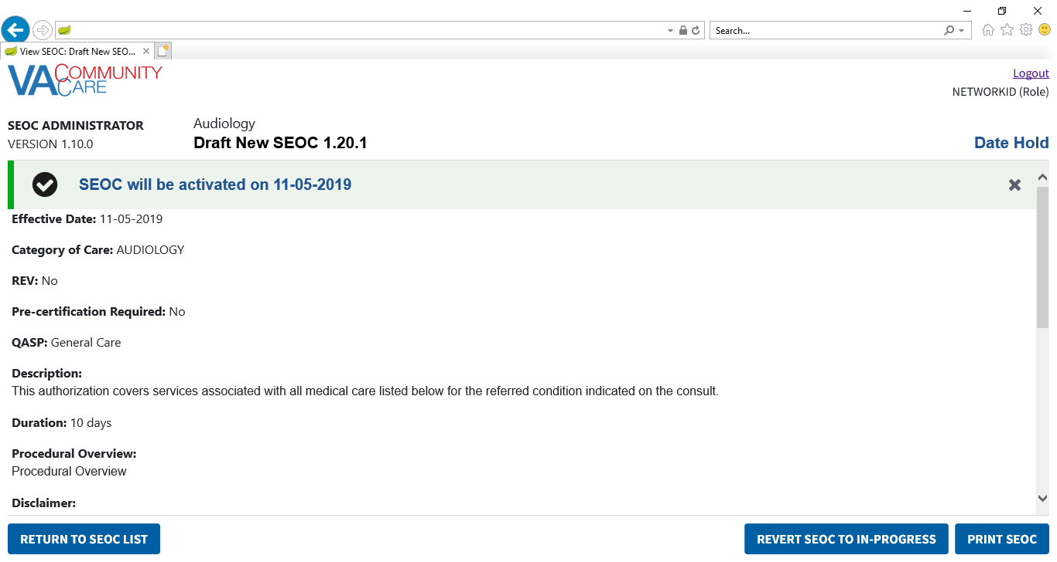

1. The confirmation message can be dismissed by clicking the X button.
2. Click **Return to SEOC List** to see the **SEOC** in the list with a **Date Hold** status.

### Delete an In-Progress SEOC

To delete a SEOC that is currently marked as In-Progress, follow the steps listed below:

1. From the SEOC Admin home page, select the draft SEOC you would like to delete.
2. Click **View Selected SE**OC, the **View SEOC** page displays.
3. Click **Delete SEOC**. The **Confirm Deletion** dialog box displays.

Figure 100: Confirm Deletion

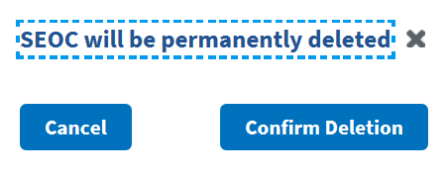

1. Click **Confirm Deletion**. The SEOC is deleted from the SEOC List.

## Pending Revisions

### Create a Revision

To create a revision to an existing SEOC, follow the steps listed below:

1. From the SEOC Admin home page, select the active SEOC you would like to create a pending revision.
2. Click **View Selected SE**OC, the **View SEOC** page displays.
3. Click **Create Pending Revision**. The **Revision: Name and Service Line** window displays.

Figure 101: Revision: Name and Service Line

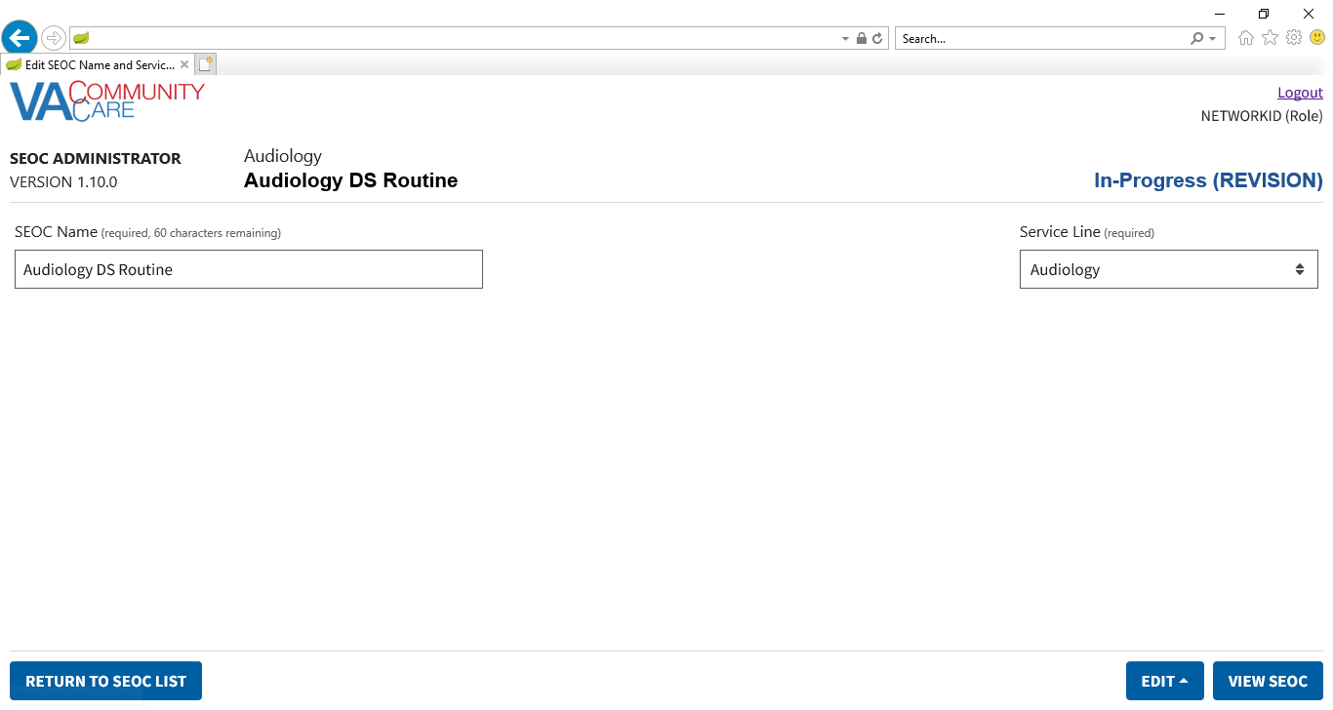

1. To return to the SEOC Admin home page while editing a new **SEOC** or **Revision**, click **Return to SEOC List** in the bottom left-hand corner of any page in the **Edit SEOC** workflow.
2. Update the **SEOC Name** and **Service Line** as needed.
3. Click **Add/Edit SEOC Details**. The **Revision: Details** window displays.

Figure 102: Revision: Details

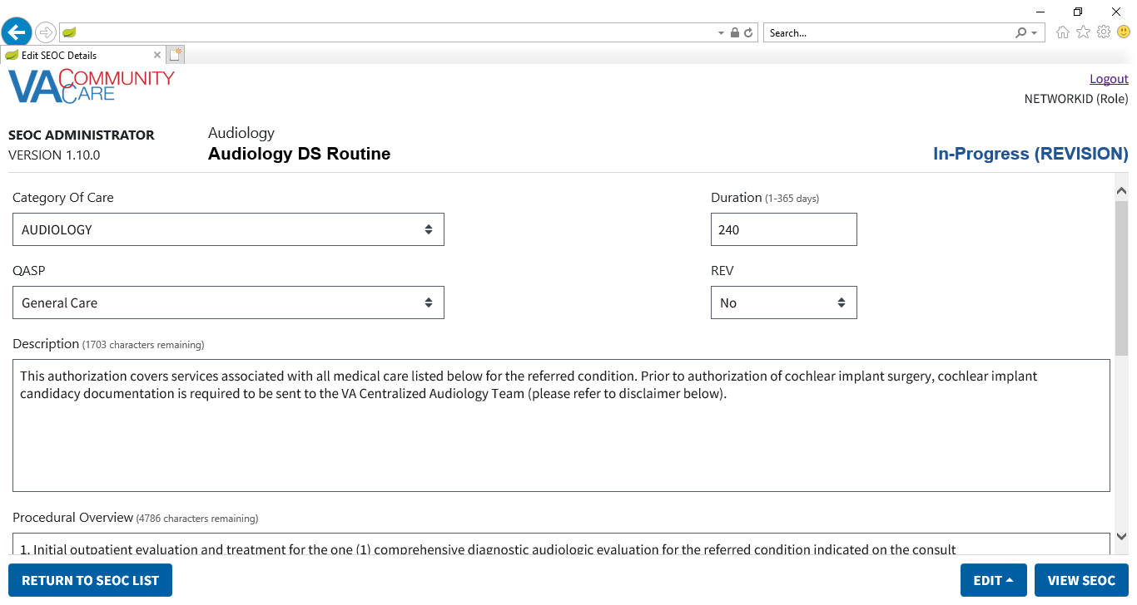

Figure : Revision: Details (Middle of the Page)

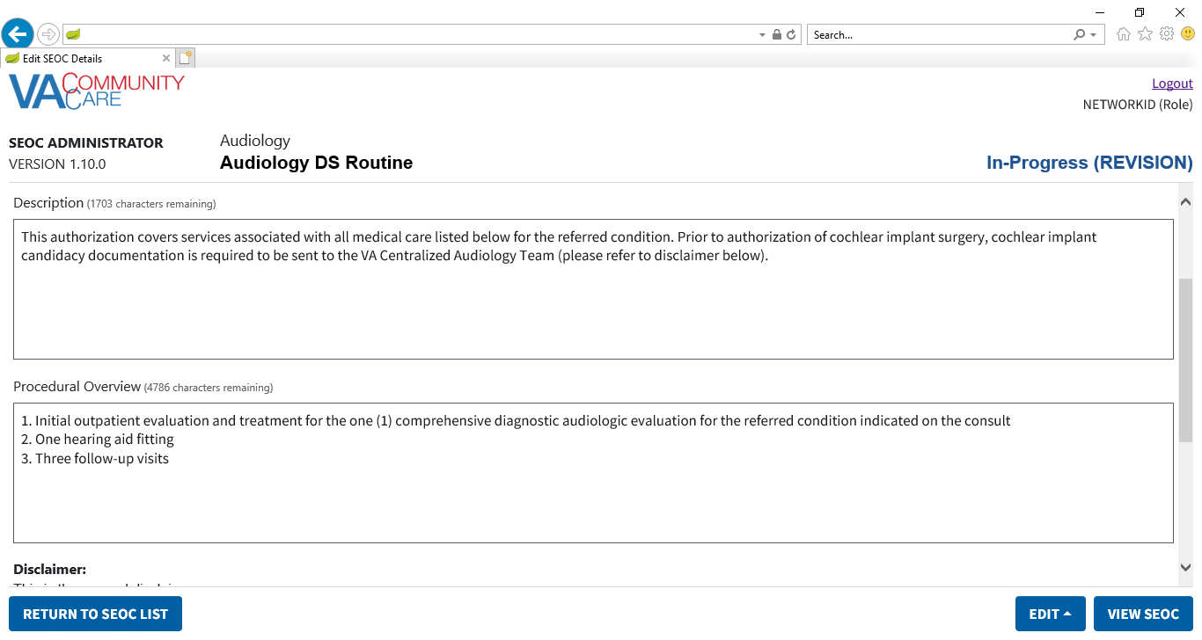

Figure : Revision: Details (Bottom of the Page)

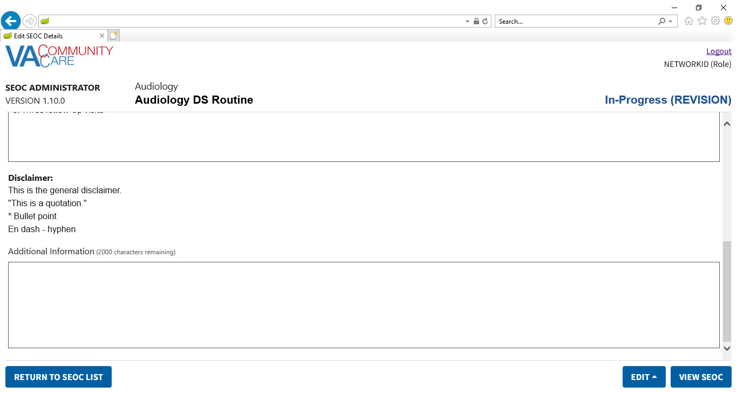

1. Update the details for the SEOC as needed.
2. Click **Add/Remove HPTCs**. The **Revision: SEOC Provider Taxonomy Codes** window displays.

Figure 105: Revision: SEOC Provider Taxonomy Codes

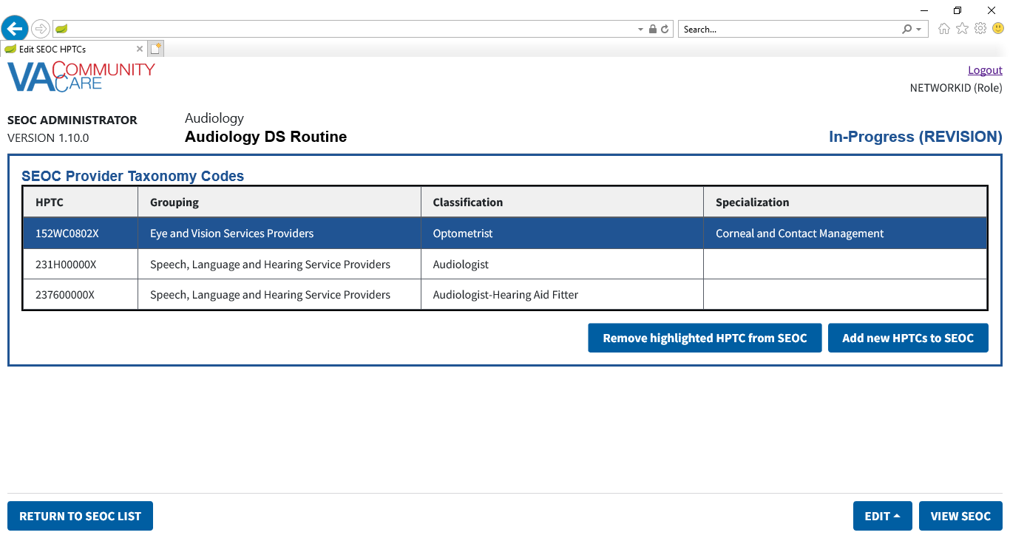

1. Update the **Provider Taxonomy Codes (HPTCs)** for the **SEOC** as needed.
2. Click **Add/Edit Payable Services**. The **Revision: Payable Services** window displays.

Figure 106: Revision: Payable Services

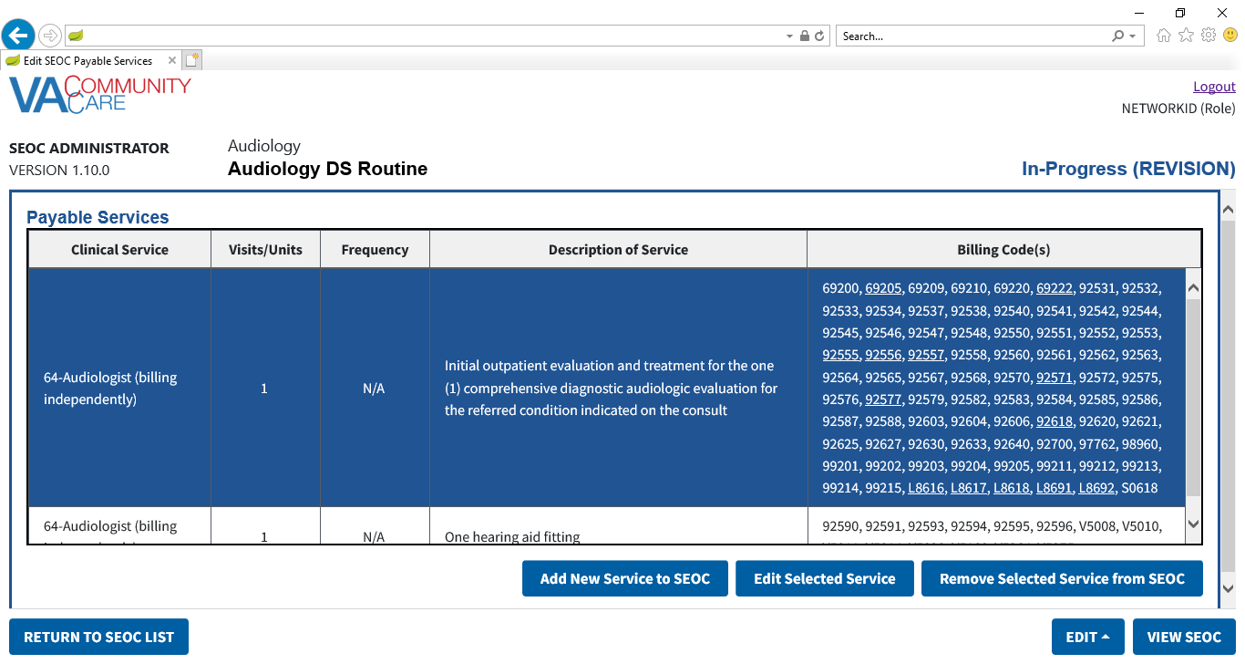

1. Select a **Payable Service**.
2. Click **Edit Selected Service**. The **Edit Payable Service** section will display.

Figure : Edit Payable Service

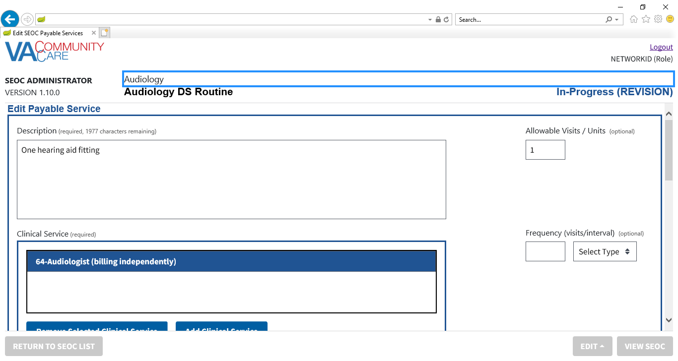

Figure : Edit Payable Service: Billing Codes

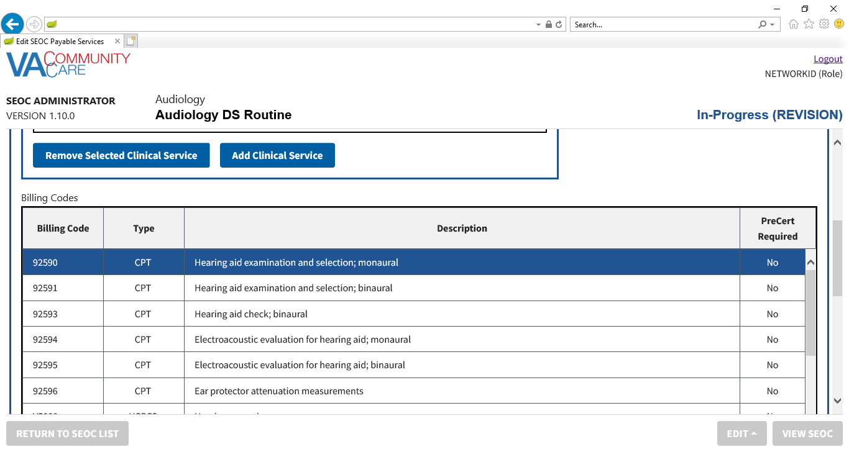

Figure : Edit Payable Service: Billing Codes and Action Buttons

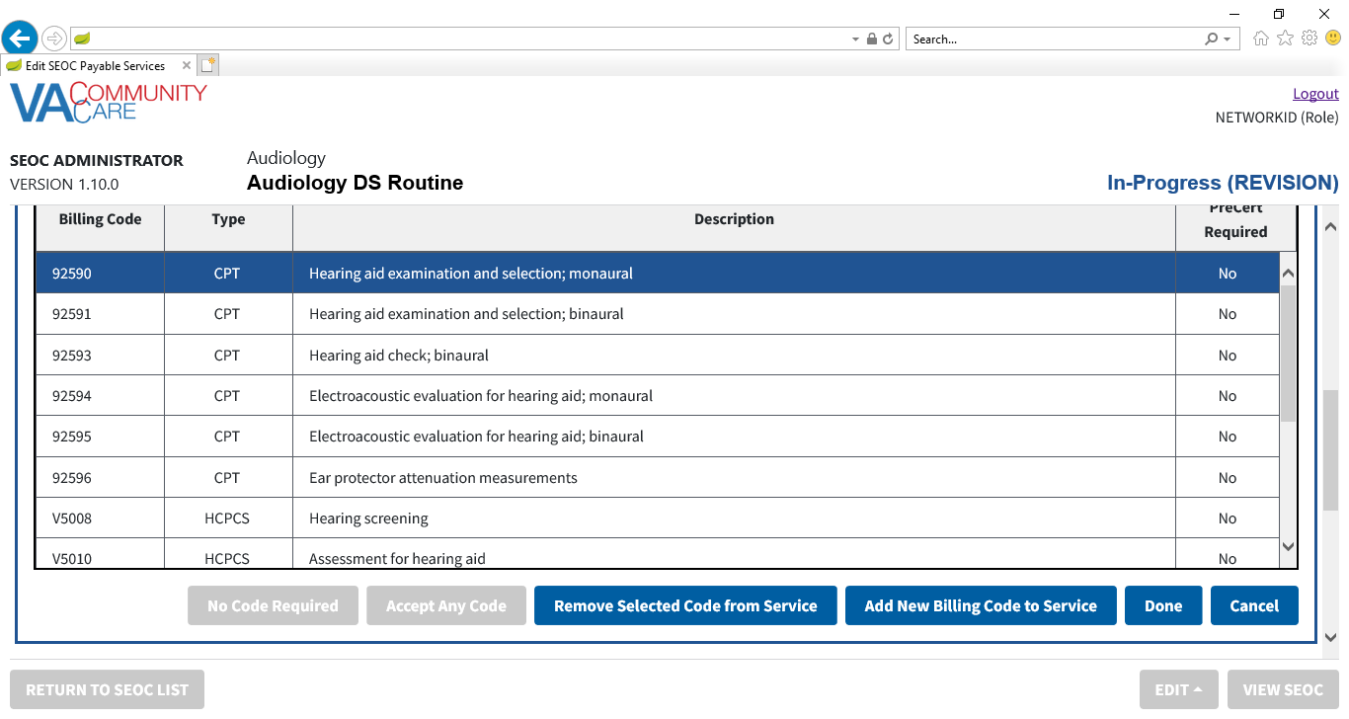

Figure : Edit Payable Service: Payable Services List

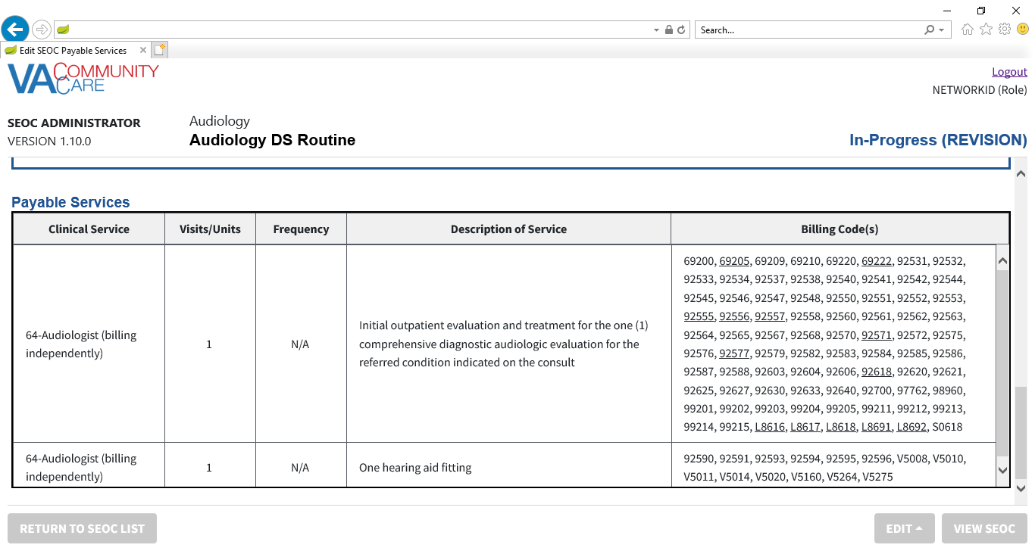

1. Make any desired updates
2. Click **Done**. The **Revision: Payable Services** page will display.
3. Repeat steps 10-13 for the other **Payable Services** as needed.
4. Click **View SEOC**. The **In-Progress (Revision)** status will display in the window.

Figure : In-Progress (Revision) Status

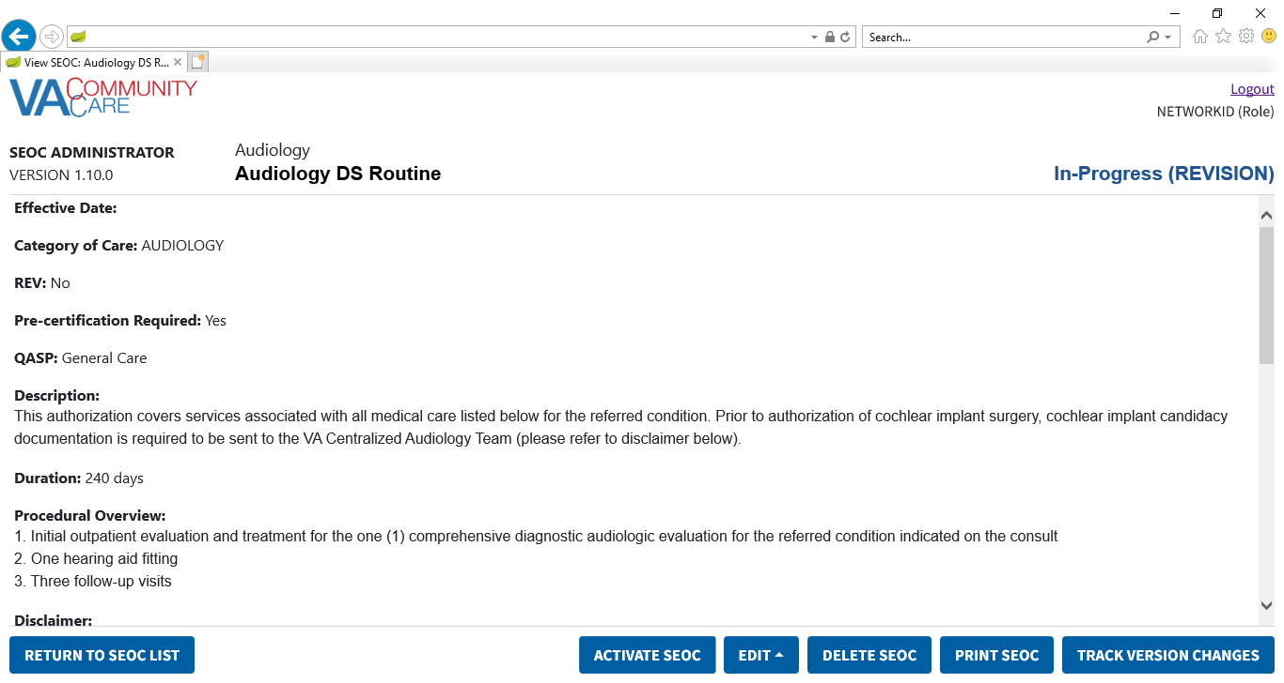

1. Click **Return to SEOC List**. The **Revision** will display in the list of **SEOCs**.

Figure : Revision Displayed in SEOC List

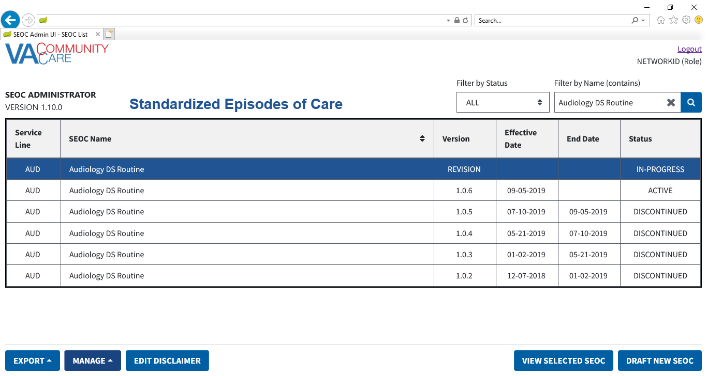

### Activate a Revision

To activate a pending revision, follow the steps listed below:

1. From the SEOC Admin home page, select the **Revision** **SEOC** that you would like to activate.
2. Click **View Selected SE**OC, the **View SEOC** page displays.
3. Click **Activate SEOC**. If there are activation errors, the **Activation Error** dialog will display listing what needs to be resolved before the **SEOC** can be activated.

Figure 113: Revision Activation Errors

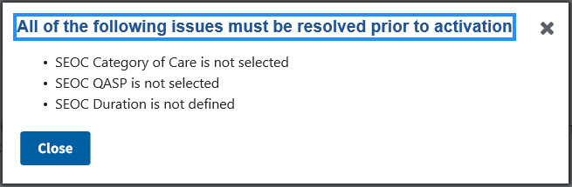

1. The **Revision Activation Confirmation** message displays.

Figure 114: Revision Activation Confirmation Message

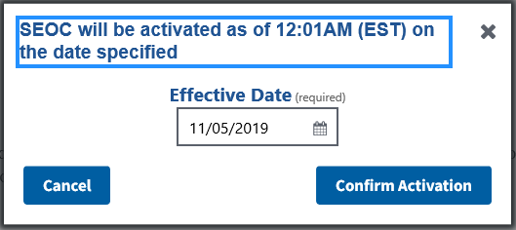

1. The **Effective Date** will default to the next day at 12:01AM EST. If needed, enter a new **Effective Date** in the input or click the calendar icon to select a date.

Figure 115: Revision Activation Confirmation Date Calendar

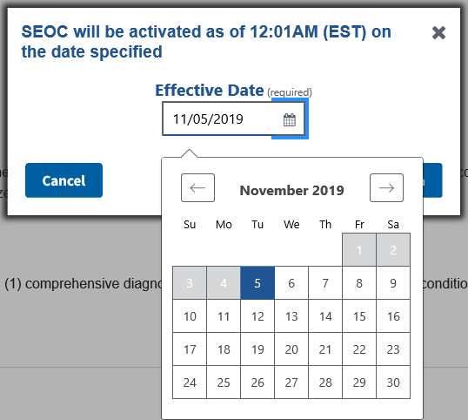

1. Click **Confirm Activation**. A confirmation message will display. The **Date Hold** **Status** will display in the upper-right-hand corner of the page.

Figure 116: Revision Will be Activated Message

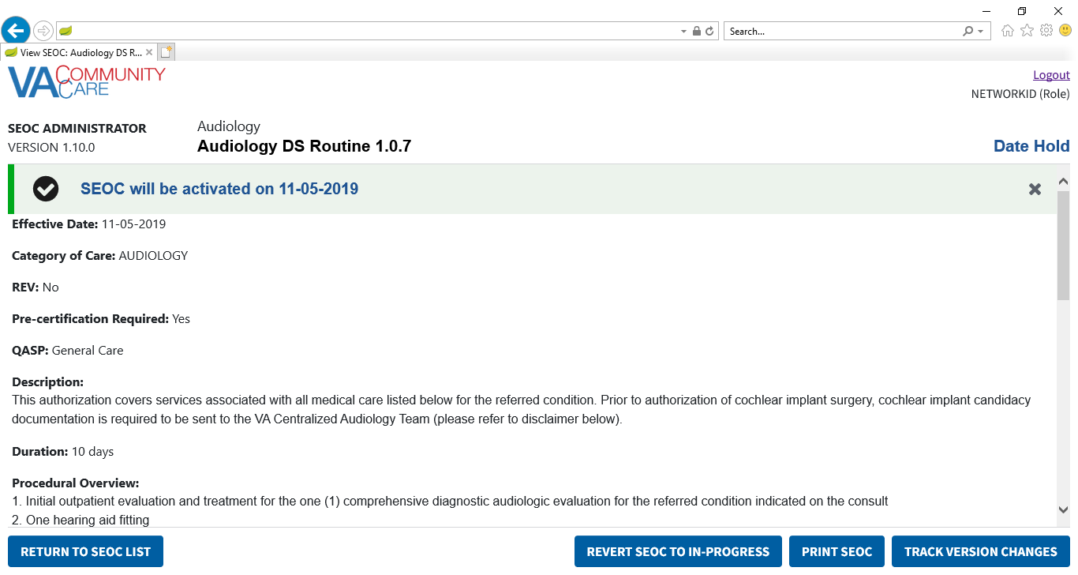

1. Click **Return to SEOC List**. The pending revision that you just activated will display as **Date Hold** in the list of SEOCs.
2. The **Revision** will remain in **Date Hold** status and the previous **SEOC** will remain in **Active** status until 12:01 AM EST on the specified **Effective Date**. At that time, the **Revision** will change to **Active** status and the previous **SEOC** will change to **Discontinued** status.

### Revert a Date Hold SEOC Back to In-Progress

If you need to revert the selected SEOC to In-Progress, follow the steps listed below:

1. From the SEOC Admin home page, select the **Date Hold SEOC** you would like to revert back to **In-Progress**.
2. Click **View Selected SEOC**, the **View SEOC** page displays.
3. Click **Revert SEOC to In-Progress**. The **Confirm Revert SEOC to In-Progress** dialog will display.

Figure 117: Confirm Revert SEOC to In-Progress

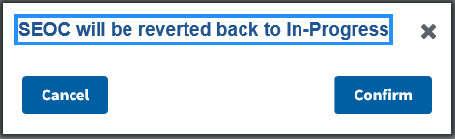

1. Click **Confirm**. The **SEOC** will be reverted back to **In-Progress** and a confirmation message will display.

Figure : SEOC Reversed to In-Progress Message

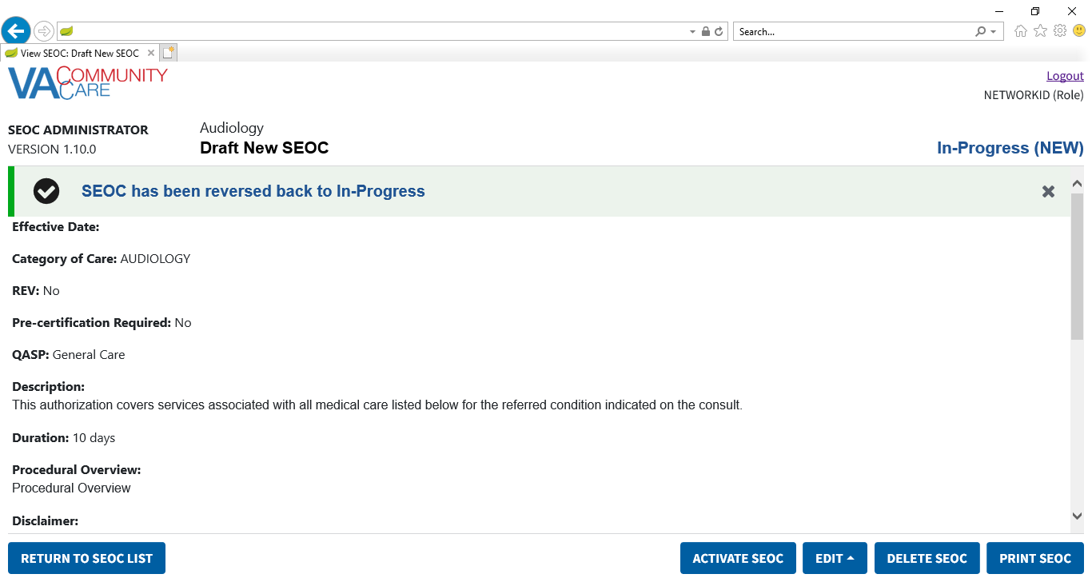

1. The confirmation message can be dismissed by clicking the X button.

# Troubleshooting

Users may encounter the following errors while using the SEOC UI.

Table 2: SEOC Error Codes with Descriptions

| Error Code | Description |
| --- | --- |
| 204 | No Content Found |
| 401 | Unauthorized |
| 403 | Forbidden |
| 404 | Not Found |

# Acronyms and Abbreviations

| Acronym | Definition |
| --- | --- |
| CAC | Clinical Application Coordinators |
| CC | Care Coordination |
| CCAD | Community Care Agile Development |
| CDW | Corporate Data Warehouse |
| CID | Clinically Indicated Date |
| CPRS | Computerized Patient Record System |
| HEC | Health Eligibility Center |
| HPTC | Healthcare Provider Taxonomy Code |
| JSON | JavaScript Object Notification |
| NSD | National Service Desk |
| OIT | Office of Information and Technology |
| PCP | Primary Care Physician |
| SAR | Secondary Authorization Request |
| SEOC | Standardized Episode of Care |
| VA | Department of Veterans Affairs |
| VDL | VA Software Document Library |
| VistA | Veterans Health Information Systems and Technology Architecture |

1. JSON Instructions
2. The steps outlined below are for Excel 2016.

To convert the SEOC JSON file to an Excel file, follow the steps listed below:

1. Select to download the SEOC JSON file. The Internet Explorer File Download Prompt displays at the bottom of the window.
2. From the **Save** menu, select **Save as**. The **Save As** window displays.
3. Select to download the file to the Desktop and click **Save**.
4. Open a blank workbook in Excel 2016.
5. Click the **Data** tab, then **Get Data** > **From File** > **From JSON**. The **Import Data** window displays.

Figure 119: Import Data Window

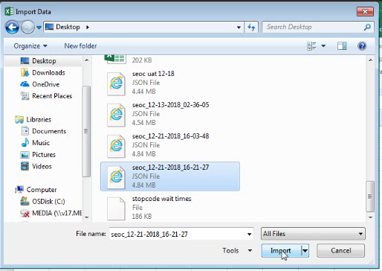

1. Select the JSON file you downloaded and click **Import**. Excel will open the file in the Query Editor.

Figure 120: Query Editor

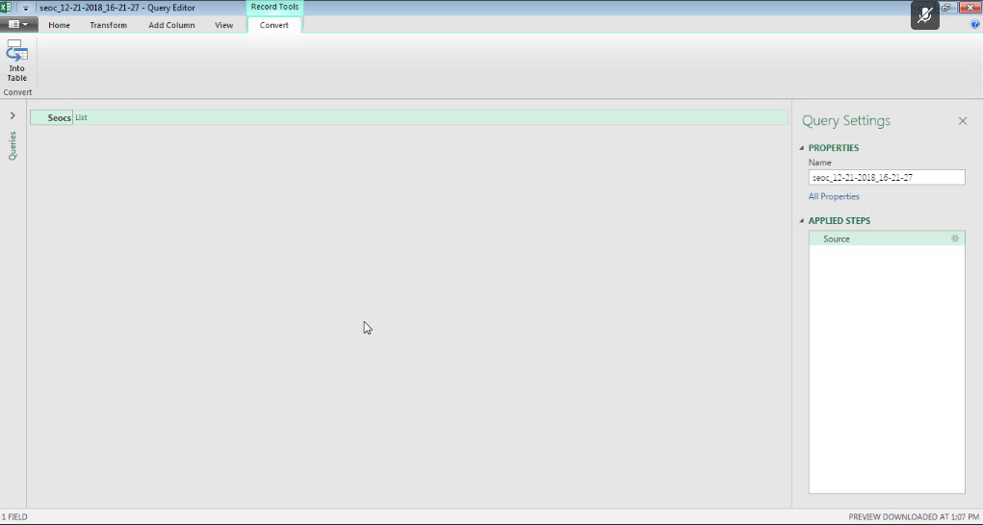

1. Click the **List** header to the right of **Seocs** to display a list of records.

Figure 121: List of Records

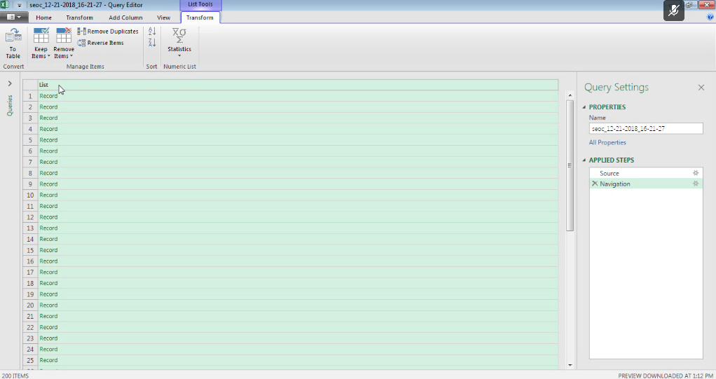

1. From the **Transform** tab, click the **Convert To Table** icon and click **OK**. The **To Table** dialog box displays.

Figure 122: To Table Dialog Box

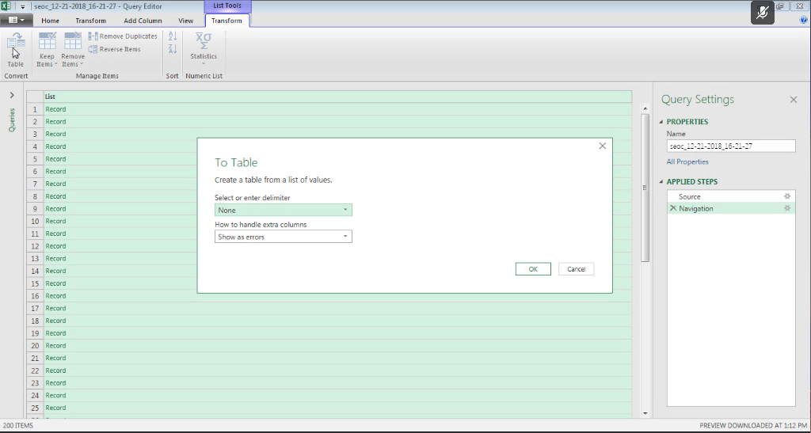

1. From the **To Tabl**e dialog box keep the default selections and click **OK**.
2. Click on the expand icon (<-||->) to the right of the **Column1** header to display the **Search Columns to Expand** dialog box.

Figure 123: Search Columns to Expand Dialog Box

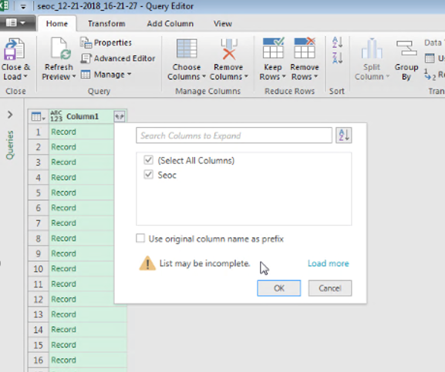

1. De-select the **Use original column name as prefix** check box.
2. Click **OK**.
3. Click on the expand icon (<-||->) to the right of the **Seoc** header to display the **Search Columns to Expand** dialog box.

Figure 124: Search Columns to Expand

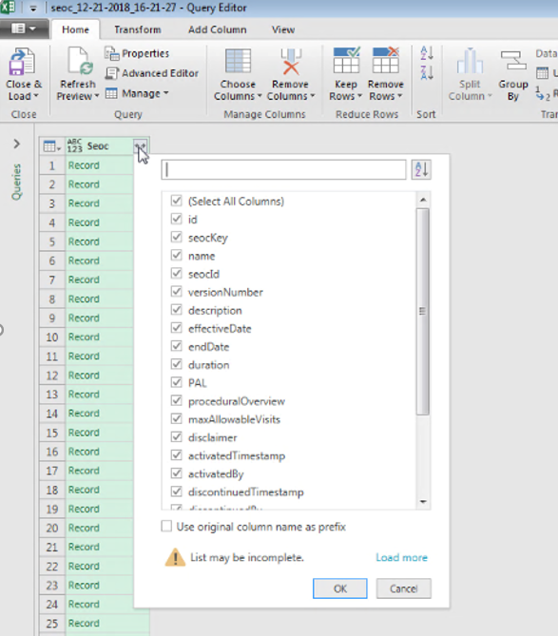

1. Uncheck the **Use original column name as prefix** check box.
2. Click **OK**. The fields in the SEOC table will be expanded to columns as shown below.

Figure 125: Expanded SEOC Fields

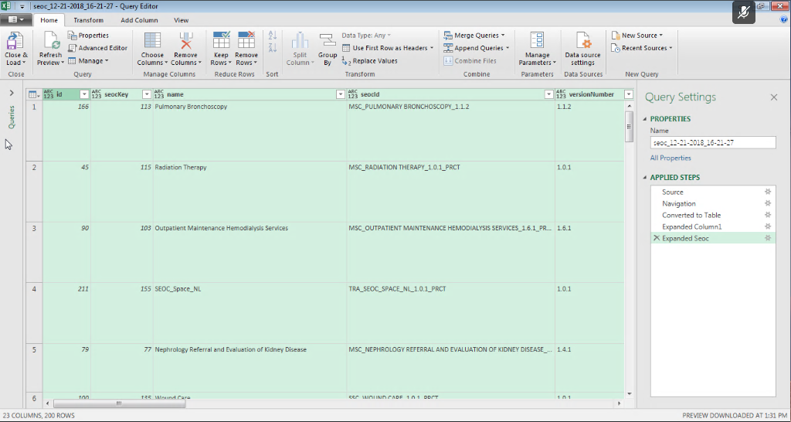

1. Scroll right to the **services** column, click on the expand icon, and select **Expand to New Rows** to display the records.

Figure 126: Expand to New Rows Menu Option

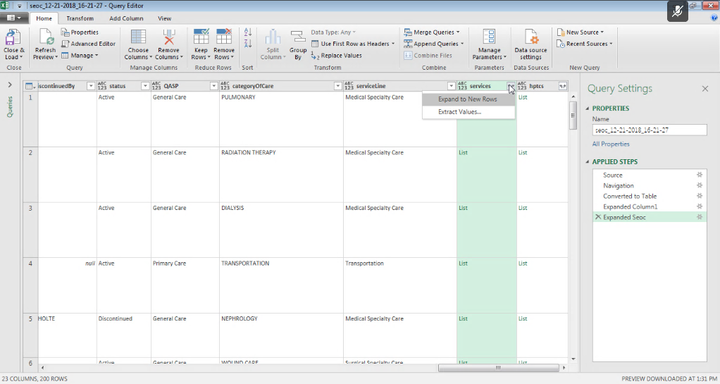

1. Click the expand icon again and press **OK** to expand the Payable Services fields into columns.

Figure 127: Payable Services Columns

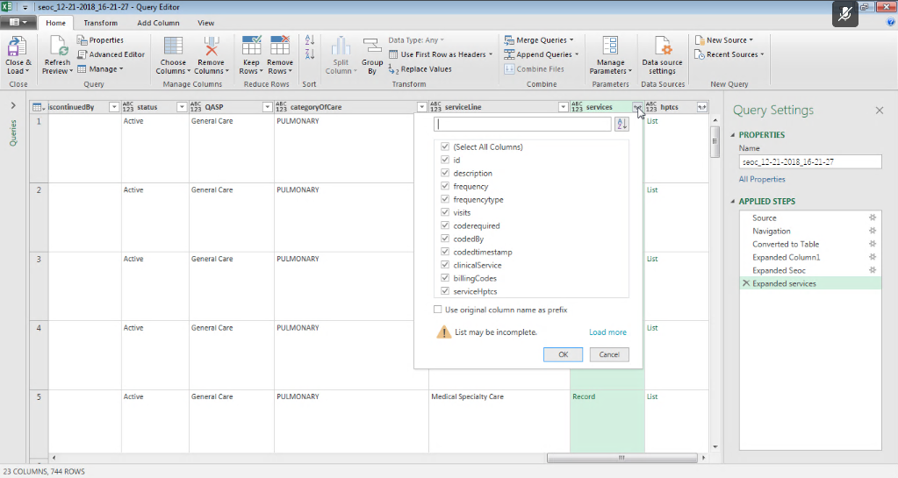

1. Scroll right to the **billingCodes** column and repeat the last two steps to expand the **Billing Code** fields into columns.

Figure 128: Billing Code Columns

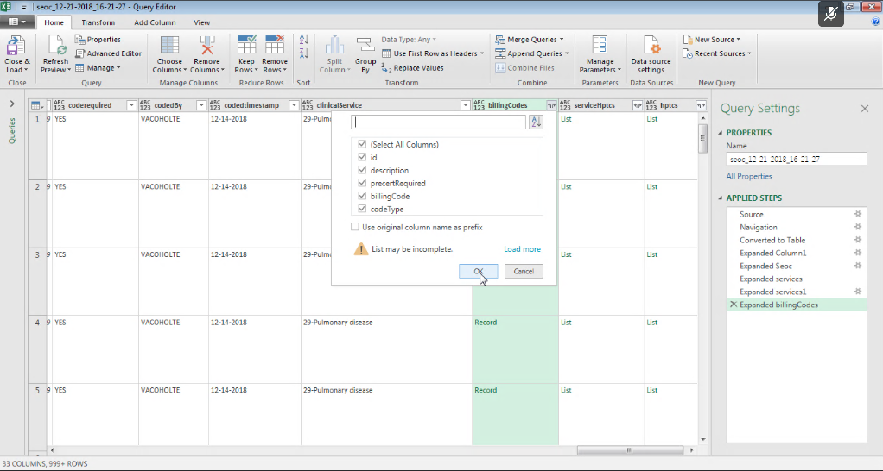

1. Optional - Repeat the last two steps again for the serviceHptcs column if you want to see the cross-walked HPTCs that are sent for each Payable Service.
2. Scroll right and repeat the last two steps again for the hptcs column to expand the HPTC fields that were assigned to each SEOC.

Figure 129: Expanded HPTC Fields

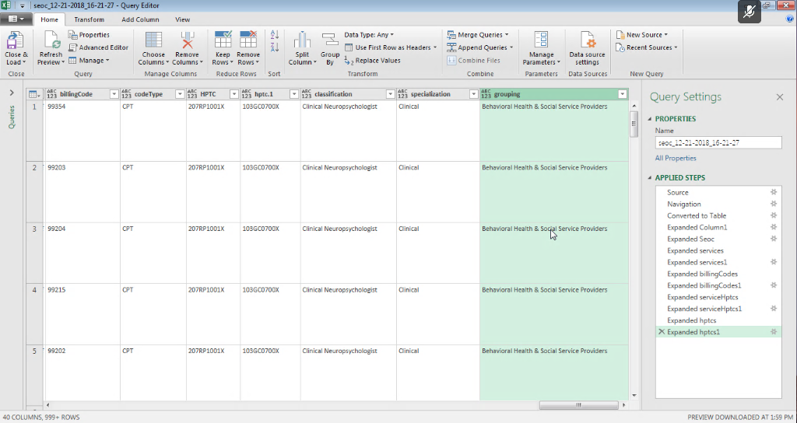

1. Click the **Close & Load** option at the left of the ribbon to create load the imported data into a spreadsheet tab.

Figure 130: Imported Data

